Statewide Park and Trail Visitation

A joint research project between Minnesota Department of Natural Resources, Greater Minnesota Regional Parks and Trails Commission, and Metropolitan Council | 2023-09-05

Table of Contents

# 1 Introduction

Understanding visitation to Minnesota’s parks and trails is essential for planning, programming, and investment decisions. Visitation estimates generally rely on methods such as intercept surveys, in-field visitation counts, and automated trail counters. Visitation estimates using passively generated data sources may offer opportunities to complement existing strategies.

In many cases, there is limited (or no) information on park or trail visitation at the individual unit level. Existing strategies such as intercept surveys or trail counters are often prohibitively expensive. For example [Metropolitan Council staff estimate](https://metrocouncil.org/Council-Meetings/Committees/Community-Development-Committee/2020/May-4,-2020/2020-136.aspx) that it costs approximately $15,000 per park or trail to collect representative intercept survey data for one summer. Implementing an intercept survey to collect unit-level data for all state and regional parks and trails across the state of Minnesota would cost millions of dollars for a one-time data collection effort.

Within the last decade, rapid adoption of mobile devices like smartphones (Figure 1.1) allows for park visitation to be estimated using aggregated and anonymized location-based services (LBS) data. Mobile phone applications, such as couponing, dating, weather, or tourism apps, collect anonymous user locations. Apps can collect location information in the foreground or background, meaning that a user does not have to be actively using the app for data to be collected. This passive data collection results in a unique opportunity for park and trail research.

This project used aggregated and anonymized location-based services (LBS) data to estimate and evaluate visitation to Minnesota parks and trails. LBS data gives information about when and where people travel. This approach provides detail about how visitors use parks and trails and broadly describes who those visitors are. Visitation and use patterns can be analyzed at annual, monthly, weekly, and hourly time intervals. This data makes it possible to understand how people travel to parks and trails and where they are coming from. This data is intended to supplement, but not replace existing data used for decision making.

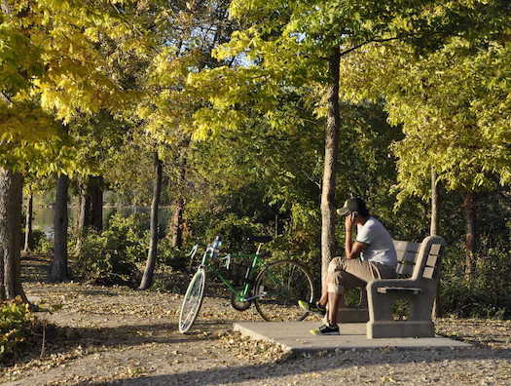

Figure 1.1: A person uses a cellphone while resting on a bench.

StreetLight Data, Inc. is a big data firm specializing in mobility analytics via location-based services (LBS) data. StreetLight purchases de-identified LBS data from third-party vendors, such as [Cuebiq](https://www.cuebiq.com/). StreetLight then processes the data, completing quality assurance and statistical tests. Finally, the project team runs queries on the dataset, specifying the geographic area and output metrics.

StreetLight reviews every query to ensure sample sizes are sufficiently large. LBS data shared by StreetLight always describes aggregated behavior trends, not the behavior of individuals. This means that the data can never be used to identify individuals, only to describe and analyze broad travel patterns. StreetLight’s sample contains roughly 110 million devices, which accounts for roughly one third of the population ofthe United States and Canada. StreetLight publishes detailed methodologies and whitepapers on their [website](https://www.streetlightdata.com/whitepapers/).

Using StreetLight to understand park visitation is an experimental project, and any findings are meant to complement existing and future parks research. Importantly, different methodological approaches may be employed to understand various facets of park and trail visitation and certain methods may be preferable over others based on the key research question. A brief description and comparison of several most-used methodologies are given in Table 1.1.

Table 1.1: Park and recreation research methods compared

| Data source | Description | Population sampled | Sample size | Sampling type | Use case | Benefits | Challenges |
| --- | --- | --- | --- | --- | --- | --- | --- |
| Aggregated location-based services | Anonymous data collected from cell phone apps that use opt-in GPS services | Devices (smartphones, in-vehicle GPS) | Very large | Passive | Estimating use over long periods of time, during off-peak seasons, at low-use units, or at many locations simultaneously. Generating spatially or temporally detailed use estimates. Locating high activity areas within a park or on a trail. Estimating visitor demographics (with limitations). | Low resource intensity, high scalability. | Experimental research. Results require interpretation. Location-based services (and other novel data sources) may change more rapidly than established research methods. |
| Intercept survey | Questionnaires administered by surveyors onsite at parks or trails | People | Limited | Active | Understanding generalized visitor experiences, detailed demographic information | Established research technique with well understood outcomes and implications. | High investment of time. Some evidence for biases in survey results. |
| Focus groups, interviews, workshops | In-depth interviews and moderated focus groups with park and trail visitors and community members | People | Limited | Active | Developing a rich understanding of visitor experience, behavior, activity preferences, desires, and/or barriers to accessing parks and trails. | Community members can discuss items not explicitly asked for. Opportunity for education, relationship building, and learning about visitors' lived experiences. | High investment of time and researcher expertise. |
| Automatic counters | Devices such as pneumatic tubes or infrared sensors that count the number of passing pedestrians, bicyclists, or vehicles | People or vehicles | Large | Passive | Enumerating visitors and evaluating trends over time. Estimating use at specific points on trails. | Passive data collection at a consistent location over time. | High startup cost. Require ongoing maintenance. |
| Manual counts | Counts performed by individuals at specific location at parks or trails during a specified time interval | People | Limited | Active | Enumerating visitors at specific points in parks or on trails for a limited time period. | Straightforward method with easily interpreted results. | Low sample size. Resource intensive. |

The specific goals of this project are to:

1. Broadly determine whether or not location-based services data may be a useful tool for park and trail research,
2. Estimate weekly park visitation and monthly trail use,
3. Compare, or validate, LBS use estimates to traditional use estimates (intercept surveys and automatic trail counters),
4. Explore and validate visitor home locations and demographics inferred by the LBS data provider

Section 2 of this report describes the methods, data validation, and findings developed for the analysis of parks. Section 3 details trail methods and findings and Section 4 summarizes inferred visitor home locations and demographics. Section 5 discusses recommendations, resources, and future work. Appendices provide additional methodological detail.

More summarized data, including high-level key findings and interactive visualizations are available on a project-specific website [here](https://arcg.is/0Oee0W0). Complete project results (Excel workbooks and shapefiles) are available for download on the project website. The code used to conduct the analysis and create this report is available on a public GitHub repository [here](https://github.com/Metropolitan-Council/legacy-LBS-parktrail-research). Many of the results in this report are replicated on the project website. The goal of this report is to provide methodological detail such that this analysis could be repeated using the provided Github repository.

This project was funded with Legacy Partnership Research Funds from the State of Minnesota Parks and Trails Legacy Fund. The joint research project was conducted in collaboration with the Minnesota Department of Natural Resources, the Greater Minnesota Regional Parks and Trails Commission, and the Metropolitan Council. We thank staff from across these organizations and their associated implementing agencies for their cooperation in sharing data and providing feedback.

# 2 Parks

Understanding park visitation is essential for planning, programming, and investment decisions. This project used location-based services (LBS) data to analyze weekly use of 206 state and regional parks across Minnesota from January 2019 - April 2022. This data is intended to supplement, but not replace existing data used for decision making. Approximately 207.41 million park visits occurred across all parks during the study period. In total, 2020 had the highest use across the years analyzed. We found that parks were used in all seasons, although the summer months of June, July, and August had the highest use. Most visitors traveled to parks in vehicles, but this analysis also considered people arriving on bike or foot. Weekly-level detail revealed considerable variation in use patterns across and within individual park units.

## 2.1 Methods

Aggregated and anonymized LBS data was used to estimate weekly use of 206 state and regional parks across three systems (n = 78 Minnesota Department of Natural Resources parks (DNR State), n = 57 Greater Minnesota Regional Parks and Trails Commission parks (Greater MN Regional; 43 designated and 14 eligible for designation), and n = 67 Twin Cities metropolitan regional parks (Metro Regional)). The resulting data set consists of 173 weekly observations for each park. Each observation reports estimated weekly use disaggregated by travel mode (vehicle, bicycle, and pedestrian).

Geographic boundaries used to measure park use were accessed via the Minnesota Geospatial Commons for [DNR State](https://gisdata.mn.gov/dataset/bdry-dnr-lrs-prk) and [Metro Regional parks](https://gisdata.mn.gov/dataset/us-mn-state-metc-plan-parks-regional). Greater MN Regional park geographies were obtained via personal communication with Renee Mattson (Executive Director, Greater Minnesota Regional Parks and Trails Commission). In all cases, park geographies were post-processed to optimize suitability for LBS analyses.

Total park use was estimated by summing the number of visitors entering a park via vehicle, bicycle, or foot. The LBS data provider does not explicitly measure visitors arriving by other transportation modes, but other modes (i.e., snowmobiles, boaters) may be captured and classified as either vehicle, bike or foot visitors by the LBS data provider using their probabilistic models. A park visitor must have remained within the park boundary for at least five minutes to be counted. Visitors were counted once upon each park entry (i.e., overnight campers making a day trip outside the park would be counted upon their return as well as initial entry but visitors making multiple stops or short trips within the park are only counted upon initial entry).

LBS data was obtained from StreetLight Data, Inc. and last accessed in July 2023. The StreetLight application programming interface was used to run a zone activity analysis for each park’s vehicle, bike, and pedestrian counts during each week of the study period. Vehicle multipliers representing the average number of persons per vehicle were applied to convert vehicle counts to visitor counts. Devices registered to minors (under age 18) are not included in the LBS data source, however vehicle multipliers represent visitors of all ages.

### 2.1.1 Geography

Park geographies were post-processed to suite LBS estimation methods. Original park geography files were accessed via a combination of pathways. DNR files from the [Minnesota Geospatial Data Commons](https://gisdata.mn.gov/dataset/bdry-dnr-lrs-prk) were last accessed in July 2023, and management boundaries are used for the polygons. Greater Minnesota files were obtained via personal communication with Renee Mattson in 2021 and both “designated” and “eligible for designation” park boundaries are used. Metro Regional files from the [Minnesota Geospatial Data Commons](https://gisdata.mn.gov/dataset/us-mn-state-metc-plan-parks-regional) were last accessed in July 2023, and park boundaries with the status of “existing” are used.

#### 2.1.1.1 Processing geography for visitor use estimates

Park boundaries used for estimating total visitation contain all potential entrances, parking areas, and park amenities while excluding unrelated roadways or parking lots. Removing unrelated roads and parking lots allows for better isolation of park-specific traffic.

The resulting park boundaries used for LBS analyses typically deviate slightly from official park boundaries (Figure 2.1). Recall, the goal of these project-specific polygons is not to correspond perfectly to existing legal or management boundaries. In many cases, polygons will be nearly identical to those existing boundaries. However, to get reasonable LBS estimates, it is often necessary to deviate from official park plans to ensure that parking lots and other park features are included.

To prepare park polygons, the following procedure was used:

1. The original park polygon was modified to remove intersecting roads as follows:
   1. Park polygons were expanded (“buffered”) by 30 meters and intersected with [road centerlines (Minnesota Department of Transportation)](https://gisdata.mn.gov/dataset/trans-roads-centerlines) and [water features (Minnesota Department of Natural Resources)](https://gisdata.mn.gov/dataset/water-dnr-hydrography). This step located roads and water features associated with each park. Park polygons were expanded to ensure that park features near the edges of the original park polygon were retained.
   2. Roads not directly associated with the park were buffered by 30 meters and removed from the original park polygon. Roads associated with the park, such as roads to campgrounds or official park entrances, were left in the polygon. Note that, in some cases, a 30 meter buffer was too large. In these cases, the buffer was reduced manually on a case-by-case basis (Appendix 6.4).
2. Water features entirely within a park were added to the park polygon. Although water features may be managed by a different agency, this report considers activity on a lake as activity within the associated park. Additionally, when a park included a shore with lake or river access, the park polygon was extended by 50 meters into the water. This decision was made to ensure that all activity associated with a park was captured.
3. Manual additions or subtractions were made as needed. In many cases, this step was not necessary. In other cases, key amenities such as park offices or parking areas fell outside of the given legal or management boundary. In these cases, important areas were manually added into the park polygon, often based on feedback from staff across the three systems in this project.
4. Basic geographic smoothing was conducted as needed. When small gaps or “slivers” (<10,000 m $​^{2}$) were left behind by post-processing, they were filled in or removed. Gaps or slivers larger than <10,000 m $​^{2}$ may still appear in final park geographies. These small irregularities are unlikely to affect LBS estimates; smoothing was conducted primarily to improve mapping of park boundaries.
5. Each park was visually examined using existing maps and satellite imagery to find cases where this process needed to be altered. The most common change was decreasing the size of road buffers when there were parking lots within 30 meters of removed roads. Park polygons were further refined with feedback solicited from each partner agency. A complete list of changes from this procedure is available in Appendix 6.4.

There are a small number of cases where further changes were made to the procedure described above. Additional polygons without roads removed were created for four urban parks (Minneapolis Chain of Lakes (Metro Regional), Minnehaha (Metro Regional), Nokomis-Hiawatha (Metro Regional), and Phalen (Metro Regional), Figure 2.2). These polygons without roads removed are referred to as being road “inclusive.”

The decision to have supplemental “inclusive” boundaries arose from the unique nature of visitation at urban parks with roads – specifically, parkways – as key amenities. For example, visitors may use a park simply by driving along a parkway to enjoy the scenery. These supplemental boundaries were included in the analysis based on feedback from park staff. The accompanying data downloads contain data for each of these units separately. Inclusive boundaries are not included in total estimates throughout this project. Similar edits may be appropriate for additional parks across the project sample; park staff familiar with individual units are most qualified to make this decision.

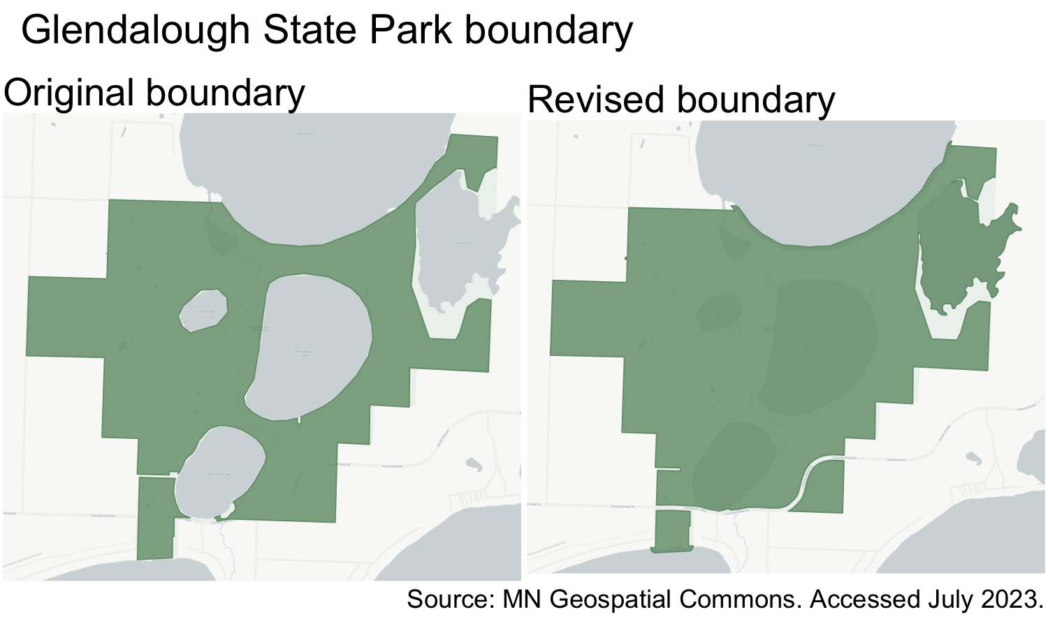

Figure 2.1: Park boundaries at Glendalough State Park before (left) and after (right) processing. Note the inclusion of lakes and shorelines and the removal of an unrelated road in the southeast corner of the park.

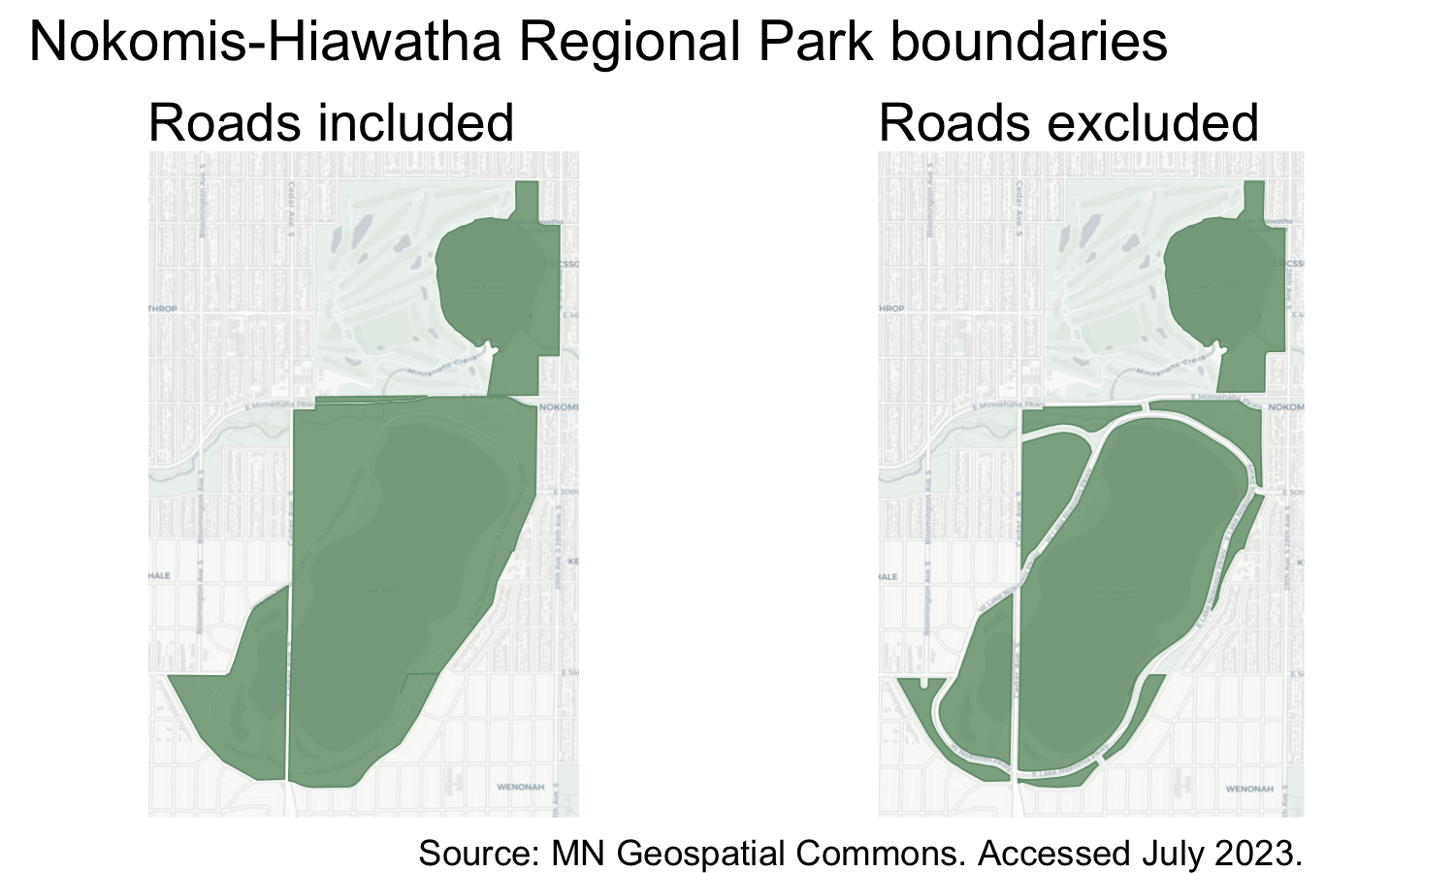

Figure 2.2: Comparison of road-inclusive (left) and road-exclusive (right) boundaries for Nokomis-Hiawatha Regional Park (Metro Regional). The inclusive boundary, which encompasses roads and/or parkways, may allow for better understanding of visitation at this urban park.

#### 2.1.1.2 Processing geography for inferred demographics and home locations

A “perimeter zone” was additionally generated for each park (Figure 2.3). The LBS data provider estimates visitor home locations for polygons up to 4 km $​^{2}$. Naturally, many of the parks in the project sample are larger than this maximum. Thus, in order to collect information about visitor home locations, perimeter zones of less than 4 km $​^{2}$ were created for each park. When travelers “pass through” these perimeter zones, they are counted and the LBS data provider analyzes the aggregated and anonymized data to produce an estimate of home locations for all visitors.

Perimeters were created by buffering into the interior of the polygon by 30 meters. This means that the perimeter does not extend beyond the boundary of the park. The buffer width was decreased in several cases when the original perimeter was greater than 4 km $​^{2}$ in area. In one case (Grand Portage, DNR State), perimeters were manually edited to ensure the geography was sufficiently far from the Canadian border for the data provider to provide metrics. These zones are used for pass-through analyses, so it is unnecessary to remove roads or conduct similar edits.

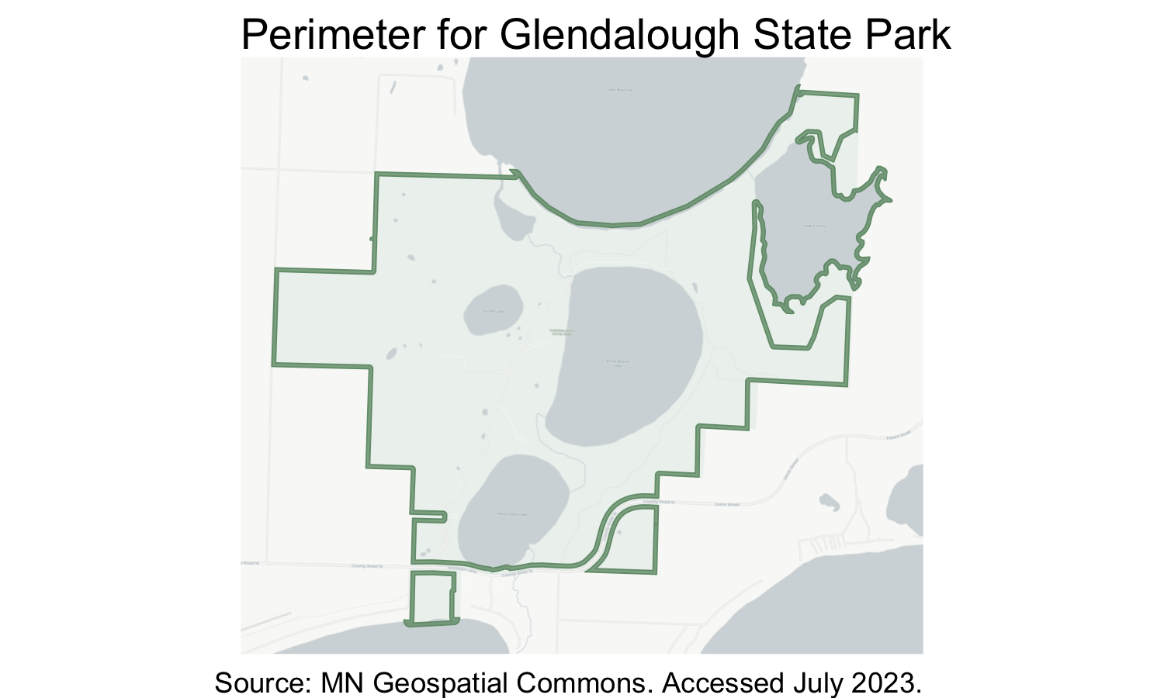

Figure 2.3: Perimeter zone for Glendalough State Park.

### 2.1.2 LBS analyses

The finalized park geographies are used as the “zone set” for StreetLight analyses. The following StreetLight analyses were run:

On park polygon zones:

* Weekly, Biweekly, and Monthly Zone Activity analyses for Vehicle Volume. Trips ending within the polygon are counted. Results in 79,516 analyses.
* Monthly Zone Activity analyses for each Bicycle and Pedestrian Volume (bicycle and pedestrian volume is not available at more detailed intervals). Trips ending within the polygon are counted. Results in 16,480 analyses.
* Monthly Origin-Destination analyses run on polygon zone sets for Vehicle, Bicycle, and Pedestrian Volume. Trips starting and ending within the same polygon are counted. Results in 24,720 analyses.

On park perimeter zones:

* Zone Activity analyses for Vehicle, Bicycle, and Pedestrian Volume, with the Home & Work Locations add-on and the Traveler Attribute add-on. Pass-through trips are counted. Results in 1,236 analyses.

In total, 121,952 StreetLight analyses were run for parks. StreetLight’s “zone activity” analysis type is used for the majority of this analysis. Zone activity analyses capture activity starting and ending in each park polygon. Trips ending within a given park polygon are counted as visitors. A trip has “ended” when the traveler stops moving (or moves less than 50 meters) for at least five minutes, meaning a visit can be defined as a vehicle, bicyclist, or pedestrian who enters the park polygon and stays there for at least five minutes.

A supplementary origin-destination analysis was conducted for vehicles, bicycles, and pedestrians. The origin-destination analysis results were used to identify trips that begin and end within the same park polygon. When such trips were identified, they were removed from vehicle, bicycle, or pedestrian counts respectively to avoid double-counting visitors.

The StreetLight application programming interface (API) was used to run each analysis. The API is accessed using [streetlightR](https://github.com/Metropolitan-Council/streetlightR), an API wrapper written in R by Metropolitan Council staff. The resulting data consists of 106,914 weekly observations (206 park polygons x 173 weeks x 3 travel modes).

StreetLight provides two main measures of traffic or activity – StreetLight Volume (volume), which is an estimated count of vehicles, bicyclists, or pedestrians, and StreetLight Index (index), which is a relative measure of activity. There are two major motivations for using volume over index. First, volume represents an actual vehicle count whereas index is a unitless measure. Secondly, StreetLight recommends against comparing the index across time. Therefore, we prefer to use volume for all three modes. To confirm that both volume and index reflect similar temporal patterns and align with existing use estimates, the measures were compared throughout time using the Pearson correlation coefficient. Index and volume were found to have strong positive correlation. Based on this evaluation, volume is used for the analyses in this report.

### 2.1.3 Producing park visitor estimates

The following procedure was used to create park visitor estimates:

1. Intrapark trips were removed for each mode (vehicle, bicycle, and pedestrian).
2. Missing data was imputed.
   1. Parks missing >50% of vehicle records were discarded from the analysis.
   2. For vehicles, missing weekly estimates were filled in, or replaced, with biweekly estimates or monthly estimates when possible. Remaining missing data was imputed using time series imputation.
   3. For bicycle and pedestrian data, missing monthly estimates were imputed using time series imputation.
3. Vehicle multipliers (average numbers of persons per vehicle) were applied to convert vehicle estimates to visitor estimates.
4. Monthly vehicle, bicycle, and pedestrian data were combined to create total monthly use estimates.
5. Monthly scaling factors were used to convert bicycle and pedestrian data into weekly estimates.
6. Data was aggregated at the weekly, monthly, seasonal, and annual level.

The following sections further describe each step of this procedure.

#### 2.1.3.1 Imputing missing data

In some cases, weekly LBS data was not available for a given park polygon. This generally occurred when visitation was low and the data provider masked data to maintain privacy standards. Data was masked (i.e., not reported) when the LBS provider estimated less than 50 daily visits over the analysis period. This was most common during winter months and at smaller park units.

When weekly vehicle data was unavailable, biweekly and monthly records were used in their place. Biweekly and monthly analyses resolved many data privacy issues because more visits occurred in the longer time frame, meaning fewer records were discarded.

Remaining missing vehicle records were resolved using data imputation. In other words, missing data was estimated based on those weekly, biweekly, and monthly records which were available. Because park visitation generally follows strong seasonal patterns and does not differ dramatically week-to-week, time series imputation is a reasonable method for filling in missing records.

Several imputation methods were tested using the [imputeTS R package](https://steffenmoritz.github.io/imputeTS/). Values were imputed separately for vehicle, bicycle, and pedestrian data. For each mode, imputation was not performed if greater than half of the expected records were missing and visitation for that time period and mode was assumed to be zero.

If biweekly, monthly, or imputed data was used, intrapark trips were assumed to be zero.

Linear interpolation, spline interpolation, and a weighted moving average were each tested as possible imputation methods. To evaluate each method, imputed values were compared to observed LBS estimates at parks without missing data (109 of 206). For these parks, 30 (~17%) weekly records were removed from each park. This reflects the average number of missing records for parks with any missing data.

Recall that imputation was not performed if greater than half of expected records were missing. This requirement excluded 4 parks from the project: Devil’s Track Falls State Wayside (DNR State), Hill Annex Mine State Park (DNR State), Joseph R. Brown State Wayside (DNR State), and Northerly Regional Park (Greater MN Regional, Eligible). An additional 55 parks were missing >50% of expected bicycle records. For these parks, bicycle imputation was not performed, and missing bicycle records were assumed to be zero. No parks were missing >50% of pedestrian records. These and other park exclusions are documented in Appendix 6.3.

Each imputation method was tested on the randomly removed records described above. Figure 2.4 shows one example of imputation at Ramsey Park in Redwood County, MN. Because there are no missing records for Ramsey Park, the original StreetLight estimates (“ground truth” shown as green stars) can be compared to the imputed values (red triangles). Methods were formally evaluated using the root-mean-square-error (RMSE) and mean absolute percent error (MAPE). An RMSE close to zero indicates that the imputation performed well. The MAPE indicates the difference between the observed LBS estimates and imputed values. For the Ramsey Park example above, the RMSE is 0.8768 and the MAPE is 9.19, meaning that the average difference between the LBS estimate and the imputed values is 9.19%.

The RMSE and MAPE were compared for each imputation method (Table 2.1). Based on this evaluation, a weighted moving average was selected for imputing weekly vehicle data as well as monthly bicycle and pedestrian data.

A “moving average” simply means that each missing value is estimated based on surrounding values. For example, an imputed estimate for the first week of January would be based on observed data from the last week of December and the second week of January. “Weighted” means that values closer to the missing week contribute more to the estimates than values further away. In other words, the second week of January will be more influential than the third or fourth week.

In total, weekly vehicle estimates consist of 3% biweekly LBS estimates, 2% LBS estimates, and 2% imputed estimates. Additionally, 100% of monthly bicycle records and 100% of monthly pedestrian records were imputed.

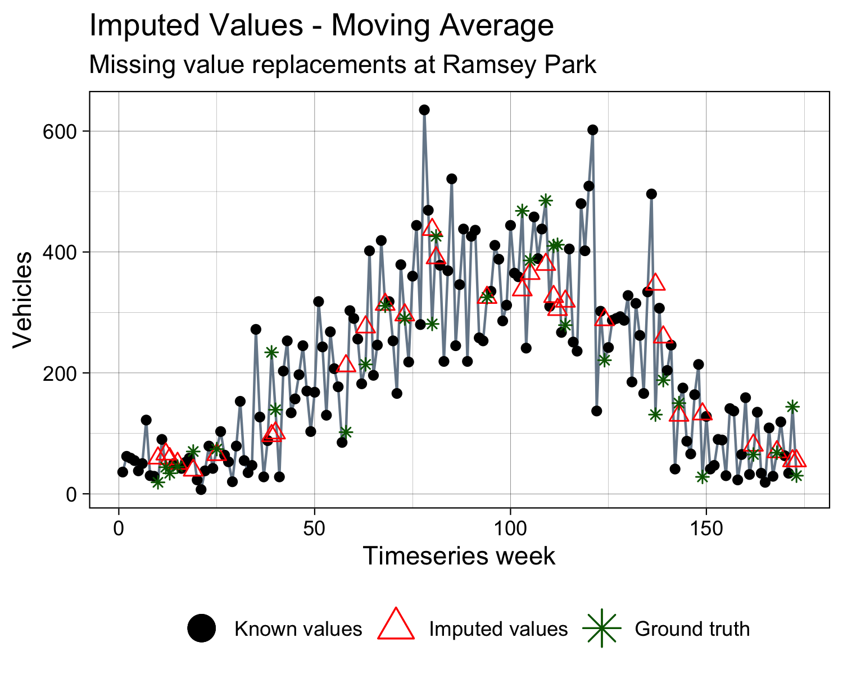

Figure 2.4: An example of moving average imputation method at Ramsey Regional Park (Greater MN).

Table 2.1: Root mean squared error (RMSE) and mean absolute percent error (MAPE) for three imputation methods.

| Imputation Method | Mean RMSE | Mean MAPE |
| --- | --- | --- |
| Weighted Moving Average | 0.43 | 6.3 |
| Linear Interpolation | 0.45 | 6.3 |
| Spline Interpolation | 0.58 | 7.8 |

#### 2.1.3.2 Intrapark trips

The supplemental origin-destination analyses described above revealed many intrapark, or within-park, trips across all three systems (Figure 2.2). These are trips that begin and end within the same park polygon. When intrapark trips were identified, they were removed from trip counts in order to avoid double-counting visitors such as multi-day campers. The data provider is not able to determine how long a visitor spends in a park, so multi-day campers are counted once per entry to a park. Removing double-counted visitors via intrapark trips makes LBS estimates more comparable to existing use estimates.

Intrapark vehicle trips were most common at large parks with multiple internal amenities, typically state parks with campgrounds. Across all three systems, the majority of bicycle and pedestrian trips began and ended within the same park. This is likely because visitors on foot or bicycle are more likely than vehicles to stop within a park for more than five minutes before continuing their park trip (consider visitors stopping to sightsee, picnic, wayfind, and so on).

Removing these trips improved the agreement of LBS estimates with existing DNR State use estimates (Figure 2.5). While removing intrapark trips increase overall correlation (r = 0.86, p < 0.001 before removal, r = 0.89, p < 0.001 after removal), the improvement was most noticeable at individual parks. For example, in 2020, the LBS use estimate at Cuyuna Country State Recreation Area was initially a 274% overestimate compared to DNR State counts; with intrapark trips removed this was reduced to a 5.4% overestimate (see highlighted points in Figure 2.5).

This pattern was particularly evident at large, high-use state parks with many multi-day camping trips, such as Tettegouche, Itasca, or Gooseberry Falls DNR State parks where LBS estimates were initially overestimates of up to 436%. In these cases, adjusted LBS estimates are still higher than existing use estimates, but the magnitude of the overestimate is drastically decreased (see highlighted points in Figure 2.5).

Table 2.2: Percent of trips that start and end within the same park by system, 2021

| System | Vehicle | Bicycle | Pedestrian |
| --- | --- | --- | --- |
| DNR State | 23% | 77% | 89% |
| Greater MN Regional | 9% | 70% | 80% |
| Metro Regional | 7% | 41% | 71% |

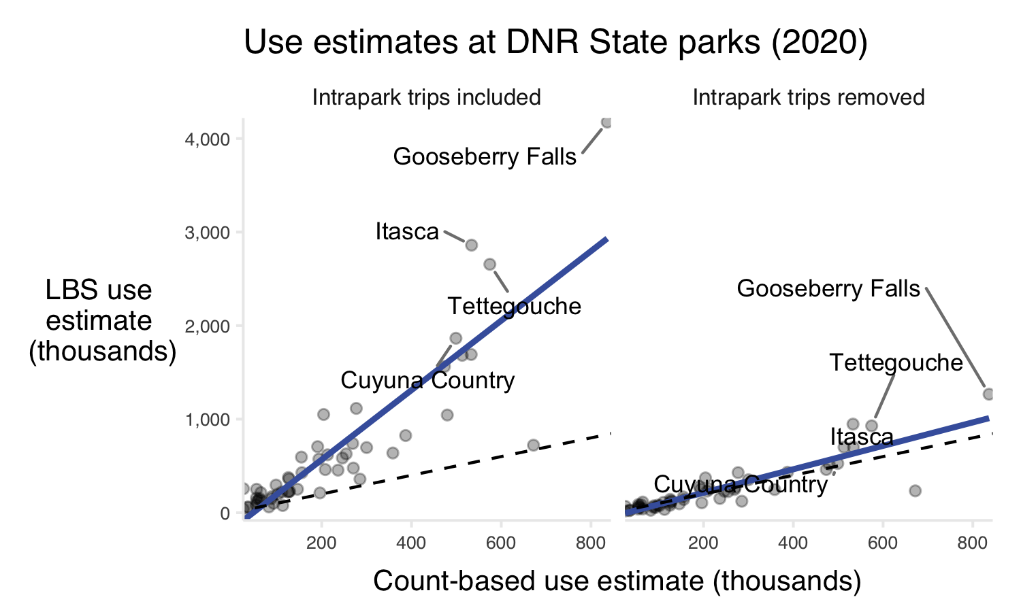

Figure 2.5: Comparison of 2020 annual count-based and LBS use estimates at DNR State parks with intrapark trips included (left) and with intrapark trips removed (right). The dashed line indicates a perfect one-to-one relationship; the solid blue line indicates the line of best fit. The relationship between DNR and LBS estimates is much stronger when intrapark trips are removed from LBS estimates.

#### 2.1.3.3 Vehicle multipliers

StreetLight vehicle volume provides an estimated count of vehicles. However, the goal of this project is to measure a count of *visitors*. Vehicle multipliers were required to translate LBS estimates into an estimate of visitors entering parks. A vehicle multiplier represents the average number of persons per vehicle at a given park. Note that vehicle multipliers are required to produce use estimates regardless of how vehicles are counted.

When available, existing multipliers were used to facilitate validation (Table 2.3). For DNR State parks, the established vehicle multiplier is 3.2 persons per vehicle (personal communication, Darin Newman). The ten metropolitan regional implementing agencies each have an agency-level multiplier, which range from 1.71-2.72 persons per vehicle ([2021 Metropolitan Council Visitor Study](https://metrocouncil.org/Parks/Research/Visitor-Study.aspx)). We estimated a baseline Greater Minnesota Regional vehicle multiplier based on the state and suburban metropolitan regional multipliers. Agencies serving areas such as Minneapolis and Saint Paul were not considered because Greater Minnesota Regional parks are likely to have more similarities with suburban parks, and because very urban parks tend to have lower vehicle multipliers than parks in other regions. The recommended Greater Minnesota vehicle multiplier is 2.46 persons per vehicle.

An intercept survey is likely the appropriate method to establish vehicle multipliers; LBS data is not able to recommend vehicle multipliers. We recognize that using one vehicle multiplier for an entire system or agency may be an oversimplification of true visitation behavior. The accompanying data produced by this research allow users to supply more bespoke vehicle multipliers. Further research into vehicle multipliers may be a priority for improving estimates of park use.

Table 2.3: Vehicle multipliers used in this project. Bolded multipliers were used to suggest an average multiplier for Greater Minnesota Regional Parks.

| Park System | Vehicle Multiplier |
| --- | --- |
| **DNR State** | **3.20** |
| Greater MN Regional | 2.46 |
| **Anoka County Parks and Recreation** | **2.33** |
| Bloomington Parks and Recreation | 1.71 |
| **Carver County Parks and Recreation** | **2.72** |
| **Dakota County Parks** | **2.07** |
| Minneapolis Park and Recreation Board | 2.16 |
| Ramsey County Parks and Recreation | 1.84 |
| Saint Paul Parks and Recreation | 1.96 |
| **Scott County Parks** | **1.89** |
| Three Rivers Park District | 2.30 |
| **Washington County Parks** | **2.55** |

#### 2.1.3.4 Combining, scaling, and aggregating data

Monthly estimates of vehicle visitors (e.g., estimates of vehicles multiplied by vehicle multipliers), bicyclists, and pedestrians were combined for each park unit. Using this monthly data, bicycle and pedestrian scaling factors were calculated for each park unit during each month of the analysis period. Scaling factors were defined as the monthly estimate of bicyclists or pedestrians divided by the monthly estimate of vehicle visitors at the given park unit during the given month.

Scaling factors were applied to weekly estimates of vehicle visitors to estimate week-level bicycle data. Recall that the LBS data provider only shares bicycle and pedestrian data at the monthly-level.

Finally, week-level data was aggregated at the monthly, seasonal, and annual level. In this project, seasons are defined as spring (March - May), summer (June - August), fall (September - November), and winter (December - February).

### 2.1.4 Data validation

Where possible, LBS estimates were compared to existing use estimates. Due to the differing data sources and methods used to generate use estimates, a perfect agreement between estimates was not expected. Note that bicycle and pedestrian data was further validated in the trail portion of this analysis.

The methods described in this report were found to generate reasonable use estimates at most types of parks in our sample. Validation was performed to address concerns regarding the effect of cell service on LBS data quality and no significant differences were observed across parks with varying levels of cell coverage. Although LBS performs well across the state, there are certain park characteristics which are less compatible with LBS methods. These characteristics include:

* Linear or trail-heavy parks where users may not stop within the park for five minutes.
* Parks with islands, or parks where boat access is more common than automobile access. Such units are excluded from this analysis.
* Low visitation units. When visitation is under a given threshold, StreetLight filters data to protect privacy. This occurs most often at smaller units during the off-season. The threshold for reporting data is an estimated 50-100 daily trips during the analysis period (this threshold may vary based the geographic area of analysis and specific metrics requested).

#### 2.1.4.1 DNR State validation

LBS estimates were compared to unit-level monthly use estimates for state parks generated by the DNR. The existing DNR estimates are based largely on automatic counters placed at park entrances and ticket sales, though methods may differ by park unit. Technology issues with automatic counters and reduced park staff in 2020 due to the COVID-19 pandemic may have affected the DNR use estimates.

The overall agreement between DNR and LBS estimates was high (r = 0.87, p = < 0.001) and confirmed that LBS data generates reasonable estimates of park use (Figure 2.6). There is some evidence to suggest that LBS data may overestimate use at particularly high-use units (Gooseberry Falls, Interstate, Tettegouche) compared to existing DNR estimates. This may be explained by the fact that LBS estimates measure use at all potential park entrances simultaneously, including informal entrances or entrances via intersecting trails. Therefore, LBS methods may report higher use than estimates based on counters or ticket sales at primary park entrances.

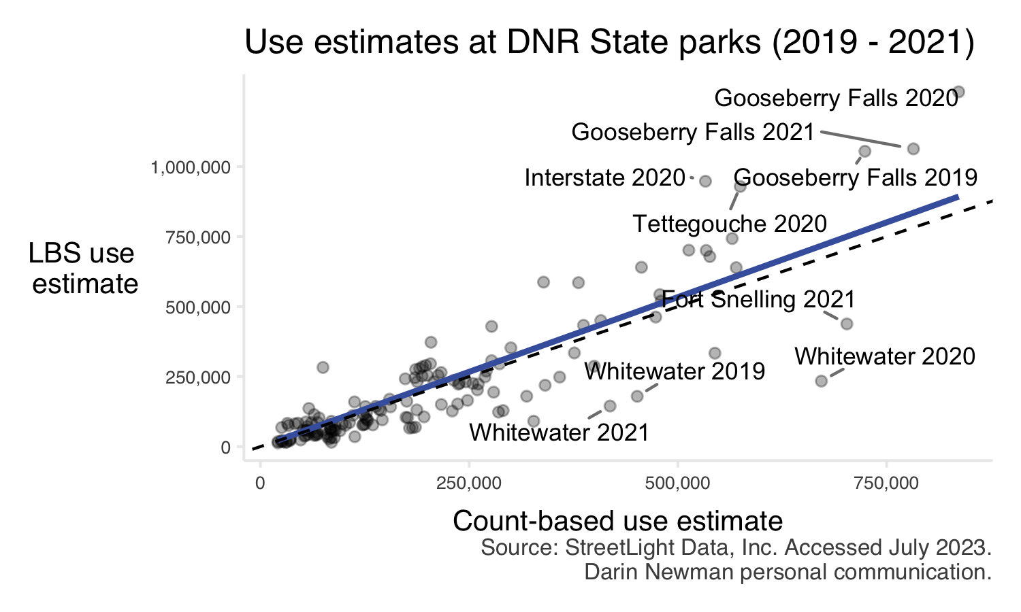

Figure 2.6: Comparison of count-based and LBS use estimates at state parks. Annual use estimates were compared. The dashed line indicates a perfect one-to-one relationship; the solid blue line indicates the line of best fit. Parks with the largest discrepancies between estimates are labeled.

#### 2.1.4.2 Metro Regional validation

LBS data was additionally compared to unit-level 2021 annual use estimates for Metro Regional parks created by the Metropolitan Council. These estimates are based on manual counts performed during the summer. Summer counts were converted into annual use estimates using vehicle multipliers (persons per vehicle) and seasonal multipliers (used to adjust summer visitation for other, typically lower visitation seasons). The conversion of summer counts to annual estimates may introduce error into these count-based estimates.

LBS data agreed strongly with Metro Regional park use estimates (Figure 2.7). As with the DNR State use estimates, there is some evidence that LBS data overestimates use at high-use units such as Como or Minnehaha Regional Park. This may be particularly true at units such as Como, which is adjacent to the Como Conservatory and Zoo Special Recreation Feature, or Bunker Hills, which contains a golf course. However, this is not universally true.

There are several locations where LBS data underestimated visitation compared to the count-based use estimates. The most notable example is the Minneapolis Chain of Lakes (Figure 2.7), in addition to Mississippi Gorge park units in both Saint Paul and Minneapolis (Figure 2.7). All three of these units feature trails as a primary amenity. In the case of Mississippi Gorge (Saint Paul), the park is largely “shaped” like a trail (Figure 2.8). Parks with these features may be less compatible with the LBS methods developed in this project. Recall that users must stop within the park boundary for at least five minutes to be counted by LBS data. In the case of a linear park largely centered around a trail, it is possible that a portion of visitors may not meet these criteria. In these cases, a more bespoke unit-level analysis may be appropriate.

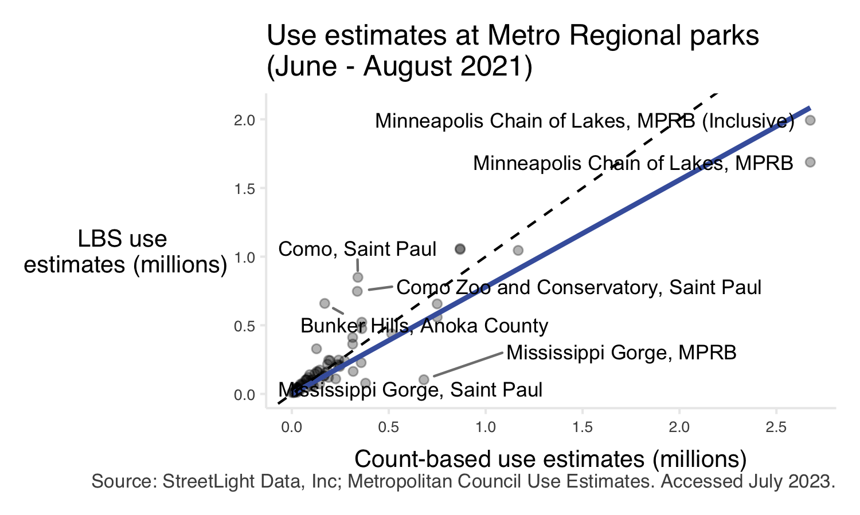

Figure 2.7: Comparison of count-based and LBS use estimates at Metro Regional parks. Data for summer of 2021 (June - August) is compared. The dashed line indicates a perfect one-to-one relationship; the solid blue line indicates the line of best fit. Parks with the largest discrepancies are labeled.

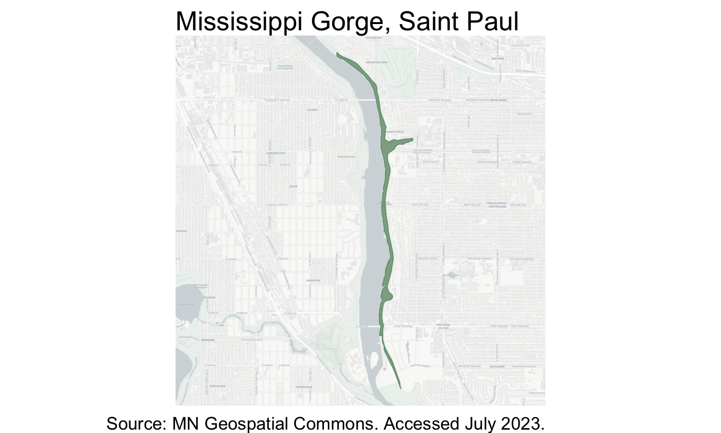

Figure 2.8: Map of Mississippi Gorge Regional Park in Saint Paul, MN.

#### 2.1.4.3 Parks with limited cell service

The LBS data provider’s methods are designed to work whether or not a device has cell service and can even retrieve GPS data from cell phones in airplane mode. However, there are a number of state and regional parks across Minnesota with [limited, or no, cell service available](https://www.fcc.gov/BroadbandData/MobileMaps/mobile-map). Therefore, confirming that the presence or lack of cell service did not impact data quality was an important step.

LBS estimates were evaluated at parks with different levels of data or LTE coverage (Figure 2.9). Because cell service varies so much across the state and between providers, it was not feasible to test the relationship between LTE coverage and LBS data accuracy across the state simultaneously and only two units are presented in this report. However, no significant differences were observed between LBS and existing DNR State estimates at the evaluated parks. Based on this finding, we conclude that limited cell service does not present problems for LBS use estimates.

Note that areas without GPS connectivity may present problems for LBS methods. However, [GPS coverage is generally very complete and accurate](https://www.gps.gov/systems/gps/performance/accuracy/), meaning it is very unlikely that GPS connectivity challenges have affected the outcome of this work.

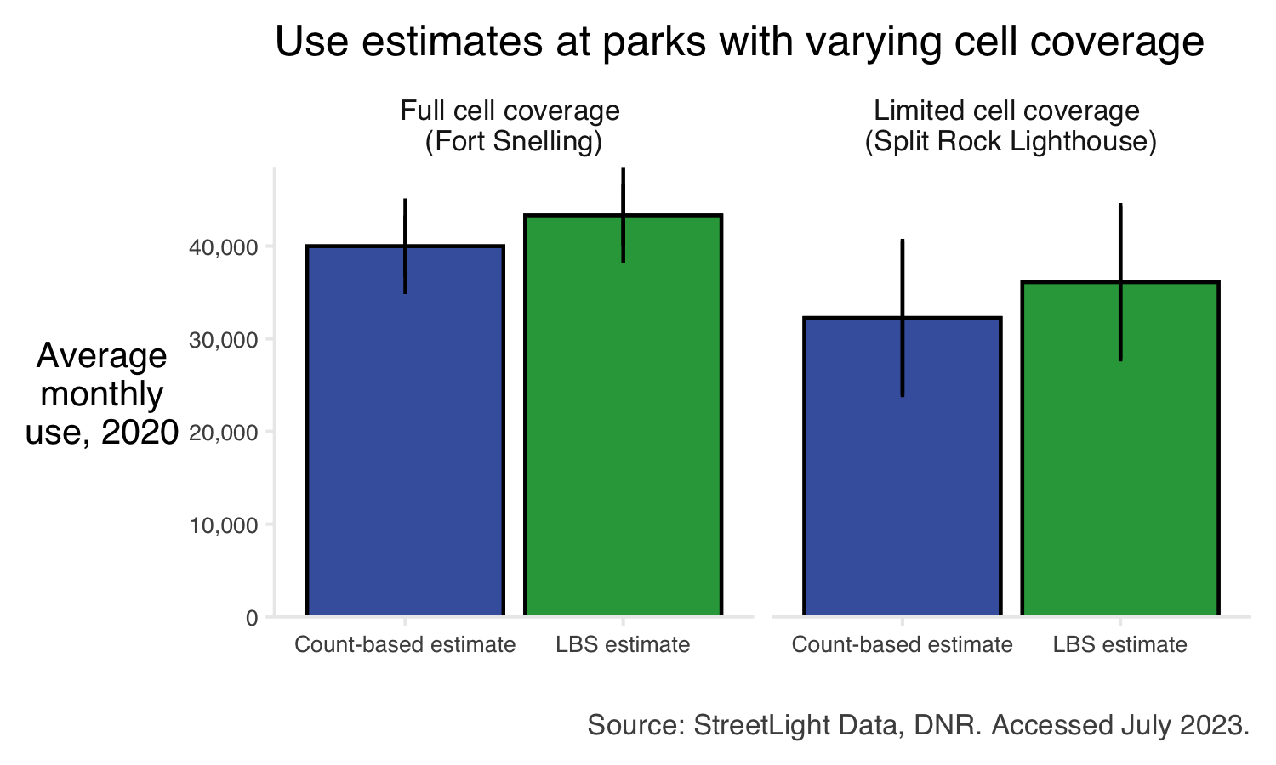

Figure 2.9: Comparison of average monthly estimates for Fort Snelling State Park and Split Rock Lighthouse State Park. Fort Snelling has complete cell coverage by all three service providers in the state. Split Rock Lighthouse has coverage gaps under all three providers. Error bars indicate standard error. No significant difference is observed.

## 2.2 Results

### 2.2.1 Park use increased in 2020

In total, 2020 had the highest park use across the years analyzed (70.3 total million visitors across three systems compared to 60.31 and 67.6 million visitors in 2019 and 2021, respectively). In many cases, the COVID-19 pandemic encouraged the use of Minnesota’s outdoor spaces as other indoor social and recreational opportunities were limited. While pandemic-related effects on park visitation varied across and within systems (Figure 2.10), the state park system saw the greatest overall increase in 2020. Both regional park systems (Greater MN Regional and Metro Regional) saw more modest increases from 2019 to 2020, with visitation remaining high into 2021.

At the unit level, not all parks saw increased use in 2020. While 131 units saw their highest use in 2020, 26 units had their highest use in 2019 and another 49 had the highest use in 2021. Closures of campgrounds, beaches, or other amenities to facilitate social distancing often characterized units with lower use in 2020.

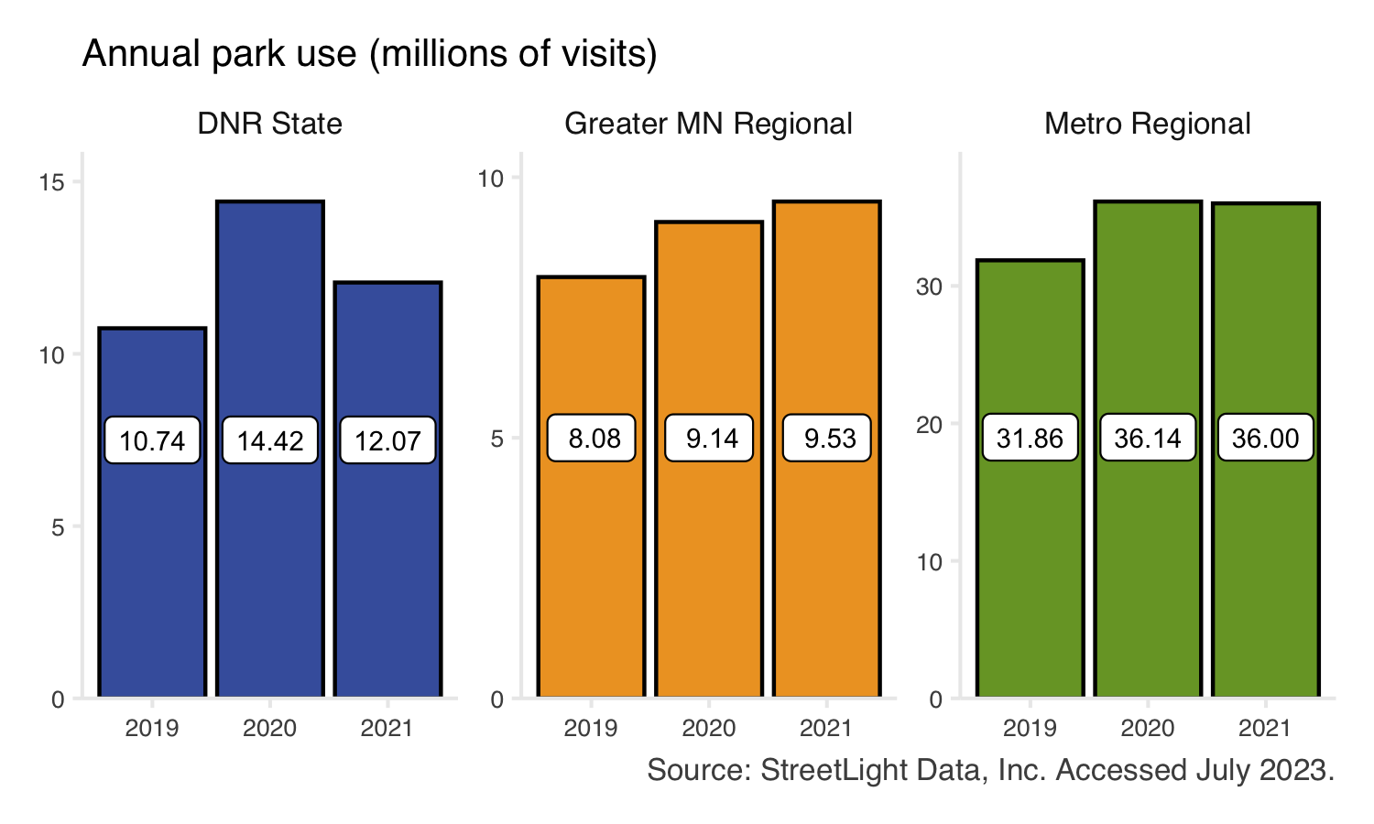

Figure 2.10: Total estimated park use. Bars show the system-wide total visits to parks across the three complete years in this study (2019, 2020, 2021). Bar color indicates park system. Individual park units may show annual visitation trends which differ from the overall system trend.

### 2.2.2 Parks are used in all seasons

Seasonal summaries are valuable for identifying nuanced changes in visitation throughout time or across parks. In this case, we observe only slight differences seasonal visitation patterns (Figure 2.11). All three systems have the most visitation in the summer, with various levels of visitation through the rest of the year. In particular, DNR State and Metro Regional parks have low winter visitation when compared to their summer peaks. Conversely, Greater MN Regional parks see less of a difference between winter, spring, and fall visitation.

At the park-level, variation in seasonal visitation patterns is often driven by season-specific amenities. For instance, two parks saw the majority (> 50%) of 2021 use occur during the winter months of December, January, and February (Figure 2.12). Both Detroit Mountain Regional Recreation Area (58.3% winter use) and Hyland-Bush-Anderson Lakes Regional Park Reserve, Three Rivers (53.6% winter use) have downhill skiing facilities. There were 40 parks that saw the majority of their annual visitation occur during the summer and no parks that had the majority of visits during the spring or fall. Most parks (163) did not see the majority of annual visitation occur within a single season.

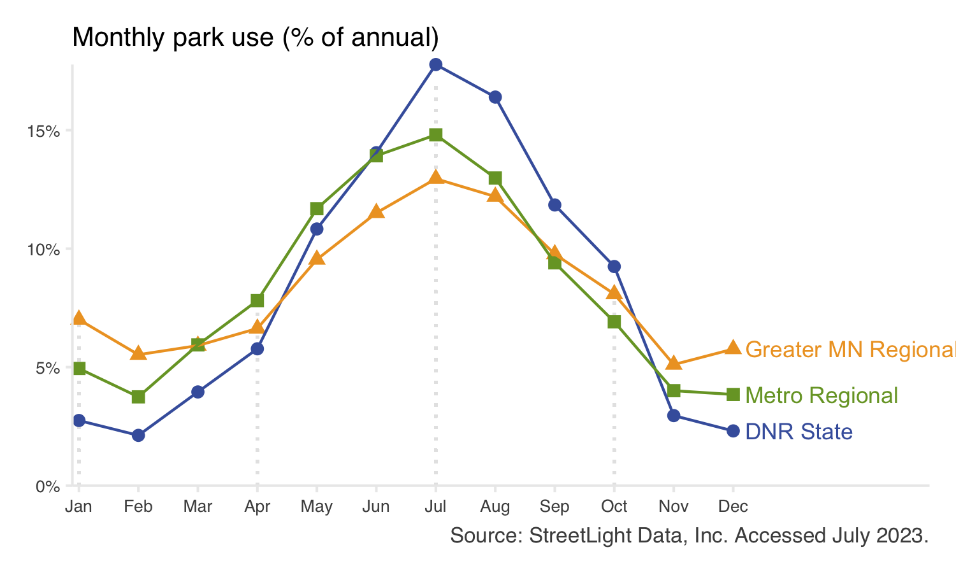

Figure 2.11: Monthly park use as a percent of total annual use for each system. Points show the average monthly use across the three complete years in this study (2019, 2020, 2021). Point color indicates park system. Individual park units may show trends that differ from the overall system trend.

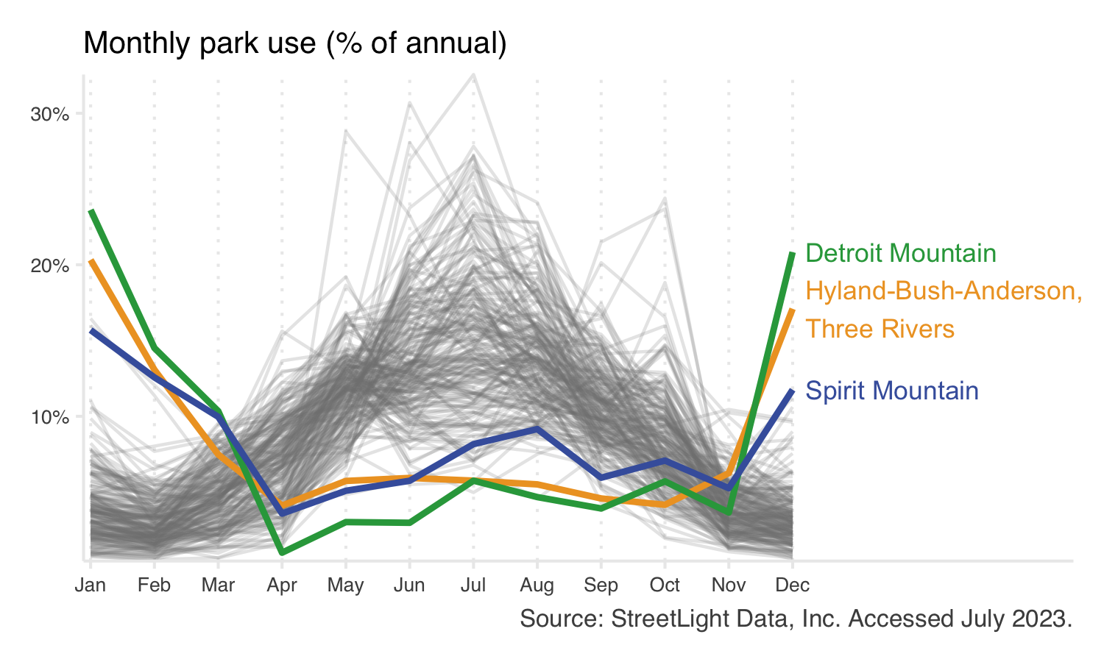

Figure 2.12: Monthly park use as a percent of total annual use for each park unit. Detroit Mountain Recreation Area (Greater MN), Spirit Mountain Recreation Area (Greater MN), and Hyland-Bush-Anderson Lakes Park Reserve (Metro Regional, Three Rivers unit) are highlighted. These units contain downhill ski slopes and therefore display different monthly or seasonal use patterns than the majority of park units.

### 2.2.3 Weekly data shows nuanced use patterns

At individual park units, weekly LBS estimates can identify relatively precise changes in use. The data often reflect special events, extreme weather, and management changes. This temporal granularity may assist in evaluating park planning and management decisions.

For instance, some units closed facilities during the spring and summer of 2020 to facilitate social distancing (e.g., Spirit Mountain Recreation Area (Greater MN) closed mountain biking facilities, Figure 2.13, top panel). The associated drop in park use is clear in a weekly time series; more generalized annual or monthly summaries may have otherwise obscured this causal relationship. Additionally, some special events cause notable increases in use, which can also be observed in a weekly time series. For example, Nokomis-Hiawatha Regional Park (Metro Regional) hosts a week-long pond hockey championship every winter (Figure 2.13, middle panel). Day-long events, such as a race held in Lake Waconia Regional Park (Metro Regional) may also appear in a weekly time series (Figure 2.13, bottom panel).

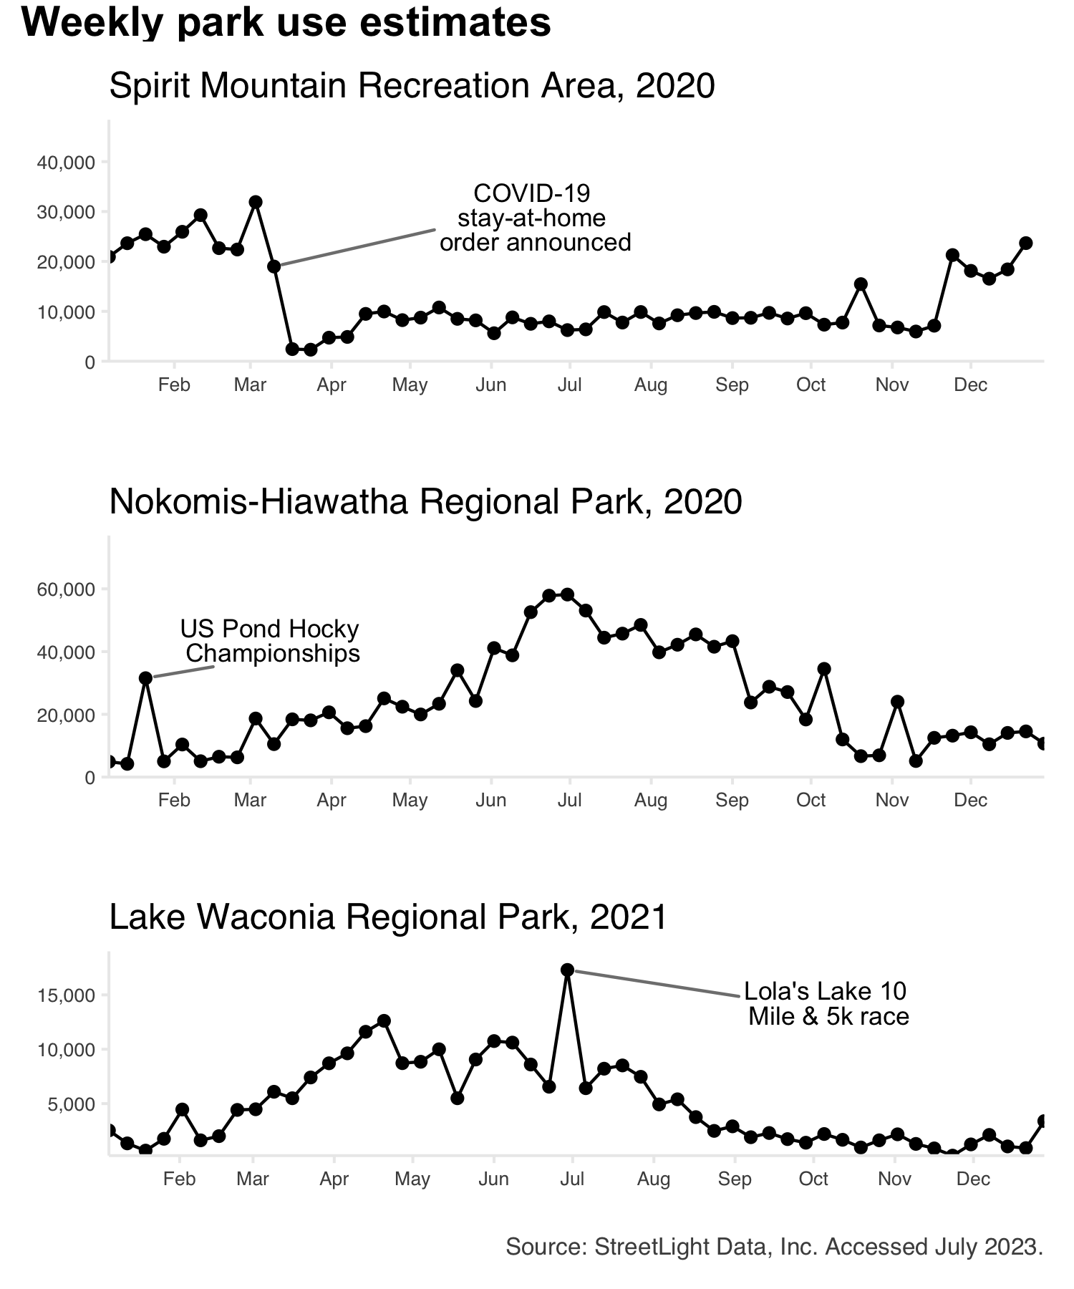

Figure 2.13: Estimated weekly park use at Spirit Mountain Recreation Area (top), Nokomis-Hiawatha Regional Park (middle), and Lake Waconia Regional Park (bottom). Notable events at each park are labeled.

### 2.2.4 Hourly park use varies by day and system

On weekends (Sa-Su), all parks showed a midday peak in use (Figure 2.14). On weekdays (M-F), this same midday peak is observed for DNR State parks. Regional parks, however, had a pronounced “after work” peak beginning around 5:00 pm.

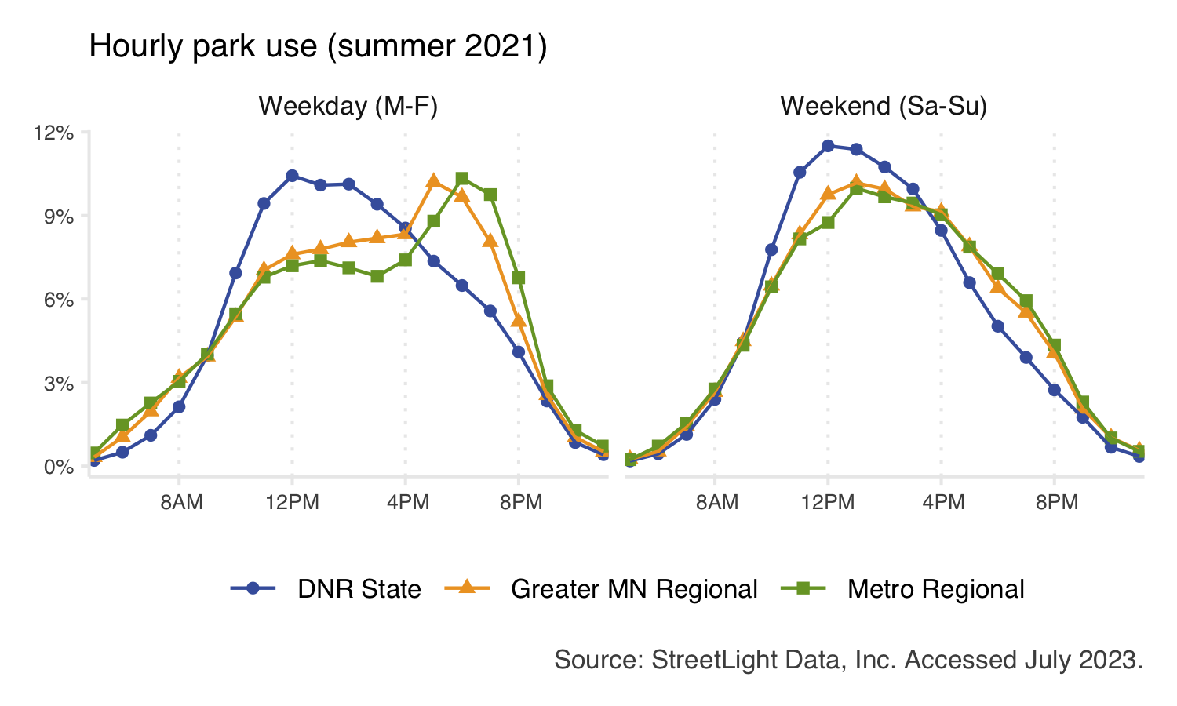

Figure 2.14: Daily use patterns during summer 2021 for each system. For each system, the total number of visits across all parks is summed, from which the percent of total visits is calculated. Individual park units may show trends that differ from the overall system trend.

### 2.2.5 Most visitors drive to parks

Our analysis includes estimated counts of visitors arriving at parks by vehicle, bicycle, or on foot. This “mode share” data provides nuance and can help characterize parks. For example, while most visitors traveled to parks in vehicles, the state park system had the highest vehicle mode share (Figure 2.15). Regional park systems had a larger portion of bicyclist and pedestrian visitors. The mode share of park visitors was relatively stable across different seasons.

At individual park units, mode share mode share information may be helpful in identifying infrastructure improvements. For example, additional bike storage may be needed at state parks with high bicycle mode share. A regional park with low pedestrian mode share in an otherwise walkable area may indicate barriers to access (e.g., fenced areas or roads without crosswalks or bridges, or lack of links to public transit). Such park-level analyses are beyond the scope of this project but may prove valuable in future work.

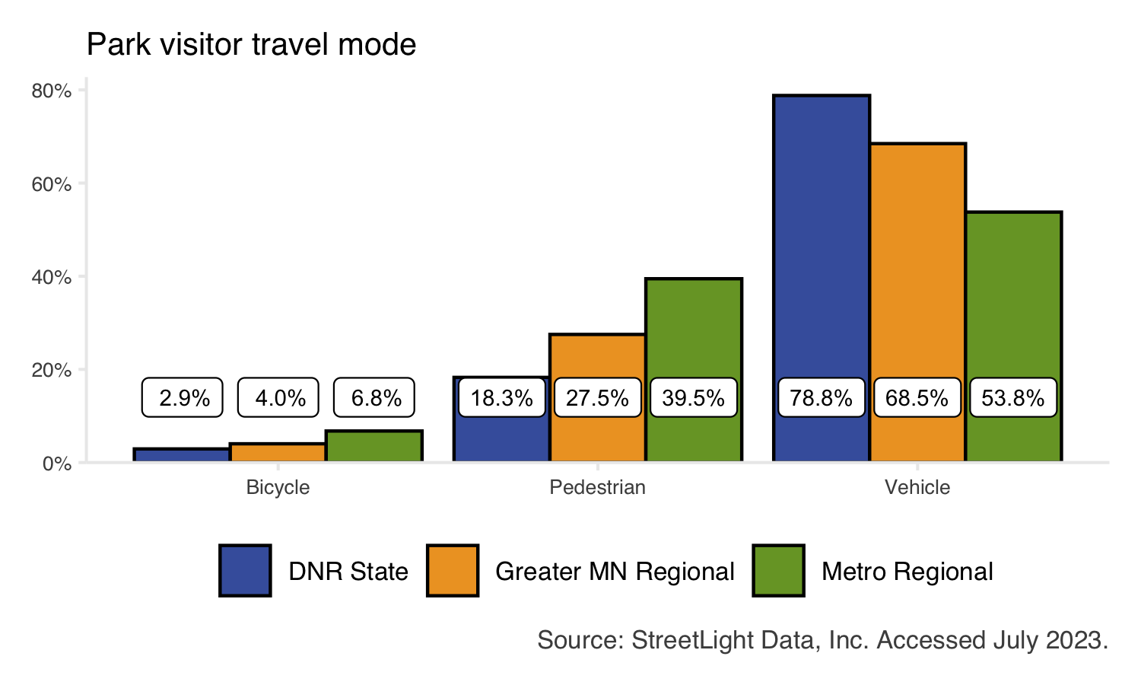

Figure 2.15: Mode share of trips made to parks. Bars show the average annual mode share across the three complete years in this study (2019, 2020, 2021). Bar color indicates park system. Individual park units may show trends that differ from the overall system trend.

# 3 Trails

Understanding trail visitation is essential for planning, programming, and investment decisions. This project used location-based services (LBS) data to analyze monthly visitation to 177 state and regional trails across Minnesota from January 2019 - April 2022. This data is intended to supplement, but not replace existing data used for decision making. Approximately 234.1 million trail miles were traveled by visitors during the study period. In total, 2020 had the highest use across the years analyzed. Bicycle activity made up the majority of trail use, although pedestrian use made up a larger portion of use on urban trail segments and during winter months. There was considerable variation in use across segments of the same trail.

## 3.1 Methods

Aggregated and anonymized LBS data was used to estimate monthly use of 177 state and regional trails across three systems (n = 35 Minnesota Department of Natural Resources parks (DNR State), n = 57 Greater Minnesota Regional Parks and Trails Commission parks (Greater MN Regional), and n = 85 Twin Cities metropolitan regional parks (Metro Regional), Figure 3.1). The resulting data set consists of 40 monthly observations for each trail. Each observation reports estimated monthly use disaggregated by travel mode (bicycle and pedestrian).

Theoretically, the concept for measuring trail use is identical for physical trail counters (e.g., infrared or pneumatic tubes) and LBS methods. Both rely on “gates” through which visitors pass. With trail counter approaches, “gates” are physical sensors on trails. LBS data detects users passing through non-physical geographic gates. This theoretical alignment means that neither approach can identify the number of unique visitors along a trail’s entire length. For instance, visitors who do “out-and-back” trips will be counted twice (passing through the same gate once in each direction).

Geographic data used to measure trail use were accessed via the Minnesota Geospatial Commons for [DNR State](https://gisdata.mn.gov/dataset/trans-state-trails-minnesota) and [Metro Regional trails](https://gisdata.mn.gov/dataset/us-mn-state-metc-trans-regional-trails-exst-plan). Greater Minnesota Regional Parks and Trails Commission (Greater MN Regional) trail files were obtained via ArcGIS Online in November 2022. Trails were decomposed into [OpenStreetMap](https://www.openstreetmap.org/about) (OSM) trail segments for analysis (Figure 3.2). OSM is a widely-used mapping service used by StreetLight (the LBS data provider), private companies (i.e., Amazon, Apple, Microsoft, ESRI), and government sectors around the world.

Each trail in the project sample consists of multiple segments split by roads or other intersecting trails/paths; however, it was beyond the scope of this project to edit or customize OSM trail segments. Trail segments less than 50 feet were removed from the analysis. This analysis contains 177 unique trails with 3,934 distinct trail segments totaling over 2,600 miles (Table 3.1). Both paved and unpaved trails are represented in the data.

LBS data was used to estimate use along each of these standardized trail segments. Bicycle and pedestrian use is considered in this project. The LBS data provider does not explicitly measure trail visitors using other transportation modes, but other modes (i.e., snowmobiles, equestrians, skiers) may be captured and classified as either bikers or walkers by the LBS data provider using their probabilistic models. Segment-level LBS estimates of trail use are conceptually identical to estimates generated by one trail counter per segment. At the segment level, we report these “counter estimates.” At the trail level, we report total trail miles traveled, which is the estimated count of trail users per segment (counter estimate) multiplied by the length of the trail segment being used. When summed at the trail level, this produces a single, robust estimate of trail use.

LBS data was obtained from StreetLight Data, Inc. and last accessed in July 2023. The StreetLight application programming interface was used to run a zone activity analysis for each trail segment’s bicycle and pedestrian use during each month of the study period. Users who traveled along any trail segment for any distance or duration were counted; no stoppage time was necessary. Devices registered to minors (under age 18) are not included in the LBS data source.

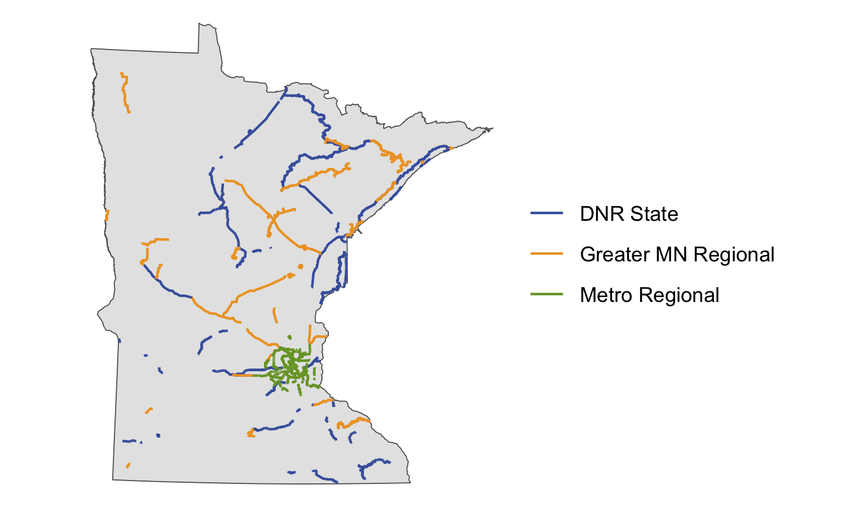

Figure 3.1: The project sample of trails across the state of Minnesota. This map indicates original trail alignments accessed via the Minnesota Geospatial Commons (DNR State, Metro Regional) or personal communication with the Executive Director of the Greater Minnesota Regional Parks and Trails Commission (Greater MN Regional).

### 3.1.1 Geography

Geographic data used to measure trail use was obtained from each agency. Minnesota Department of Natural Resources ([DNR state](https://gisdata.mn.gov/dataset/trans-state-trails-minnesota)) and Twin Cities metropolitan regional trails ([Metro Regional](https://gisdata.mn.gov/dataset/us-mn-state-metc-trans-regional-trails-exst-plan)) were last accessed from the Minnesota Geospatial Data Commons in July 2023. Greater Minnesota Regional Parks and Trails Commission (Greater MN Regional) trail files were obtained via ArcGIS Online in November 2022.

In order to conduct detailed analyses, trails were decomposed into [OpenStreetMap](https://www.openstreetmap.org/about) (OSM) trail segments (Figure 3.2). Trail alignments were overlaid with OSM data and the intersection of these geographic data sets was used to identify relevant trail segments for each trail in the project sample. The following procedure was used to identify trail segments:

1. Original trail alignments were buffered by 15 meters to create a single polygon representing the trail, even if the trail consists of 2 side-by-side lanes (e.g., a bicycle path adjacent to a sidewalk). Note that the ends of the original trails were *not* buffered, meaning the overall length of the trail was not affected. This step simplified trail geography in the case of side-by-side lanes and ensured that OSM segments were identified even if the alignment between OSM and agency-specific trail data was imperfect. These buffered trails, or trail polygons, were used for some LBS analyses.
2. A “bounding box” was generated for each trail. The bounding box for a given trail is a rectangle which contains the entire extent of the trail.
3. The [osmdata R package](https://cran.r-project.org/web/packages/osmdata/vignettes/osmdata.html) was used to query all line features within each bounding box. The original query returned many line types, such as trunk highways, bicycle paths, interstates, and residential sidewalks.
4. Queried OSM data was restricted to OSM segments tagged for bicycle or pedestrian use. Use tags are defined within OSM and it was beyond the scope of this work to edit classifications. Other OSM segments were not discarded at this stage because, in some cases, trails consist of OSM segments *not* tagged for bicycle or pedestrian use (e.g., some trails run along abandoned railroad right-of-ways which are tagged as “abandoned” by OpenStreetMap).
5. Bicycle- and pedestrian-specific OSM segments were intersected with the buffered trail alignments described in step 1 to identify the segments most likely to be related to the trail.
6. Manual edits were performed to add or remove OSM segments as necessary. OSM segments were typically removed if approximately 1/3 or more of the segment did not intersect with the trail alignment. Segments that consisted primarily of road intersections were generally discarded and all segments less than 50 feet in length were removed from the analysis. At this stage, OSM segments not tagged for bicycle or pedestrian use (described in step 4) were added to individual trails on a case-by-case basis to better reflect on-the-ground trail alignments.

In some cases, OSM “relations” were used to retrieve all segments related to a given trail by name (for example, querying OSM for all segments tagged “Duluth Traverse”). OSM relations were not available for the majority of trails in the project sample, hence the methods described above. Relations were used to query geographies for the Duluth Traverse (Greater MN Regional), the Luce Line (DNR State), the Paul Bunyan trail (DNR State), and the Sakatah Singing Hills trail (DNR State).

A total of 3,934 distinct trails segments totaling over 2,600 miles were identified (Table 3.1). Please note that the identified trail segments may not reflect official trail alignments. This is for several reasons: some trails are not documented (or documented well) in OSM data; OSM data is not real-time and therefore will not reflect recent on-the-ground changes; some OSM segments follow trail alignments but extend beyond the trail’s end; and short segments such as road intersections or bridge crossings were discarded. Recall that the goal of the geography editing in this project is to improve compatibility with LBS methods, not to reflect official management boundaries or alignments.

Trails typically consist of multiple segments split by roads or other intersecting features (Figure 3.2). The median number of segments per trail is 15, though some long trails have significantly more segments (the maximum is 156 segments for the Duluth Traverse (Greater MN Regional)).

The median segment length across the state is 0.23 miles. Because OSM segments typically break at cross-streets or similar features, OSM segments tend to be shorter in more urban or residential areas. The median segment length varies by trail system: 0.46 miles for DNR State trails, 0.43 miles for Greater MN Regional trails, and 0.15 miles for Metropolitan Regional trails.

Table 3.1: Summary of unique trails, identified trail segments, and trail miles covered by identified trail segments across the three systems.

| System | Trails | Segments | Miles |
| --- | --- | --- | --- |
| DNR State | 35 | 991 | 1,121 |
| Greater MN Regional | 57 | 897 | 950 |
| Metro Regional | 85 | 2,046 | 589 |

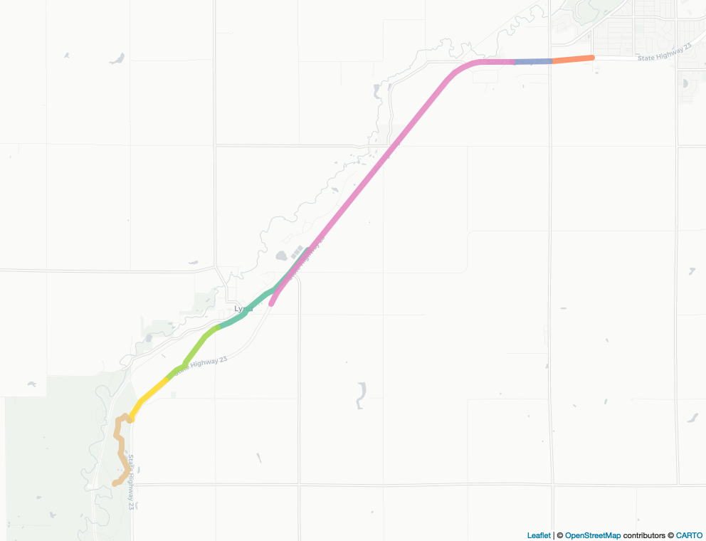

Figure 3.2: Example of OSM segments identified for Camden Regional Trail (Greater MN). Each colored portion of the trail represents one OSM segment. LBS methods identified seven OSM segments with an average length of 1.3 miles.

### 3.1.2 LBS Analyses

Revised trail segments were used as the “zone set” for StreetLight analyses. The following StreetLight analyses were run:

On trail segments:

* Monthly Zone Activity analyses for Bicycle and Pedestrian Volume (January 2019 - April 2022). “Pass-through” trips were counted, meaning that users who traveled along any trail segment for any distance or duration were measured. Results in 314,720 analyses.
* Zone Activity Analysis with Traveler Attribute add-on for Bicycle and Pedestrian Volume for summer 2021 (June 1 - August 31) and the full 2021 calendar year (January 1 - December 31). Pass-through trips were counted. Results in 15,736 analyses.
* Zone Activity Analysis with hourly time steps for Bicycle and Pedestrian Volume for summer 2021 (June 1 - August 31). Pass-through trips were counted at an hourly frequency. Results in 7,868 analyses.

On trail polygons:

* Zone Activity Analyses with Home-Work Location add-on for Bicycle and Pedestrian Volume for summer 2021 (June 1 - August 31) and the full 2021 calendar year (January 1 - December 31). Pass-through trips were counted. Results in 708 analyses.

In total, 339,032 StreetLight analyses were run for trails. StreetLight’s “zone activity” analysis type is used for the entirety of the trail portion of this project. Zone activity analyses capture activity passing through, or along, each trail segment in the project sample. No stoppage time is necessary for a pass-through trip to be counted. When the LBS provider did not report data for a given trail segment in a given month (due to low use), use was assumed to be zero.

The StreetLight application programming interface (API) was used to run each analysis. The API is accessed using [streetlightR](https://github.com/Metropolitan-Council/streetlightR), an API wrapper written in R by Metropolitan Council staff. The resulting data consists of 314,720 monthly observations (3,934 trail segments x 40 months x 2 travel modes). In most cases, data is aggregated to the trail level, resulting in 14,160 monthly observations (177 trails x 40 months x 2 travel modes).

#### 3.1.2.1 Segment-level gates

For each trail segment, the LBS provider retrieves data based on geographic gates along the segment’s length (Figure 3.3). Users must pass through the *center* gate to be counted as activity on the given segment. Segment-level LBS use estimates, therefore, are conceptually identical to estimates generated by placing physical trail counters at the “middle gate” location of each OSM segment.

The need for users to pass through the center gate is required by StreetLight’s proprietary algorithms and cannot be changed. While custom line segments can be created for use with StreetLight, creating custom lines and/or gates was beyond the scope of this project. However, such specificity may be appropriate for smaller-scale analyses focusing on fewer overall trail segments.

Because users must pass through the center gate to be counted, it is possible that some trail users will not be counted by LBS data if they enter and exit the trail without passing through any required gates. Note that the same would be true were the geographic gate replaced with a physical trail counter. The gates underlying StreetLight’s methods may affect the interpretation of segment-level data for longer trail segments. However, due to the short median segment length (0.23 miles), it is unlikely for this limitation to affect the broader findings of this work. Further, trail segments in more walkable areas (e.g., areas where users are more likely to enter and exit trails over short distances)tend to be shorter. For example, the average identified trail segment length in Minneapolis is 0.13 miles, meaning that users would have to travel less than one tenth of a 0.06 miles to be missed by LBS data.

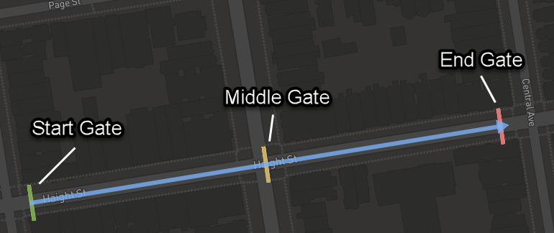

Figure 3.3: An example of gates used in StreetLight’s underlying methods to analyze use of OSM segments. Source: StreetLight Data, Inc. support site.

### 3.1.3 Data validation

Where possible, LBS estimates were compared to existing use estimates based on physical trail counters. Data validation was performed at individual points along trails based on the locations of physical trail counters. Due to differences in data sources and methods, perfect agreement between LBS and counter-based estimates was not expected. In particular, both LBS methods and physical trail counters may struggle to differentiate bicyclists versus pedestrians due to similar travel patterns and speed. Therefore, some misclassification was anticipated. Additionally, LBS and trail counter methods inherently represent slightly different geographies (i.e., an entire OSM trail segment versus a single physical censor) and therefore measure slightly different subsets of trail users.

#### 3.1.3.1 Greater MN data validation

LBS estimates were compared to estimates of mountain bike use on two Greater Minnesota regional trails. During the summer of 2021, use estimates were generated using a combination of trail counters and intercept surveys for the [Duluth Traverse](https://duluthmn.gov/media/13011/duluth-traverse-visitor-profile-2021.pdf) and two mountain biking trail systems in [Cook County](https://www.gmrptcommission.org/uploads/5/1/2/9/51294637/cook_county_mt_bike_visitor_profile_2021.pdf). Short-term trail counters (i.e., counters placed for less than one month) were excluded from validation because LBS data is only available at monthly increments.

Estimates for average daily bicycle use during the summer of 2021 were compared for a segment of Short Stacker mountain biking trail at Britton Peak in Cook County and a segment of the Duluth Traverse near Spirit Mountain Recreation Area. These sites were selected for validation because counters were placed for at least one month, and the physical trail counter locations coincided with an OSM segment appropriate for LBS analysis. Note that only bicycle data was considered.

Correlation between physical trail counter and LBS estimates were strong (r = 0.99, p < 0.001). Notably, estimates based on short-term trail counters had weaker correlation (p = 0.66, p < 0.001), confirming that only counters placed for a minimum of one calendar month should be considered for comparison with LBS estimates.

LBS estimates were observed to be lower than counter-based estimates at the Cook County site, and higher than counter-based estimates at the Duluth Traverse site. These differing patterns may be explained in part by geography and nearby activity. The Cook County site is located approximately 3 miles outside of Tofte, MN (population 266 according to the [2020 US Census](https://www.census.gov/data/tables/time-series/demo/popest/2020s-total-cities-and-towns.html)) and is fairly geographically isolated. Conversely, the Duluth Traverse site is within the city limits of Duluth, MN (population 86,718 according to the [2020 US Census](https://www.census.gov/data/tables/time-series/demo/popest/2020s-total-cities-and-towns.html)) and the OSM segment used for LBS analysis runs parallel to an adjacent OSM segment belonging to the Duluth Winnipeg and Pacific railroad trail (this trail is not included in the project sample). It is possible that the LBS analysis at the Duluth Traverse site picked up some “noise”, or nearby activity, on the Duluth Winnipeg and Pacific trail. However, there was insufficient evidence to confirm the precise reason for these differences.

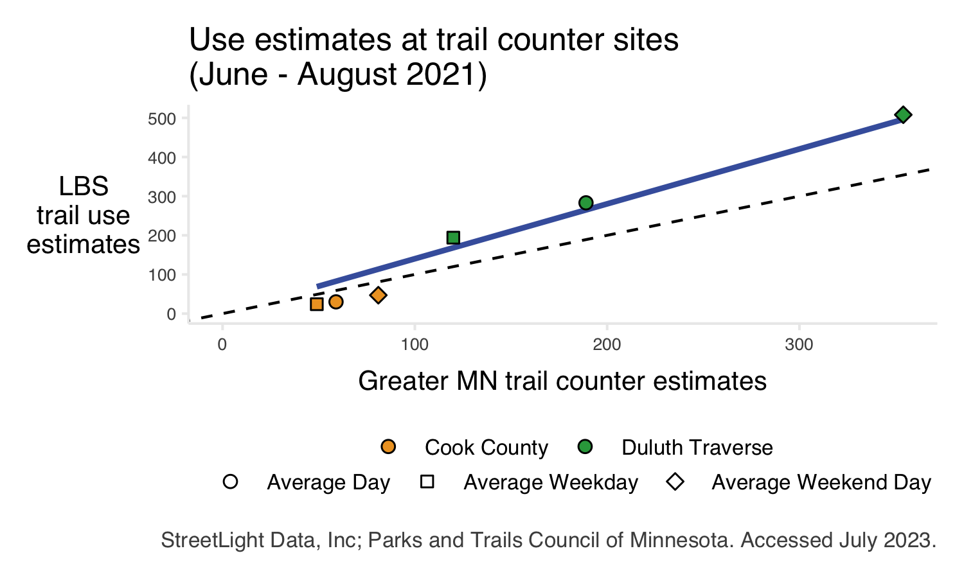

Figure 3.4: Comparison of Greater MN counter-based estimates and LBS estimates at two long-term trail counter sites. The dashed line indicates a perfect one-to-one relationship; the solid blue line indicates the line of best fit.

#### 3.1.3.2 MnDOT data validation

LBS data was additionally validated against [Minnesota Department of Transportation (MnDOT) bicycle and pedestrian counters](https://www.dot.state.mn.us/bike-ped-counting/index.html). Only permanent counters on one of the state or regional trails in the project sample were included, and sites were excluded if greater than 25% of estimates were imputed by either data source. In total, 6 sites were used for validation (Figure 3.5). Daily MnDOT estimates were converted to average monthly values for comparison with LBS estimates. Estimates for average daily bicycle and pedestrian use during each month of 2019, 2020, and 2021 were compared.

Correlation between MnDOT and LBS estimates were generally strong, with higher agreement for bicycle data (Table 3.2). This may be explained in part by behavioral differences between bicyclists and pedestrians. For example, pedestrians may be more likely to “sidestep” a trail counter and be missed by physical trail counters than bicyclists, who are more likely to stay on designated bikeways. There is a noted decline in agreement, particularly for pedestrian estimates, from 2019 to 2020. This may have been caused in part by the COVID-19 pandemic if, for example, social distancing caused more pedestrians to sidestep trail counters.

Total use estimates were compared at all sites (Figure 3.6). A strong positive relationship between trail counter and LBS estimates was observed. Visitor travel mode was also evaluated at each site. Average mode share (i.e., the percent of trail use occurring on bicycles versus on foot) was calculated at each site across all months. LBS data generally estimated a larger share of bicycle use than trail counters (Figure 3.7). There are several potential causes for this pattern. First, as described above, some misclassification between bicycle and pedestrian activity was expected for both methods. The specific OSM segments used for analysis may also contribute to these discrepancies. For example, the OSM segment used for the West River Greenway (Metro Regional) site is tagged as a “cycleway” and runs adjacent to a separate OSM segment tagged as a “footway.” This specific geography may cause the LBS provider to estimate more bicycles on the “cycleway” and more pedestrians on the “footway.” However, the LBS provider’s methods are proprietary, meaning there was insufficient information to determine the precise cause of this pattern. Therefore, we recommend combining bicycle and pedestrian data into a single measure of total activity for segment-level data.

Finally, estimates were compared at each site individually (Figure 3.8). While overall correlation between LBS and counter estimates is strong, there is some variation in this relationship from site to site. It is likely that site-specific characteristics, such as geography or nearby OSM segments, contributed to this variation. Differences between the extent of OSM segments used for LBS analysis and the specific location of the physical trail counter may also play a role. Note also that at each site, between 4% and 16% of MnDOT records were imputed and up to 22% of monthly LBS records were missing. Missing LBS data, or imputed MnDOT values, may have exacerbated discrepancies between use estimates.

In summary, there is a strong positive correlation between MnDOT’s trail counter estimates and LBS estimates. However, site-specific variation may influence the outcomes of LBS analyses.

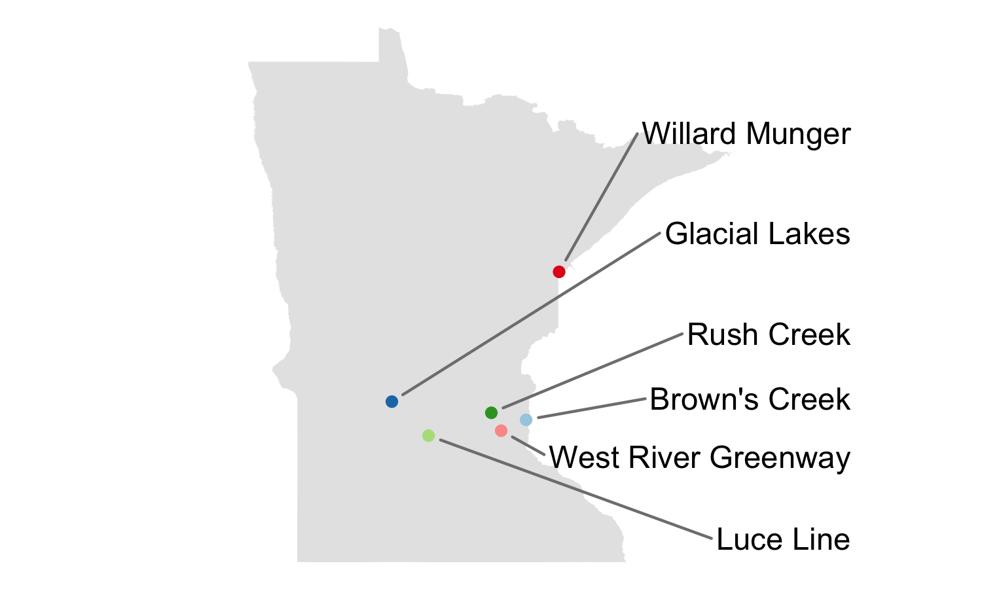

Figure 3.5: Sites used to validate LBS against MnDOT’s physical trail counters.

Table 3.2: Pearson's correlation between LBS and trail counter data by year and mode

| Year | Bicyclist | Pedestrian | Total |
| --- | --- | --- | --- |
| 2019 | 0.96 | 0.81 | **0.89** |
| 2020 | 0.90 | 0.55 | **0.84** |
| 2021 | 0.96 | 0.61 | **0.89** |
| **Total** | **0.93** | **0.61** | **0.92** |

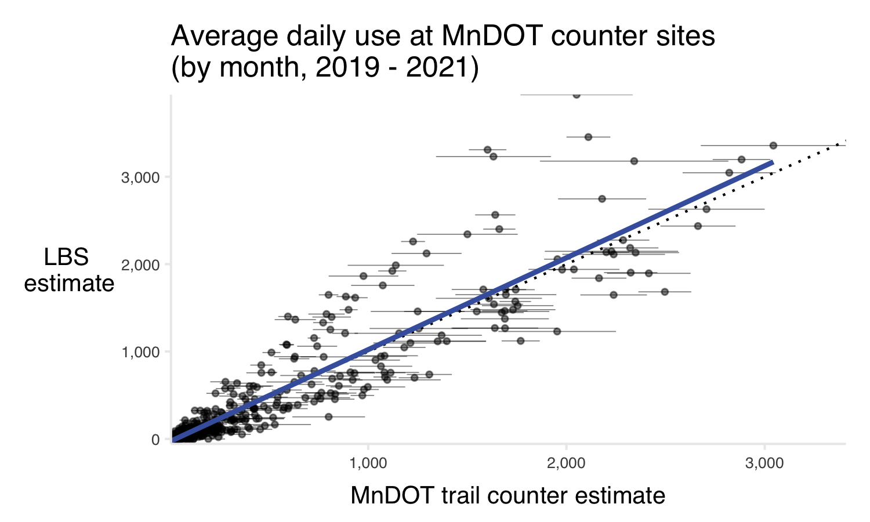

Figure 3.6: Average daily use estimates by month at six permanent MnDOT trail counter sites. The dashed line indicates a perfect one-to-one relationship; the solid blue line indicates the line of best fit. Error bars indicate standard error on MnDOT’s counter estimates.

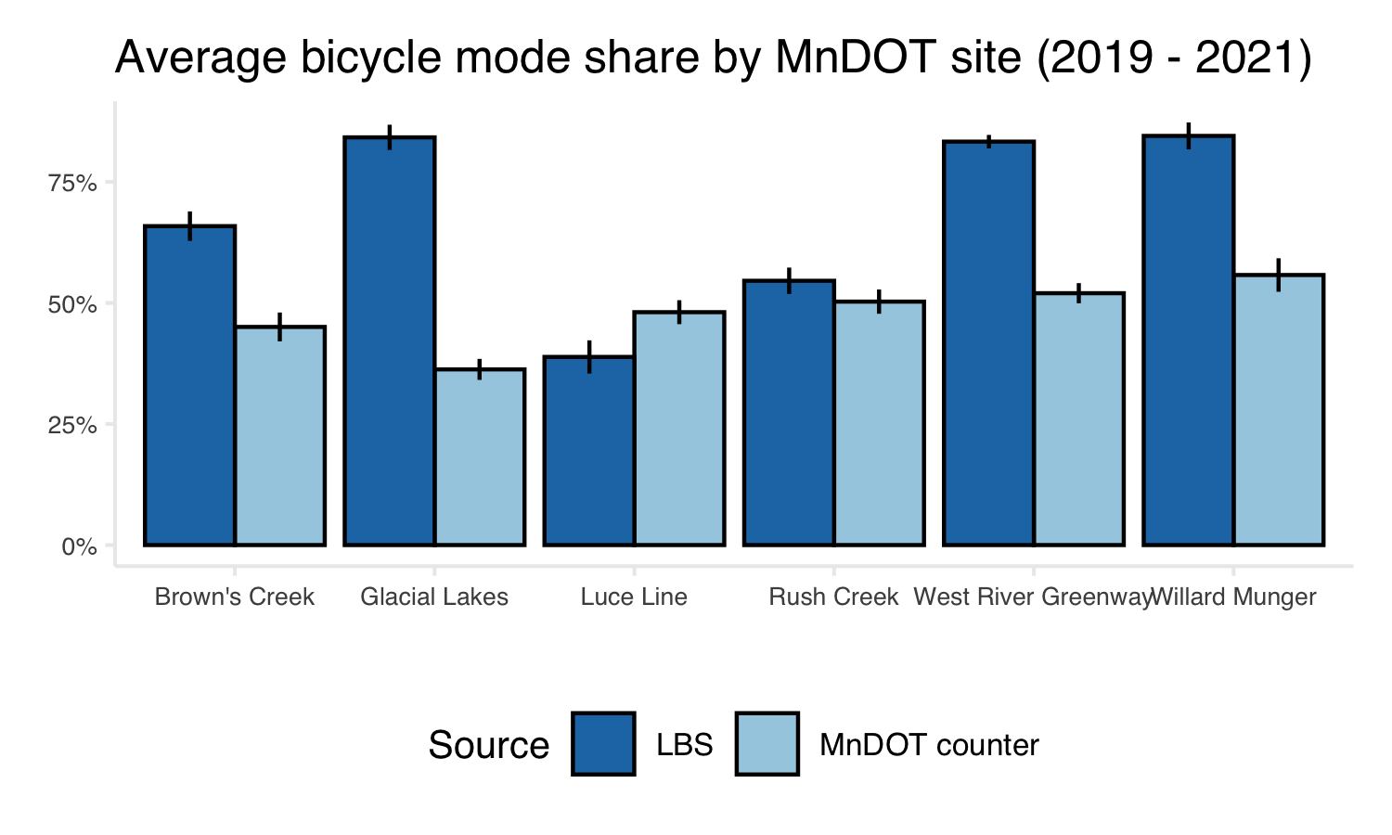

Figure 3.7: Average estimated bicycle mode share at six MnDOT trail counter sites. Error bars indicate standard error.

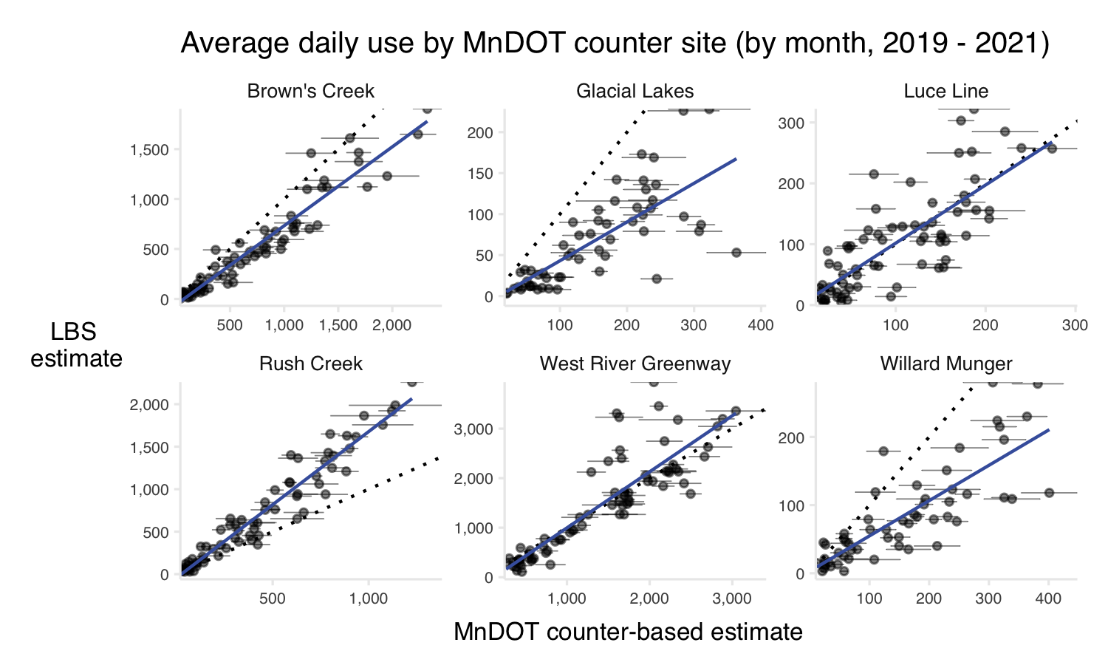

Figure 3.8: Monthly use estimates at six permanent MnDOT trail counter sites by site. The dashed line indicates a perfect one-to-one relationship; the solid blue line indicates the line of best fit. Error bars indicate standard error. Note different scales for each site.

### 3.1.4 Producing trail use estimates

Producing trail use estimates presented several unique challenges. Recall that, in the parks section of this project, park visitors were counted when they *stop* within a defined park boundary. However, given the nature of trails, we suspect that some trail users do not stop for the 5 minutes required to be counted by LBS data. Therefore, pass-through trips were counted along each trail segment in the project sample. This produces estimates similar to those generated by placing one physical trail counter on each identified trail segment.

Whether LBS data or physical counters are used to create these segment-level estimates, summarizing the data at the trail level is non-trivial. Consider the example of Camden trail (Greater MN Regional), for which 7 trail segments were identified (Figure 3.2). Seven individual use estimates along the trail – whether they be LBS or trail counter estimates – cannot be used to identify the total number of unique users along the length of the trail. For example, if one user biked from one end of the trail to the other, they would be counted 7 times, once by each trail counter (or once per OSM trail segment). Neither method can differentiate between 1 user passing through 7 gates, or 7 users passing through 1 gate each.

Therefore, the 7 individual estimates cannot be summed together. This would likely create an overestimate of individual trail users. Similarly, the estimates cannot reasonably be averaged. Taking the average across segments would assume that use is equal across the length of a trail, which is often untrue. In this project, we identified significant variation in use between individual segments of the same trail.

With these challenges in mind, two primary methods for reporting trail use were explored: using the most-used trail segment as a proxy for total use, and reporting total trail miles traveled.

There may be additional options for smaller-scale analyses focused on a smaller number of trails. For example, it may be possible to define parking areas for a trail and apply the methods described in our park methodology to estimate visitors who drive to a trailhead to access a trail. However, this method would miss any users who walk or bike onto a trail without first stopping at a designated access point. Identifying all relevant trailheads or parking areas also presents a challenge and may not be possible in all cases, particularly for trails in more walkable areas. This method would require substantial on-the-ground knowledge about individuals trails and is, therefore, beyond the scope of this project. Similarly, it may be possible to augment LBS data with other data sources, such as intercept survey results, to create an estimate of individual trail users. The methods explored in this report, however, rely solely on LBS data.

#### 3.1.4.1 Most-used segment approach (counter estimates)

One option for reporting trail data is to consider the most-used trail segment on a given trail as a proxy for total trail use. The rationale behind this approach is that the most-used trail segment is likely where a single physical trail counter would be placed, were physical counters being used. Following this reasoning, we refer to these estimates as “counter estimates” throughout the project. Most-used segments were determined on a monthly basis to better reflect changing use patterns throughout the year.

LBS counter estimates were found to be reasonable in some cases. For example, the [Metropolitan Council’s annual park use estimates](https://metrocouncil.org/Parks/Research/Annual-Use-Estimates.aspx) report 17,965,400 total trail visits in 2021. The LBS most-used segment approach estimated 18,350,578 total visits in the same year, a difference of only 2%. At this high level of summary, LBS counter estimates may be sufficient.

LBS counter estimates were additionally compared to unit-level summer 2021 use estimates for Metro Regional trails (Figure 3.9). The existing estimates are based on manual counts performed during the summer (June - August 2021). Across all Metro Regional trails for which data was available (n = 57), agreement between LBS counter estimates and manual count-based estimates was moderate (r = 0.52, p < 0.001). Results differed for individual trails and, overall, the most-used segment approach underestimated trail use compared to the count-based use estimates. At individual trails, the difference between LBS counter estimates and count-based estimates ranged from 1% (Rush Creek, Three Rivers) to 480% (North Creek Greenway, Dakota County).

This approach is sensitive to the specific OSM segments used to represent a trail. A short segment, such as a bridge or major road crossing, may capture a significant number of “incidental users” and appear to be the most-used segment of a trail. If such a segment were not included in the analysis for any reason (i.e., the OSM segment was not detected using the procedure described above, or the segment was less than 50ft in length), a given trail may have a very different use estimate. This method may also misrepresent trails which are very high-use across their entire length, or which have significant variation between their most- and least-used segments. Additionally, by reporting only one value, this method inherently limits the amount of detail included in use estimates and further analysis. Because of these challenges, and the relatively weak correlation with existing estimates observed, this approach is not the preferred method for this project.

Note that this method may be appropriate for specific trails, or specific research questions. Therefore, the LBS counter estimate is provided at the segment-level in the final project data. LBS counter estimates are also used throughout this project when segment-level data is presented.

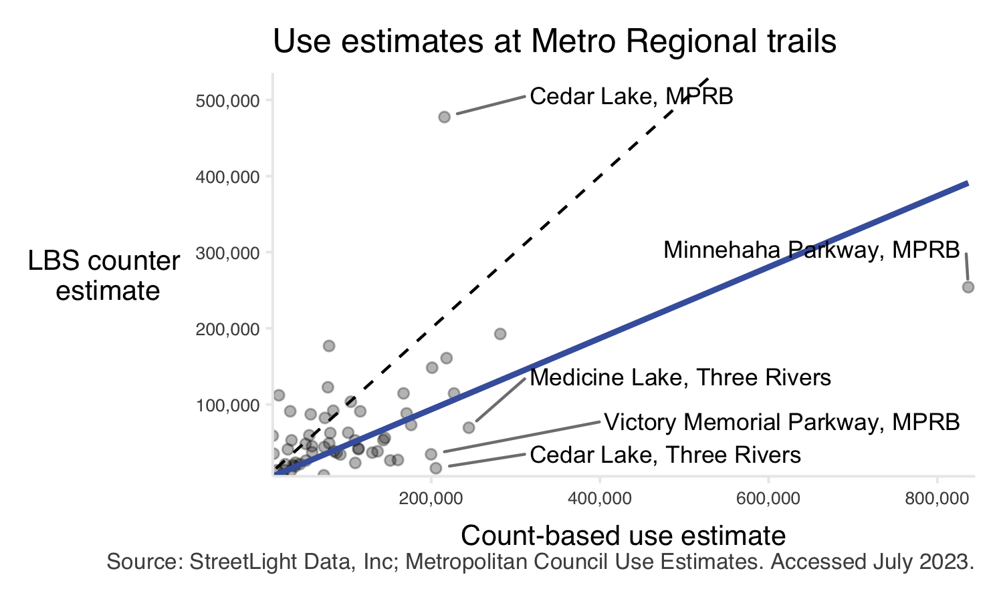

Figure 3.9: Comparison of count-based use estimates and LBS counter estimates at Metro Regional trails. Data for summer of 2021 (June - August) is compared. The dashed line indicates a perfect one-to-one relationship; the solid blue line indicates the line of best fit. Trails with the largest discrepancies are labeled.

#### 3.1.4.2 Trail miles traveled

A key goal of this analysis was to create a measure of trail use which performs similarly across trails and is robust to small changes in identified OSM segments. To achieve these goals, we propose trail miles traveled (TMT) as the primary method for reporting trail-level data.

Trail miles traveled is the estimated count of users on a given segment (i.e., the LBS counter estimate described above) multiplied by the length of said trail segment. As a measure of trail use, trail miles traveled is conceptually similar to vehicle miles traveled (VMT), a measure of vehicle traffic [used by the US Department of Transportation](https://www.transportation.gov/mission/health/vmt-capita). When summed at the trail level, TMT provides a single, robust estimate of trail use.

Naturally, estimated trail miles traveled will not directly correlate to existing use estimates. This is because TMT represents a trail-level summary of use, while existing estimates represent individual trail users. Therefore, to build confidence in the proposed trail miles traveled metric, annual TMT was compared to the LBS counter estimate described above (Figure 3.10). The purpose of this comparison was to confirm that TMT performs similarly for trails across the project sample. On average, we found that 2.5 trail miles were traveled for every user counted at the most-used segment of a given trail. While there was some variation in the relationship between LBS counter estimates and estimated TMT, the variation can largely be explained.

For example, the Minneapolis Chain of Lakes trail (Metro Regional) showed more trail miles traveled relative to users counted at its most-used segment. This trail is located in a densely populated area and encircles the entirety of Lake Harriet and Bde Maka Ska and the western shore of Cedar Lake over 8.23 miles. In most places, the trail is made up of parallel walking and biking paths. The most used segment is along the western shore of Lake Harriet. Due to the popularity of circumnavigating a single lake, it logically follows that total trail miles traveled may be more than 2.5 times the use at this segment. Indeed, trail miles traveled was 7.3 times greater than the maximum segment use for this trail (in the year 2020).

The Paul Bunyan trail (DNR State) is another example of a trail with more trail miles traveled relative to its LBS counter estimate. This is, in large part, due to the length of the trail: 115 miles. The most-used segment of this trail was less than one mile long and ran along a residential street in Bemidji, MN. Naturally, a trail of this length will have more than one highly-used segment, meaning a single LBS counter estimate is likely to underestimate use along the entire trail. Indeed, in 2020, TMT was 17.4 greater than use on the single highest-use segment in Bemidji.

Conversely, the Central Mississippi Riverfront trail (Metro Regional) showed fewer trail miles traveled relative to users counted at its most-used segment. This trail spans both banks of the Mississippi River in downtown Minneapolis, including two relatively short but high-use areas (the Hennepin Avenue bridge across the Mississippi and a trail segment bordering Mill Ruins Park and the Stone Arch Bridge). A large number of visitors may use either bridge for utilitarian purposes or attend one of several popular festivals held in Mill Ruins Park. In either of those cases, visitors may use only a short segment of the trail. In this case, TMT may be less than 2.5 times the LBS counter estimate. In 2020, trail miles traveled was 1.8 times the maximum segment use, in line with this hypothesis.

Cedar Lake trail (Metro Regional, Three Rivers section) also showed fewer trail miles traveled relative to users counted at its most used segment. The explanation in this case is simple: in 2019, large portions of the trail were closed for light rail construction. While the open segments continue to receive high use, use on other segments is near zero, causing trail miles traveled to be only 0.8 times the maximum segment use in 2019. This pattern may extend to other trails with small areas that have much higher use than the rest of the trail.

Trail miles traveled is more robust to changes in identified OSM segments than the LBS counter estimates described above. For example, the 2021 LBS counter estimate for the Paul Bunyan trail (DNR State) was 92,565. If, for example, all OSM segments shorter than 200m were discarded from the LBS analysis, this estimate would decrease to 75,313, a change of -19%. Conversely, the TMT estimate would only decrease by 4%. By combining data across all identified OSM segments, the TMT metric reduces the potential impact of adding or removing a single trail segment. Similarly, this method reduces the impact of site-specific characteristics (described in the data validation portion of this report) that may affect LBS estimates.

Unless otherwise specified, trail use is reported as trail miles traveled in this project. Bicycle and pedestrian use is typically combined into a single value, but disaggregated data (i.e., bicycle miles traveled and pedestrian miles traveled) is provided in the final project data. When visitor mode share is reported, it is calculated based on the share of bicycle and pedestrian miles traveled.

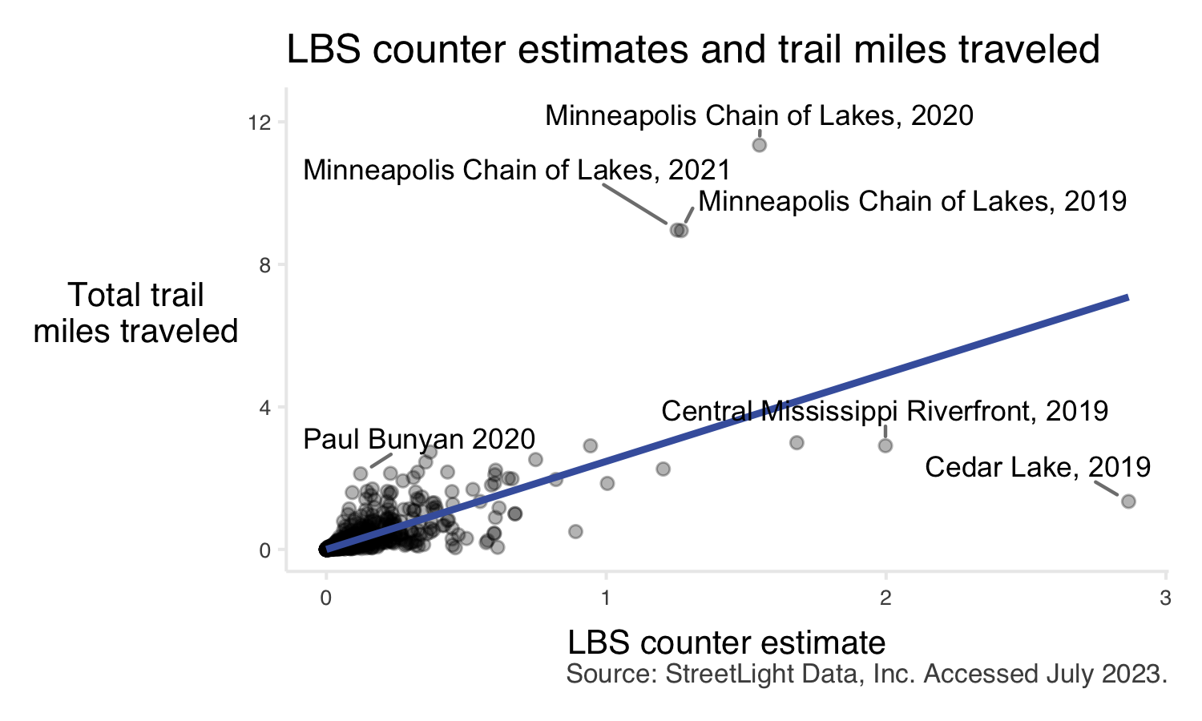

Figure 3.10: Comparison of annual trail miles traveled and annual maximum segment use (LBS counter estimate) for all trails across the three complete years in this study (2019, 2020, 2021). The solid line indicates the line of best fit. Trails with the largest discrepancies are labeled.

## 3.2 Results

### 3.2.1 Trail use increased in 2020

Across the state, 2020 saw a distinct increase in trail use (95.18 million trail miles traveled in 2020 across three systems compared to 62.78 and 68.81 million miles traveled in 2019 and 2021, respectively). This increase was likely driven by behavior changes caused by the COVID-19 pandemic. Trail use in 2021 largely returned to pre-pandemic levels, though use was higher in 2021 than 2019. The three systems saw proportionally similar changes in trail use.

At the unit level, not all trails had increased use in 2020. Year 2020 had the highest use for 129 trail units, but 22 and 25 units had the highest use in years 2019 and 2021, respectively.

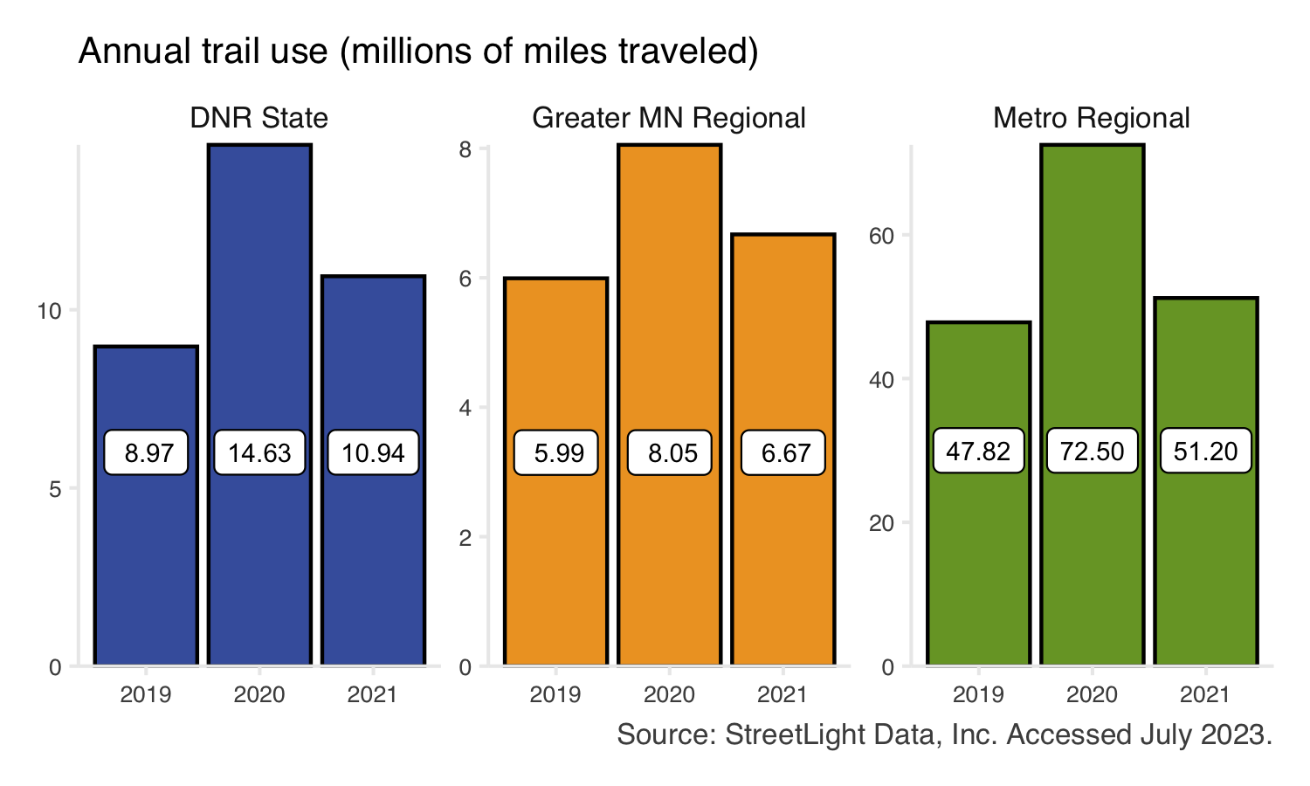

Figure 3.11: Total estimated trail use (trail miles traveled) by year. Bars show the system-wide total trail use across the three complete years in this study (2019, 2020, 2021). Bar color indicates trail system. Individual trail units may show annual visitation trends that differ from the overall system trend.

### 3.2.2 Segment-level data provides detailed insight

Trails connect Minnesotans to a wide range of land uses, essential services, cities, and other attractions. In addition to the recreation value of trails, trails are essential components of transportation networks, connect park systems, and advance natural resource conservation efforts across the state. Due to the variety of landscapes and diverse services trails provide, not all segments of trails are used equally.

While trail use estimates are often limited to several short-term trail counters sited in strategic locations, LBS methods can estimate use across a trail’s entire length and reveal spatial and temporal variation in trail use.

For example, consider a trail with several temporary closures along its length (e.g., portions of Cedar Lake trail (Metro Regional) closed in May 2019 for light rail construction. A single trail counter might indicate unchanged trail use or trail use falling to zero, depending on the counter’s specific location (a single “gate”). Segment-level LBS estimates reflect changes to all trail segments – both those which see declines in visitation and those where visitation remains high – better reflecting on-the-ground conditions (Figure 3.12).

Similarly, trails that are primarily rural with some segments passing through population centers may have large differences between their most used trail segments. For example, the most-used segment of Central Lakes trail (DNR State) is directly northwest of Alexandria, MN (Figure 3.13). Alexandria is the largest population center directly along the trail with a population of approximately 14,000 ([2020 US Census](https://www.census.gov/data/tables/time-series/demo/popest/2020s-total-cities-and-towns.html)). The population and activity associated with Alexandria contributes to the large gap between most- and least-used segments on this trail (Figure 3.12).

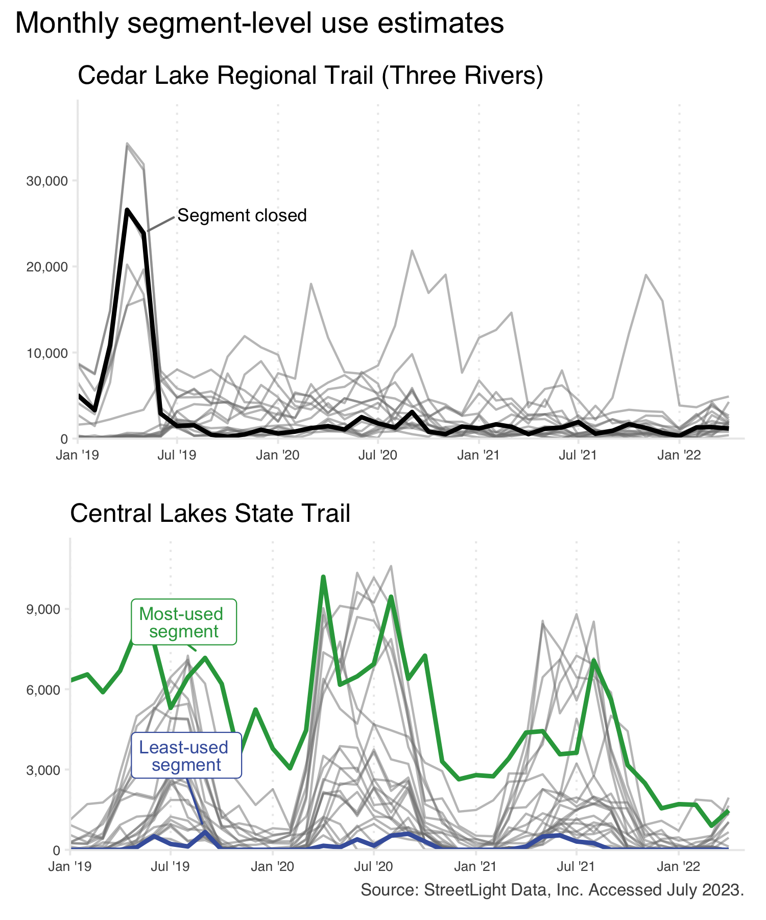

Figure 3.12: Estimated monthly segment-level trail use at two trails. For Cedar Lake Regional Trail (top panel), a segment which closed for construction in 2019 is highlighted. For Central Lakes State Trail (bottom panel), the most- and least-used segments are each highlighted. Each line corresponds to an individual OSM trail segment, therefore the values shown represent LBS counter estimates (rather than trail miles traveled).

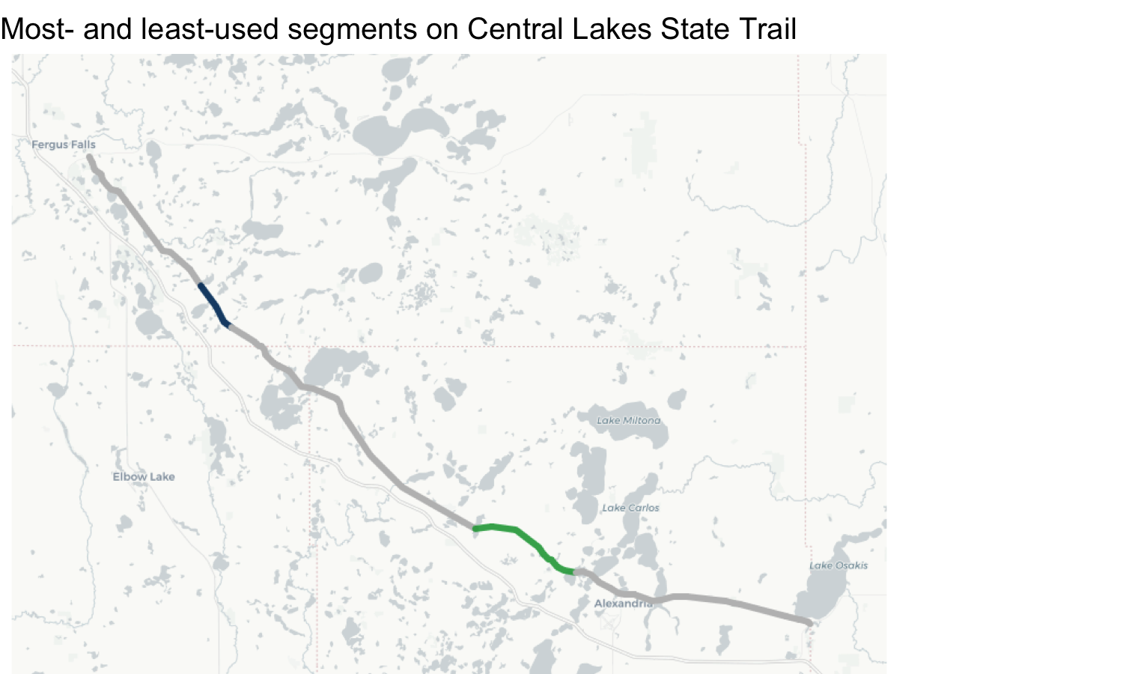

Figure 3.13: Most- and least-used trail segments on Central Lakes State Trail. Note that the most-used trail segment is directly northwest of Alexandria, MN.

#### 3.2.2.1 Visitor travel mode differs by trail segment

In addition to overall use, visitor travel mode was found to vary by trail segment. Like overall use, we observe a relationship between visitor mode share and population centers. Trail segments located near walkable areas, such as downtowns or residential neighborhoods, may receive higher pedestrian use than other segments on the same trail. In the case of Central Lakes (DNR State), pedestrian activity makes up a much larger share of trail use near Alexandria and in Osakis at the southeastern end of the trail (Figure 3.14). We observe that this change is caused by an increase in pedestrian use in these areas, rather than a decrease in bicycle activity.

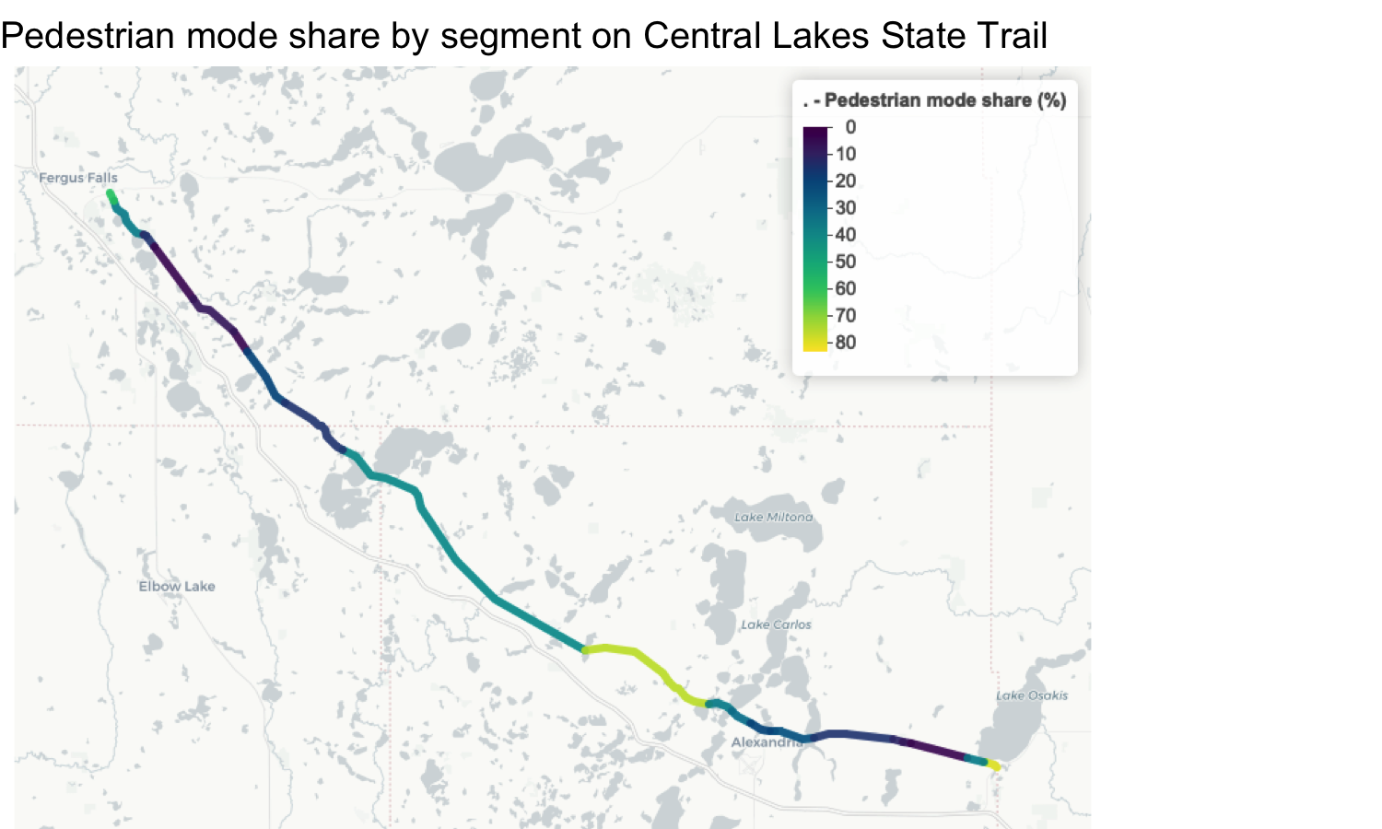

Figure 3.14: Visitor mode share by trail segment on Central Lakes State Trail. Brighter colors indicate a higher portion of pedestrian trail use. Note that trail segments closer to population centers (e.g., northwest of Alexandria, MN) or in residential areas (e.g., southeastern end of the trail in Osakis, MN) have higher portions of pedestrian use.

### 3.2.3 Trails are used in all seasons

Using LBS data to estimate trail use over a year shows that Minnesota’s trails are used in all seasons, although to a lesser extent than Minnesota’s parks. Trail use generally builds throughout the spring, peaks in the summer, and tapers off in the fall (Figure 3.15). At the trail level, many segments which retain usage into the winter are within population centers or maintained (plowed) during the winter (e.g., portions of Brown’s Creek State Trail), highlighting the year-round importance of trails to the transportation network and for recreation benefits.

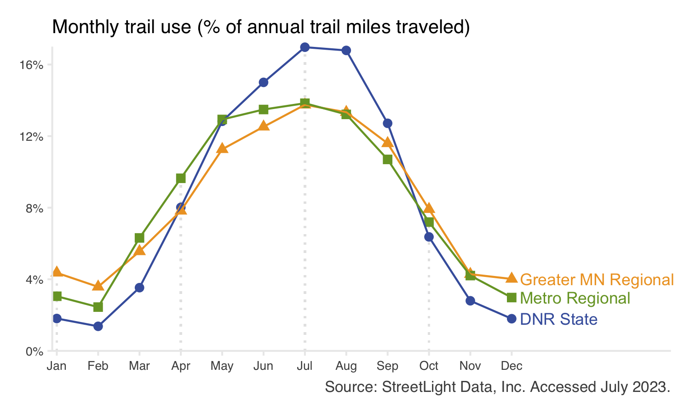

Figure 3.15: Monthly trail use as a percent of total annual use for each system. Points show the average monthly use across the three complete years in this study (2019, 2020, 2021). Point color indicates park system. Individual trail units may show trends that differ from the overall system trend.

### 3.2.4 Hourly trail use varies by day and system

On weekends (Sa-Su), trails tend to have a late morning peak in visitation around 11 a.m. (Figure 3.16). On weekdays (M-F), trail visitation shows a bimodal use pattern. A peak in the late morning to noon time frame is still observed. A second peak in use occurs around 5 p.m. The first peak (morning) is larger for DNR state trails, while the second peak (evenings) is larger for regional trails. The strength of the second peak may reflect commuting patterns (i.e., trails being used as transportation to and from work) or the ease of accessing regional trails near home after work.

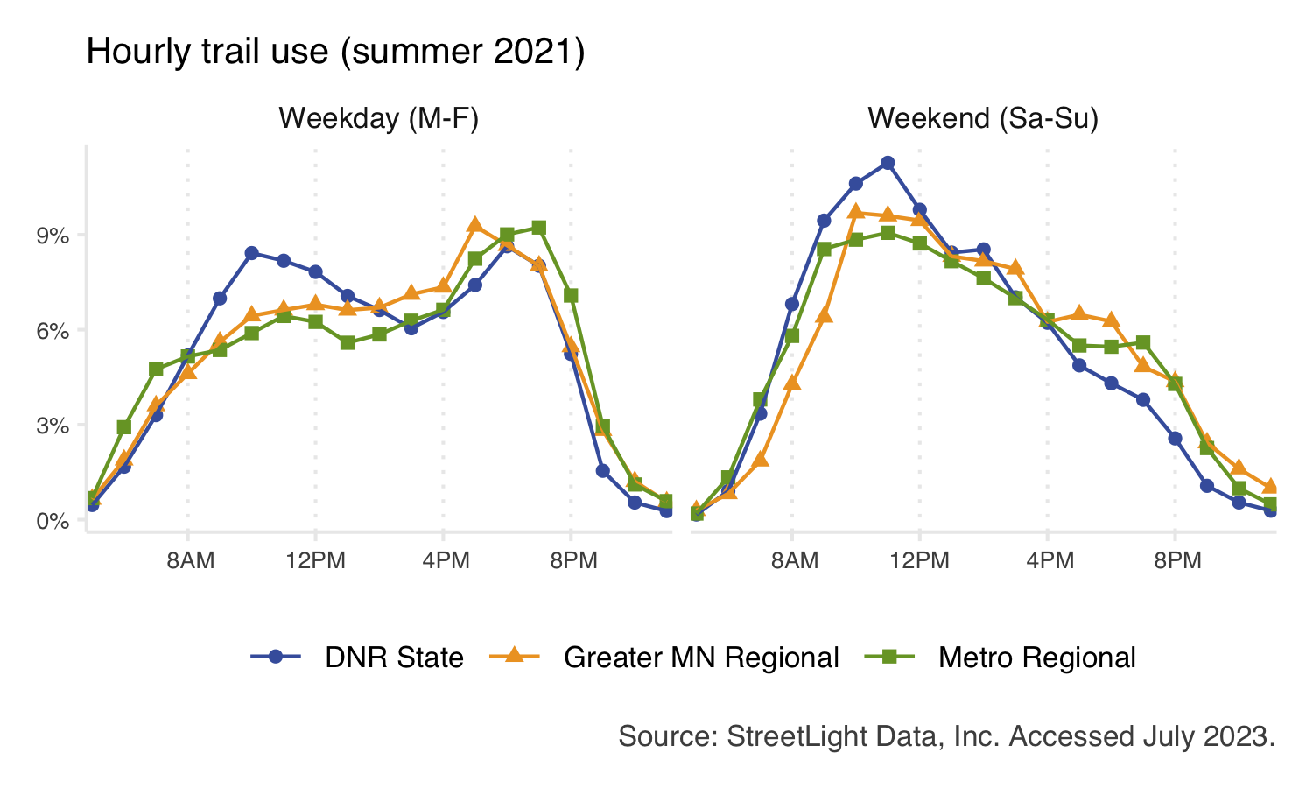

Figure 3.16: Daily trail use patterns during summer 2021 for each system. The total number of visits across all trails is summed for each system, from which the percent of total visits is calculated. Individual trail units may show trends that differ from the overall system trend.

## 3.3 Visitor modeshare varies by season

During summer months, bicycle use generally makes up the majority of trail use (Figure 3.17). However, this pattern switches in the winter when pedestrian use makes up the majority of use. Trails that are maintained for winter mountain or fat tire biking see a less pronounced decline in bike use during winter months. This is most common for DNR state and Greater Minnesota regional trails.

We observe that this change is caused by a decrease in winter bicycle use, rather than by an increase in winter pedestrian use. It is likely that longer recreational bicycle trips decline in the winter, while shorter pedestrian trips in neighborhoods or other walkable areas remain more constant.

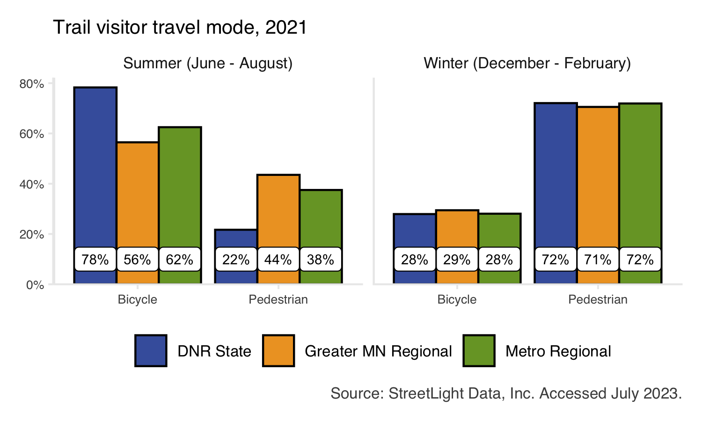

Figure 3.17: Mode share of trips made to trails in summer (June - August) and winter seasons (December - February). Bars show the average annual mode share across the three complete years in this study (2019, 2020, 2021). Bar color indicates trail system. Individual trail units may show trends that differ from the overall system trend.

# 4 Visitors

We found high use of parks and trails across the state. Most visitors live within Minnesota (90.96%), but we also found that Minnesota’s parks and trails attracted visitors from across the country. We found the benefits of accessible green space are not equitably distributed among Minnesotans and that the specific dynamics of visitor demographics varied across systems and individual park and trail units. Understanding the demographic characteristics of visitors to Minnesota’s parks and trails can help reduce barriers to access and create more equitable access to parks and trails for all Minnesotans.

## 4.1 Methods

Aggregated and anonymized LBS data was used to infer park and trail visitor home locations and demographics. StreetLight Data, Inc. produces this inferred data by combining aggregated, anonymized GPS data with census information. Inferred home locations and demographics provide an opportunity to explore the demographics of park and trail visitors on a broad scale. Note that inferred demographics cannot and should not replace data about individuals’ lived experiences. Inferred data may be used to augment existing data or guide future research efforts, but should not be considered a replacement for intercept survey data.

In this project, similar methods were used to process visitor demographics for parks and trails. Inferred home locations and demographics were accessed via StreetLight analyses described in sections 2.1.2 and 3.1.2, respectively.

Inferred visitor home locations are reported at the block group, zip code, and/or state level. Inferred demographics are reported in three categories: race/ethnicity, educational attainment, and income. Inferred home locations and demographics are available for the year 2021.

#### 4.1.0.1 StreetLight’s inferred home locations

StreetLight infers visitor home locations by assigning home locations to the devices (i.e., smartphones) in their data sample. Device home locations are probabilistically assigned based on where a device “spends the night” most often. Nighttime hours are defined as 7 p.m. - 8 a.m. every day of the week. If a device is consistently in a given location between these hours, that location is inferred to be the device’s “home.”

This method assumes that the majority of the population is at home, not work, during these hours. Naturally, some home locations will be misclassified when devices do not follow the traditional pattern of working 9 a.m. - 5 p.m. outside of the home. StreetLight performs additional data cleaning steps to minimize such errors, such as limiting home locations to residential census blocks. However, workers with atypical shifts or domestic workers who are employed in residential census blocks may be misrepresented by these methods.

StreetLight assigns home locations on a monthly basis. Therefore, seasonal residents will be captured so long as they spend at least one month in their seasonal home location. In this analysis, we can identify home locations for visitors from outside of Minnesota, but not for international visitors.

Additionally, a single device can be assigned to multiple home locations (up to five). For example, if a device spends 50% of nights in one census block and 50% of nights in another, it will be considered by StreetLight’s algorithms in each census block, weighted by the proportion of nights spent in each block.

Once device home locations are distributed at the census block level, StreetLight’s algorithms expand the sampled devices to reflect the full population of visitors. In other words, visitor home locations are modeled based on a sample of device home locations. This data is aggregated at coarser geographies, such as census block groups or zip codes, before being shared with the project team. Like all of StreetLight’s LBS data, this data is anonymized and can never be used to identify individuals.

#### 4.1.0.2 StreetLight’s inferred demographics

StreetLight infers visitor demographics by coupling the inferred home locations described above with spatially explicit census demographics. Like home locations, demographics are probabilistically assigned based on the census data associated with a device’s inferred home census block.

This method of inference can be vulnerable to the ecological fallacy (i.e., incorrectly drawing inferences about individuals based on a larger group they belong to). StreetLight addresses this challenge by correcting for the proportion of the population represented in their data sample, and for variations in cell phone usage across geographic space and socioeconomic groups (see [StreetLight’s “Larger and More Representative Sample Size” white paper](https://learn.streetlightdata.com/larger-more-representative-sample-size) for more information). However, because StreetLight never collects data on individuals, there is no way to confirm which residents in any given census block own the devices in StreetLight’s sample.

Other limitations of inferred demographics include a lack of qualitative information (e.g., visitors’ lived experiences collected through methods such as focus groups) and limited categories for describing visitors’ identities (e.g., categories of race and ethnicity [used by the US Census Bureau](https://www.census.gov/quickfacts/fact/note/US/RHI625222#:~:text=OMB%20requires%20five%20minimum%20categories,report%20more%20than%20one%20race.)).

Due to these challenges, inferred demographic data is reported only at the park- or trail-level in this project. We believe that local, historical, and/or cultural context is critical when considering these inferred data.

### 4.1.1 LBS Analyses

Various LBS analyses were used to gather inferred home locations and demographics for parks and trails. Home location data is only available for areas of less than 4km $​^{2}$. Therefore, home locations and demographics for parks were collected using zone activity analyses on park perimeter zones (described in section 2.1.1.2). Trail demographics were collected for each identified trail segment, and trail home locations were collected using the entire trail polygons (described in section 3.1.1). Trail polygons were used due to data coverage issues observed with segments (i.e., many individual trail segments had few enough daily visitors that no home location data was reported in order to maintain data privacy standards).

For both parks and trails, home locations and demographics were collected for summer 2021 for validation purposes. However, data for the entire year is reported in this project (unless otherwise specified).

Note that both polygon and perimeter zones were considered for collecting park demographics. Each method produced very similar results. No significant differences were observed when validating demographic data gathered from perimeters versus polygons. Because demographics are based on home locations, perimeter zones were selected for consistency. At individual parks, there may be slight differences in demographic estimates produced by perimeters versus polygons. Interpreting such differences would be challenging and require substantial knowledge about a given park. Therefore, comparing and/or contrasting these estimates was not feasible for the entire project sample.

### 4.1.2 Creating estimates of user attributes

Home location data for each applicable mode (vehicles, bicycles, and pedestrians for parks; bicycles and pedestrians for trails) was combined and weighted by mode to reflect the overall share of visits from a given home location. Vehicle multipliers were used when conducting this weighting. Data was aggregated at the zip code level for validation purposes. Final results are shared at the census block group and state level.

In order to facilitate validation, demographic data was processed to match the categories used by the [Metropolitan Council’s 2021 Visitor Study](https://metrocouncil.org/Parks/Research/Visitor-Study.aspx). The intercept survey and LBS data did not perfectly align in all demographic categories. Within the topic of race and ethnicity, the survey asked a combined question about race and ethnicity, while the LBS data treats race and ethnicity as two separate attributes. To align these metrics, LBS race and ethnicity data was rescaled to relative percentages such that all categories sum to 100%.

Within the topic of household income, two income brackets had different starting and ending points. The LBS data had information on people with an average household income of $60 - 74,9999 and $75 - 99,999 while the intercept survey used income categories of $60 - 79,000 and $80 - 99,999. Because there was full agreement on all other income categories, we chose to allow these two categories to have different ending and starting points (e.g., $60 - 74/79,999 and $75/80 - 99,999) and keep the finer scale resolution rather than combining into an aggregated $60-99,999 category.

Like home locations, demographics were weighted by mode. For parks, vehicle multipliers were used for weighting. For trails, demographics were collected at the segment level and data was additionally weighted by segment-level use. Home locations were also rescaled to relative percentages such that the percentage of visitors from each reported home location sums to 100% for each park or trail. This may not reflect all home locations of visitors; when there are few enough visits from a given home location, StreetLight does not report any data to maintain privacy standards.

### 4.1.3 Comparison populations

In addition to LBS data, data from the 2020 US Census was processed to match the demographic categories captured by the intercept survey and LBS data. This data was obtained using the R package [tidycensus](https://walker-data.com/tidycensus/). Data was summarized for the entire state of Minnesota, the 7-county Twin Cities metropolitan area, and the entire state minus the 7-county metro area. These “comparison populations” are used to provide context for unit-level estimates of demographics for DNR State, Metro Regional, and Greater MN Regional parks and trails respectively. Comparison populations are used in the park- and trail-level fact sheets available on the [project website](https://arcg.is/0Oee0W0).

### 4.1.4 Data Validation

Home location and demographic data gathered by the Metropolitan Council’s 2021 Visitor Study (the “intercept survey”) was used to validate LBS estimates. During the survey, ten units (8 parks and 2 trails) were over-sampled (i.e., additional surveys were conducted), in part to facilitate this validation.

One notable difference between intercept survey and LBS data was the associated sample size (Table 4.1). The intercept survey was administered in person to between 198 and 388 visitors at each over-sampled unit. Rather than visitors, StreetLight’s LBS data samples devices (i.e., smart phones with GPS services enabled). The approximate number of devices sampled ranged from 1,000 to 19,500 at each unit. This discrepancy in sample size results in some differences between the data sources. For example, LBS data detected more unique home locations than the intercept survey (Table 4.2).

Table 4.1: Comparison of sample size at each oversampled unit. The intercept survey was administered to 0.01 - 0.09% of annual visitors (as estimated by the LBS methods described in this report). StreetLight Data sampled 1.2 - 2.64% of annual visitors.

|  | **Intercept Survey** | | **LBS Data** | |
| --- | --- | --- | --- | --- |
| **Unit** | **Completed surveys** | **Percent surveyed** | **Approximate LBS  device count** | **Percent sampled** |
| Battle Creek | 200 | 0.03% | 12,500 | 1.70% |
| Cleary Lake | 200 | 0.05% | 6,500 | 1.48% |
| Como Zoo and Conservatory | 214 | 0.02% | 19,500 | 1.42% |
| Hyland Bush Anderson Lakes | 388 | 0.05% | 15,500 | 2.18% |
| Lake Elmo | 209 | 0.04% | 7,000 | 1.30% |
| Lake Minnetonka LRT | 200 | 0.07% | 4,000 | 1.46% |
| Lake Minnewashta | 198 | 0.06% | 4,000 | 1.20% |
| Lebanon Hills | 206 | 0.02% | 16,500 | 1.70% |
| North Mississippi | 202 | 0.08% | 7,000 | 2.64% |
| Rice Creek West | 208 | 0.29% | 1,000 | 1.41% |

#### 4.1.4.1 Home Locations

The intercept survey reports home locations at the zip code level. The strength of the relationship between the percent of visitors living in zip codes as measured via the intercept survey and LBS varied significantly by park or trail unit (F = 35.3 , p < 0.001; Figure 4.1). However, visitor home locations were observed to have a strong, positive correlation between methods at all ten units (Table 4.2).

Lower correlation observed at units such as Como Zoo and Conservatory can be explained in part by differing sample sizes and number of zip codes identified by each data source. In some cases, the intercept survey identified distant home zip codes with a single surveyed visitor. Consider Como Zoo and Conservatory, where 214 surveys were conducted. If a single survey were administered to a visitor from Two Harbors, for example, 0.467% of survey respondents would have a Two Harbors home zip code. Because LBS data has a larger sample size and identified more home zip codes overall, LBS data tends to estimate a smaller percentage of visitors living in more distant home locations. For example, the LBS sample for Como Zoo and Conservatory consists of approximately 19,500 devices. If one of these devices were from Two Harbors, it would represent only 0.005% of sampled devices. This phenomenon means that the intercept survey tends to estimate more visitors from distant home locations (Figure 4.2).

Table 4.2: Correlation between intercept survey and LBS data visitor home locations. A correlation test was performed on the percent of visitors inferred to live in each zip code by each data source. The total number of zip codes compared for each park are shown.

|  | **Zip codes identified** | | | **Correlation** | |
| --- | --- | --- | --- | --- | --- |
| **Unit** | **LBS** | **Survey** | **Shared** | **r-value** | **p-value** |
| Battle Creek | 185 | 48 | 42 | 0.97 | <0.001 |
| Cleary Lake | 149 | 39 | 27 | 0.98 | <0.001 |
| Como Zoo and Conservatory | 328 | 117 | 95 | 0.79 | <0.001 |
| Hyland Bush Anderson Lakes | 225 | 72 | 49 | 0.92 | <0.001 |
| Lake Elmo | 179 | 65 | 43 | 0.96 | <0.001 |
| Lake Minnetonka LRT | 171 | 31 | 26 | 0.72 | <0.001 |
| Lake Minnewashta | 211 | 42 | 32 | 0.97 | <0.001 |
| Lebanon Hills | 187 | 64 | 49 | 0.83 | <0.001 |
| North Mississippi | 195 | 45 | 40 | 0.85 | <0.001 |
| Rice Creek West | 135 | 33 | 24 | 0.99 | <0.001 |

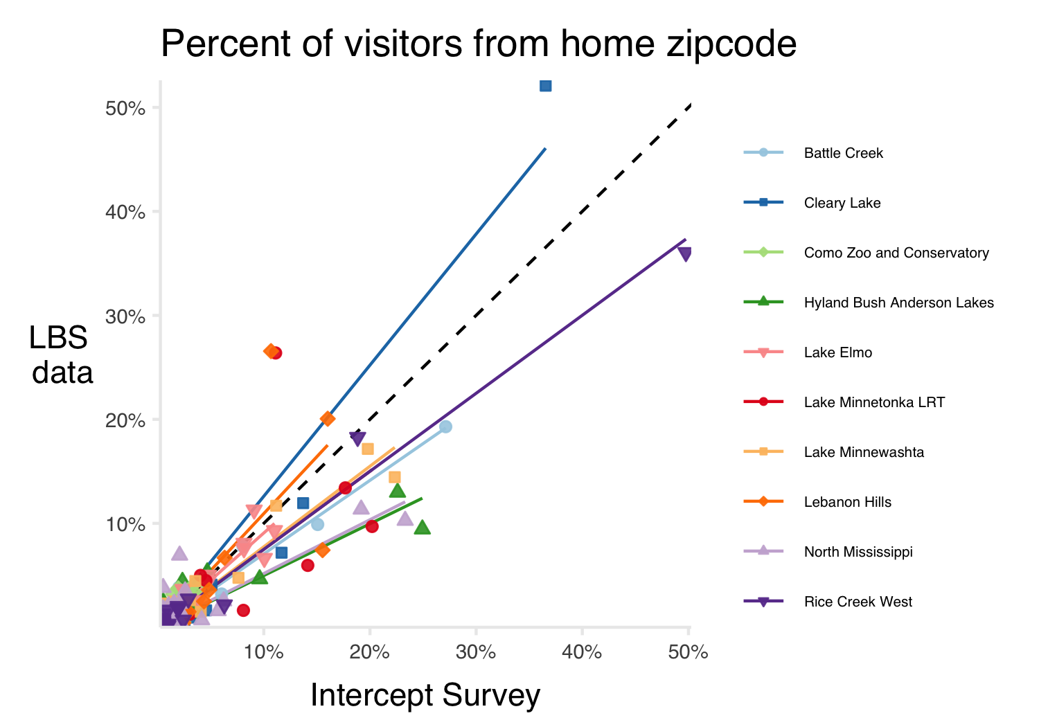

Figure 4.1: Comparison of intercept survey and LBS data home locations at eight oversampled metropolitan area regional parks. Each point represents one home zip code. The values on the axes indicate the percent of visitors to the indicated park estimated to live in that zip code. The lines of best fit shows a strong positive correlation between these estimates, while the black, dashed line shows a 1:1 relationship. Source: Metropolitan Council visitor Survey, StreetLight Data, Inc. Accessed July 2023.

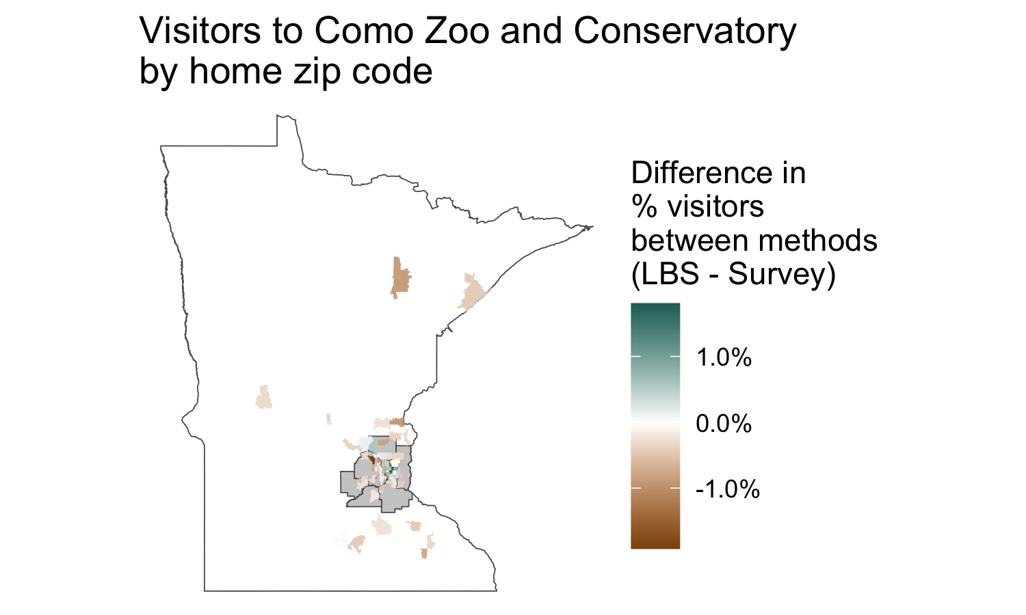

Figure 4.2: Difference in home locations identified by the intercept survey and LBS data for Como Zoo and Conservatory. Positive values (green) indicate areas where LBS data estimates a higher percentage of visitors than the intercept survey; negative values (brown) indicate areas where the intercept survey estimates a higher percentage of visitors than LBS data. Note the negative values on the North Shore, far away from the park unit in Saint Paul.

#### 4.1.4.2 Demographics

Surveyed and inferred demographics were compared using z-scores with statistical significance determined at the 95% confidence level. Comparing z-scores addresses the difference between both estimates and standard errors. When demographic estimates are significantly different at the 95% confidence level, there is less than a 5% chance that the difference between the two estimates is due to random chance.

The alignment between surveyed and inferred visitor demographics is strong (Table 4.3). No significant differences were observed across income categories. LBS methods estimated more visitors with a high school diploma as their highest educational attainment and fewer visitors with a graduate or professional degree. LBS data generally estimated fewer white visitors than the intercept survey, though this varied from unit to unit.

In sum, this validation suggests that LBS-derived demographics provide valuable views of park and trail visitor demographics, particularly when intercept survey (or similar) data is not available. The ability for LBS to record visitors spanning wider temporal and spatial dimensions than many other methods may additionally reflect a visitor sample which is likely to be more representative of the entire population of park visitors.

Table 4.3: Summary of validation between location based services derived demographic values and intercept survey values. Values show the number of units with and without a statistically significant difference in demographic percentages at the 95% confidence interval.

| Attribute | Category | Not significantly different | Significant |
| --- | --- | --- | --- |
| Education | High school | 2 | 8 |
| Associate degree or some college | 8 | 2 |
| 4-year degree | 6 | 4 |
| Graduate or professional degree | 1 | 9 |
| Income | Less than $25,000 | 10 | 0 |
| $25,000 - 39,999 | 10 | 0 |
| $40,000 - 59,999 | 10 | 0 |
| $60,000 - 74/79,999 | 10 | 0 |
| $75/80,000 - 99,999 | 10 | 0 |
| $100,000 - 149,999 | 10 | 0 |
| $150,000 or higher | 10 | 0 |
| Race/ethnicity | American Indian | 10 | 0 |
| Asian | 10 | 0 |
| Black | 10 | 0 |
| Hispanic or Latinx | 10 | 0 |
| More than one race | 10 | 0 |
| Native Hawaiian and other Pacific Islander | 10 | 0 |
| Some other race | 10 | 0 |
| White | 1 | 9 |

##### 4.1.4.2.1 Race/ethnicity

In all but one case, LBS data estimated fewer white visitors than the intercept survey (Table 4.4, Figure 4.3). The survey and LBS data agreed on the portion of visitors belonging to other races/ethnicities at all ten units.

Como Zoo and Conservatory was the only unit where no significant difference was observed for percent of white visitors estimated by each data source. We note that a larger portion of intercept surveys were conducted on weekends at Como Zoo and Conservatory as compared to the other over-sampled units (Figure 4.4). While it was beyond the scope of this research, exploring variations in demographic patterns for weekday versus weekend visitors may explain the higher agreement between survey and LBS data at Como Zoo and Conservatory.

There are several reasons LBS data may estimate fewer white visitors on average. LBS data may avoid sampling bias which can occur when conducting surveys, although it is also possible that there is some unknown level of bias in LBS estimates (see [StreetLight’s “Larger and More Representative Sample Size” white paper](https://learn.streetlightdata.com/larger-more-representative-sample-size) for more information). Additionally, LBS data has a larger sample size (Table 4.1). Larger sample sizes are typically associated with more representative samples and smaller margins of error. Therefore, it is possible that LBS-derived estimates better reflect the true population of visitors. However, it is important to acknowledge that LBS data may be underestimating white visitors by up to 27% (the difference observed at North Mississippi Regional Park). Because of these potential discrepancies, the project team recommends using LBS-derived demographic data in combination with other data sources and/or with local and historical context for individual parks and trails.

Table 4.4: Comparing the percent of visitors identifiying as white between sampling methods during summer 2021. The 95% confidence interval is shown in parentheses.

|  | **White visitors (%)** | |
| --- | --- | --- |
| **Unit** | **Intercept survey** | **LBS data** |
| Battle Creek, Ramsey County | 79.4% (±6.48%) | 56.2% (±0.74%) |
| Cleary Lake, Three Rivers | 89.1% (±4.65%) | 79.8% (±0.70%) |
| Como Zoo and Conservatory, Saint Paul | 67.5% (±7.79%) | 64.8% (±0.63%) |
| Hyland-Bush-Anderson Lakes, Bloomington | 89.8% (±3.25%) | 70.2% (±0.67%) |
| Lake Elmo, Washington County | 92.5% (±3.78%) | 69.3% (±0.93%) |
| Lake Minnetonka LRT, Three Rivers | 96.9% (±2.47%) | 82.0% (±0.08%) |
| Lake Minnewashta, Carver County | 90.1% (±4.47%) | 79.6% (±1.05%) |
| Lebanon Hills, Dakota County | 87.6% (±4.85%) | 68.8% (±0.48%) |
| North Mississippi, MPRB | 75.5% (±6.93%) | 48.8% (±1.01%) |
| Rice Creek West, Anoka County | 90.6% (±4.23%) | 66.4% (±0.41%) |

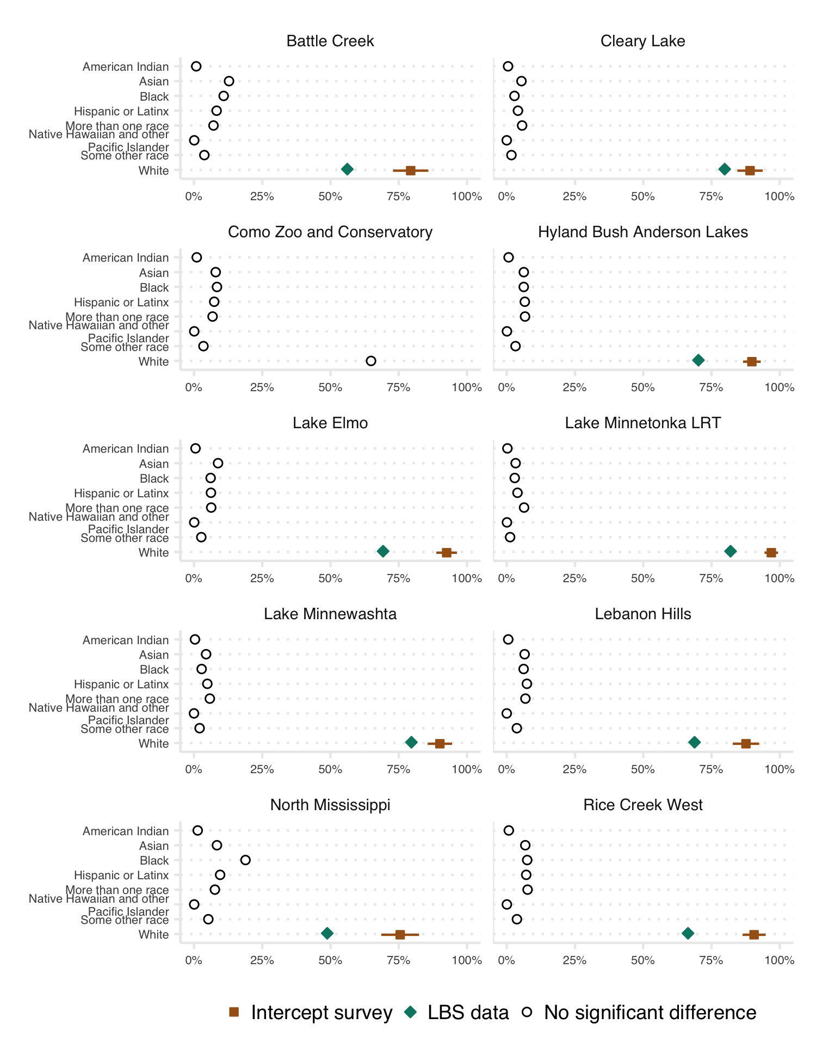

Figure 4.3: Validation of race/ethnicity categorys. Error bars show a 95% confidence interval. When there was no significant difference in percentages at the 95% confidence interval, LBS percentages are shown. Source: Metropolitan Council visitor study, StreetLight Data, Inc. Accessed July 2023.

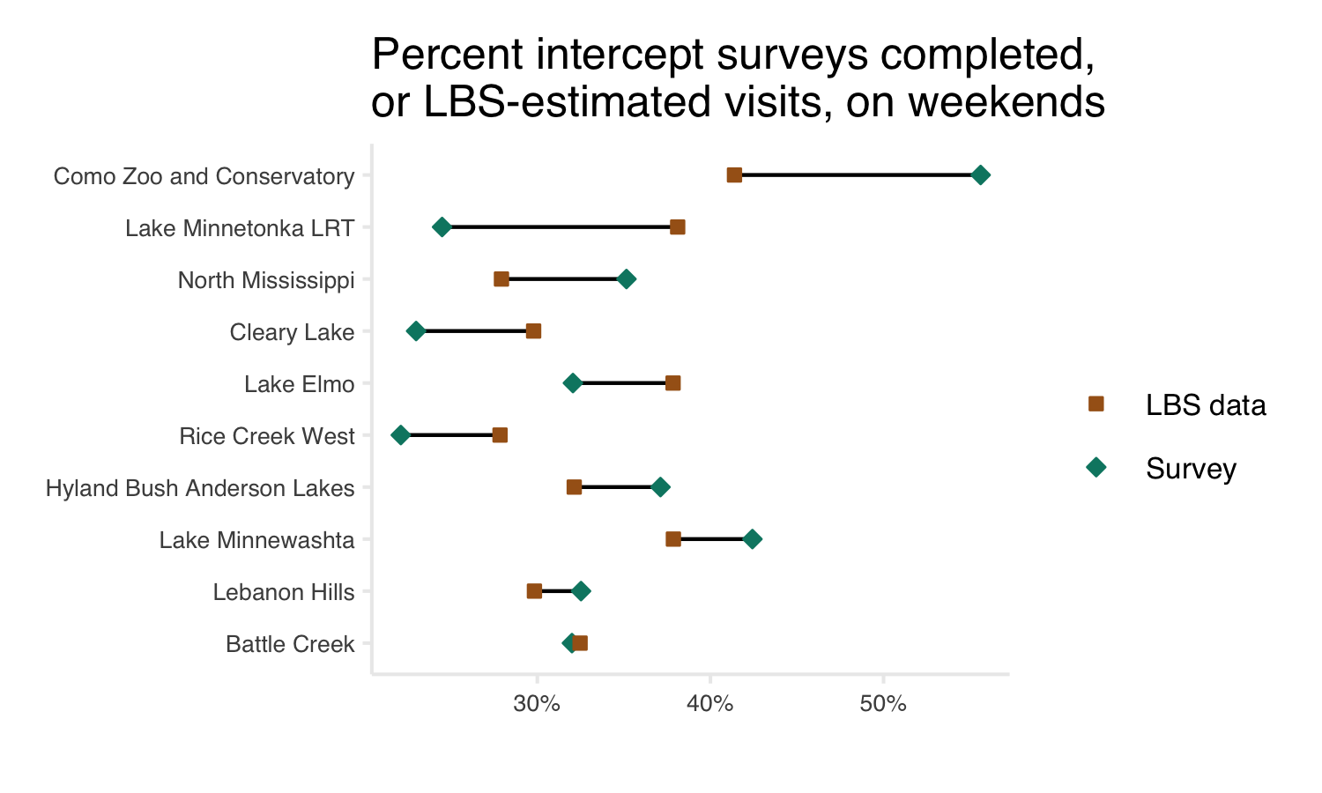

Figure 4.4: Percent of 2021 intercept surveys completed on the weekend and percent of 2021 LBS data visits which occur on the weekends. Parks are sorted by descending order of difference between survey and LBS data percents. Source: Metropolitan Council visitor study, StreetLight Data, Inc. Accessed July 2023.

##### 4.1.4.2.2 Education

LBS and intercept survey data agreed on the general distribution of visitors’ educational attainment, though the agreement was less consistent than for race and ethnicity (Figure 4.5). There was the most agreement on the portion of visitors who were currently enrolled in college, had an associates degree, or had some level of post-secondary other than a 4-year or graduate degree (no significant difference at 8/10 units; when a significant difference was observed, LBS data estimated more visitors in this group). Agreement on the portion of visitors with 4-year degrees was similarly strong (no significant difference at 6/10 units; when a significant difference was observed, LBS estimated fewer visitors in this group). In all but two cases, LBS data estimates significantly more visitors with a high school diploma as their highest level of education. In all but one case, LBS data estimates significantly fewer visitors with a graduate or professional degree. In summary, LBS data estimated more visitors with high school or some college as their highest level of educational attainment and less visitors with a 4-year or graduate/professional degree, as compared to the intercept survey.

As noted above, there are several possible explanations for this pattern: LBS data may avoid sampling bias, but there may be unknown bias in LBS estimates. Larger sample sizes associated with LBS data may indicate that LBS-derived estimates are more representative of visitors overall. However, it is important to note that LBS data may be overestimating the portion of visitors with high school diplomas as their highest educational attainment by up to 26% (North Mississippi Regional Park) and/or underestimating the portion of visitors with graduate or professional degrees by up to 22% (Rice Creek West Regional Trail).

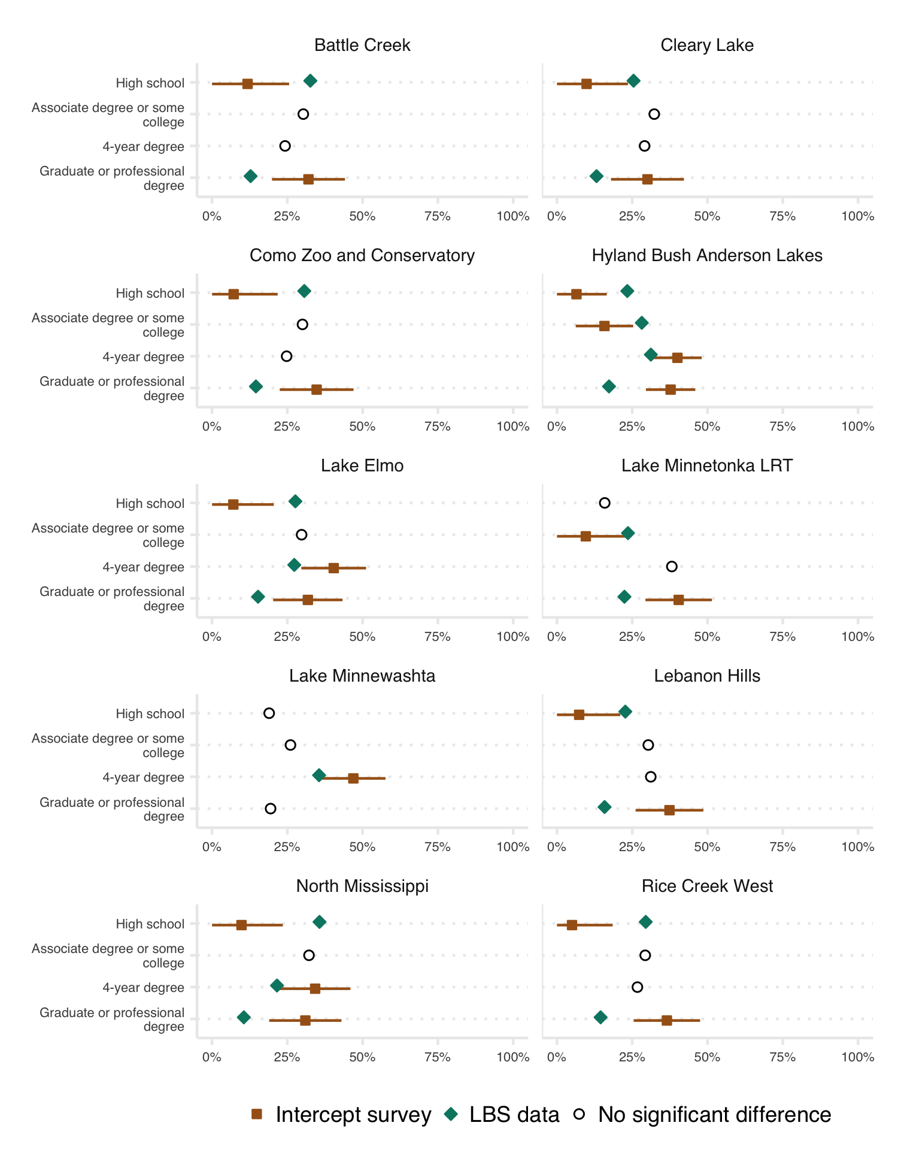

Figure 4.5: Validation of educational attainment. Error bars show a 95% confidence interval. When there was no significant difference in percentages at the 95% confidence interval, LBS data percentages are shown. Source: Metropolitan Council visitor study, StreetLight Data, Inc. Accessed July 2023.

##### 4.1.4.2.3 Income

There were no significant differences observed in estimated visitor household income for LBS and intercept survey data (Figure 4.6). This validation suggests that LBS data income categories are reliable and can provide useful information about park and trail visitors. However, similar percentages of visitors are seen across many income categories, which may obscure larger patterns.

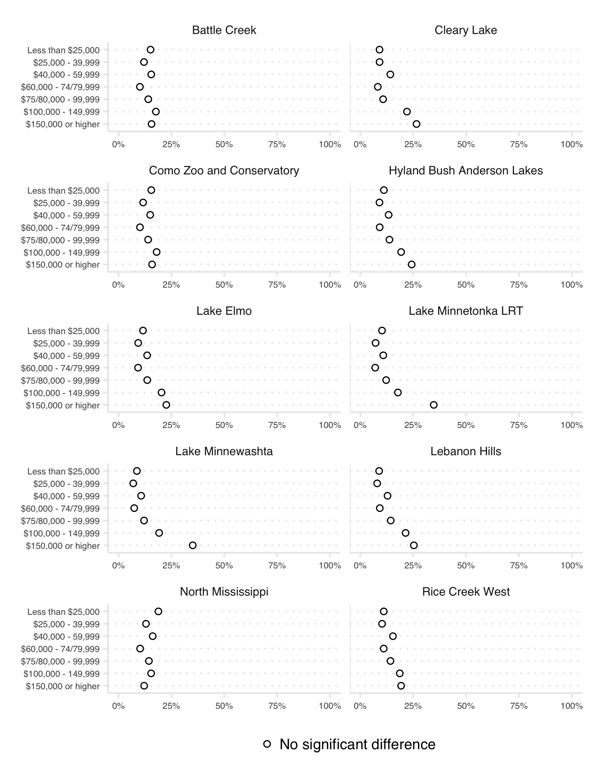

Figure 4.6: Validation of visitor household income. Error bars show a 95% confidence interval. When there was no significant difference in percentages at the 95% confidence interval, LBS data percentages are shown. Source: Metropolitan Council visitor study, StreetLight Data, Inc. Accessed July 2023.

## 4.2 Results

### 4.2.1 Visitors from across the country visited Minnesota’s parks and trails

Visitors traveled to visit Minnesota’s parks and trails from all lower 48 states (Figure 4.7). Overall, Minnesota residents made up approximately 90.22% of users to parks and trails. Following Minnesota, adjacent states represent the largest portion of total use: Wisconsin with 3%, North Dakota with 0.83%, Iowa with 0.81%, and Illinois with 0.65%. Notably, California was the 5th most common home location (outside of Minnesota), representing 0.43% of total use.

While visits by international residents are counted in park and trail estimates, LBS data does not allow for identification of home locations for international residents.

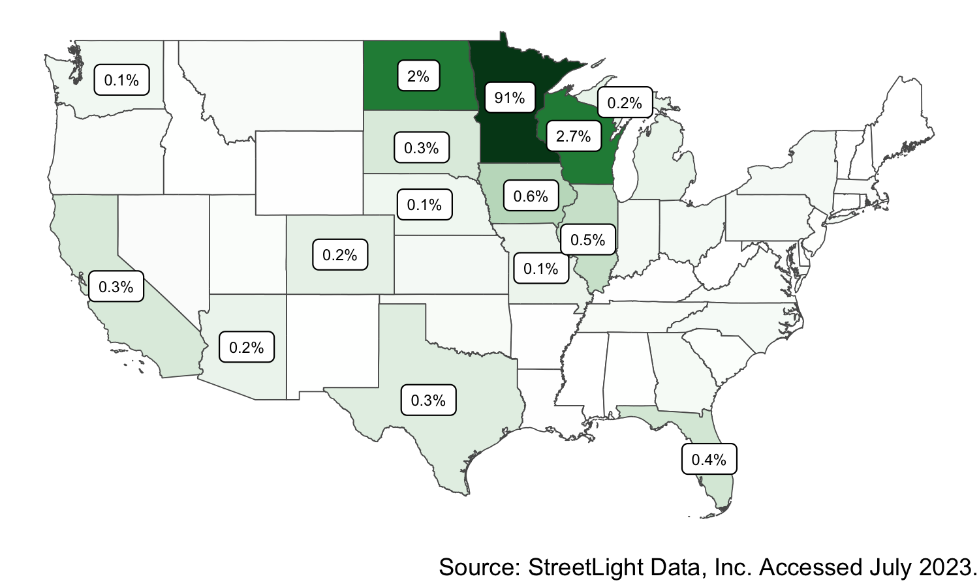

Figure 4.7: Proportion of visitors to Minnesota parks and trails in 2021 mapped by state of residence. Darker green colors indicate states with a greater share of visitors.

### 4.2.2 Park and trail visitor attributes vary at the unit level

For both visitor home locations and inferred demographics, a key finding of this work is that there is significant variation among parks and trails across the state and even within a given system. This data is best explored at the park- or trail-level (Figure 4.8, Figure 4.9, Figure 4.10). Interactive figures are available on the [project website](https://arcg.is/0Oee0W0).

Note that demographic data is only shared at the park- or trail-level in this project. This is because summarizing demographic data at the state or system level is less meaningful than summarizing total visits, for example. While highly summarized data may suggest that park and trail visitors are representative of the state or a given region’s population, it inherently obscures unit-level patterns which may reflect barriers to access at a given park or trail.

In many cases, LBS-derived demographic estimates suggest that park and trail visitors are not representative of local or regional populations (see the fact sheets on the [project website](https://arcg.is/0Oee0W0) to explore unit-level demographics alongside 2020 US Census data for context). This pattern can be referred to as a visitation gap, meaning that the use of parks and trails in Minnesota is not equitably distributed across the population. The extent of the visitation gap and specific dynamics vary across individual units and demographic categories.

Systems, and individual park and trail units, have unique missions and visitor populations. Equity analyses which compare LBS inferred demographics of park and trail users to baseline population demographics may be of interest but are recommended to be performed in a manner that is recognizes specific unit-level context. Therefore, it may be more appropriate to compare park and trail visitor demographics to local or regional demographics. Defining unit-specific reference populations is beyond the scope of this project, but park staff may be interested in using the spreadsheets produced from this project to compare visitor demographics with bespoke baseline populations.

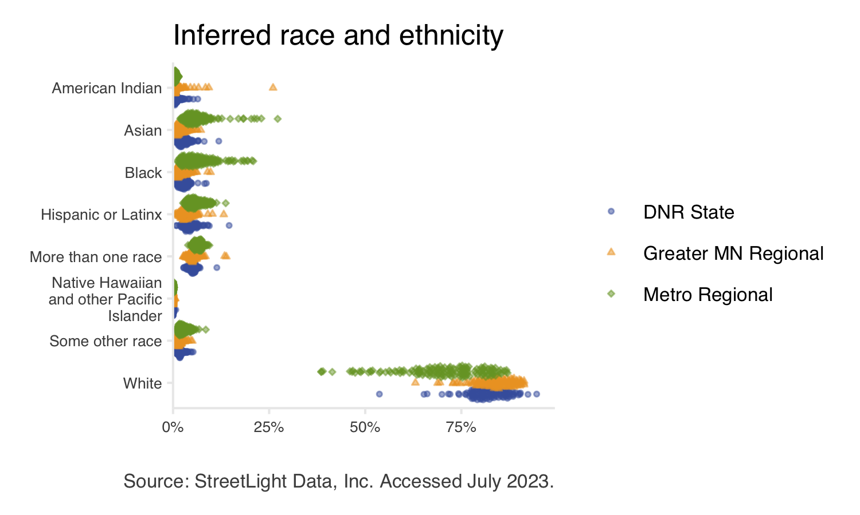

Figure 4.8: Inferred race and ethnicity of park and trail visitors. Each point represents a single park or trail. Point color and shape indicates system.

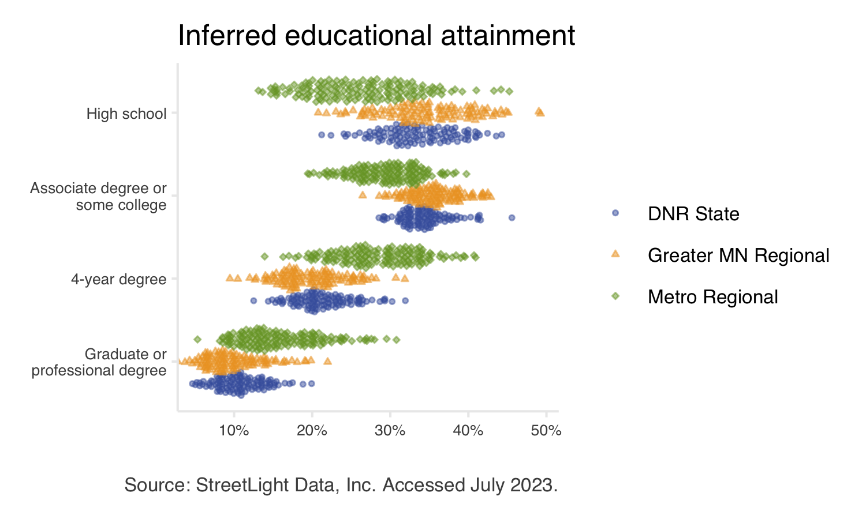

Figure 4.9: Inferred educational attainment of park and trail visitors. Each point represents a single park or trail. Point color and shape indicates system.

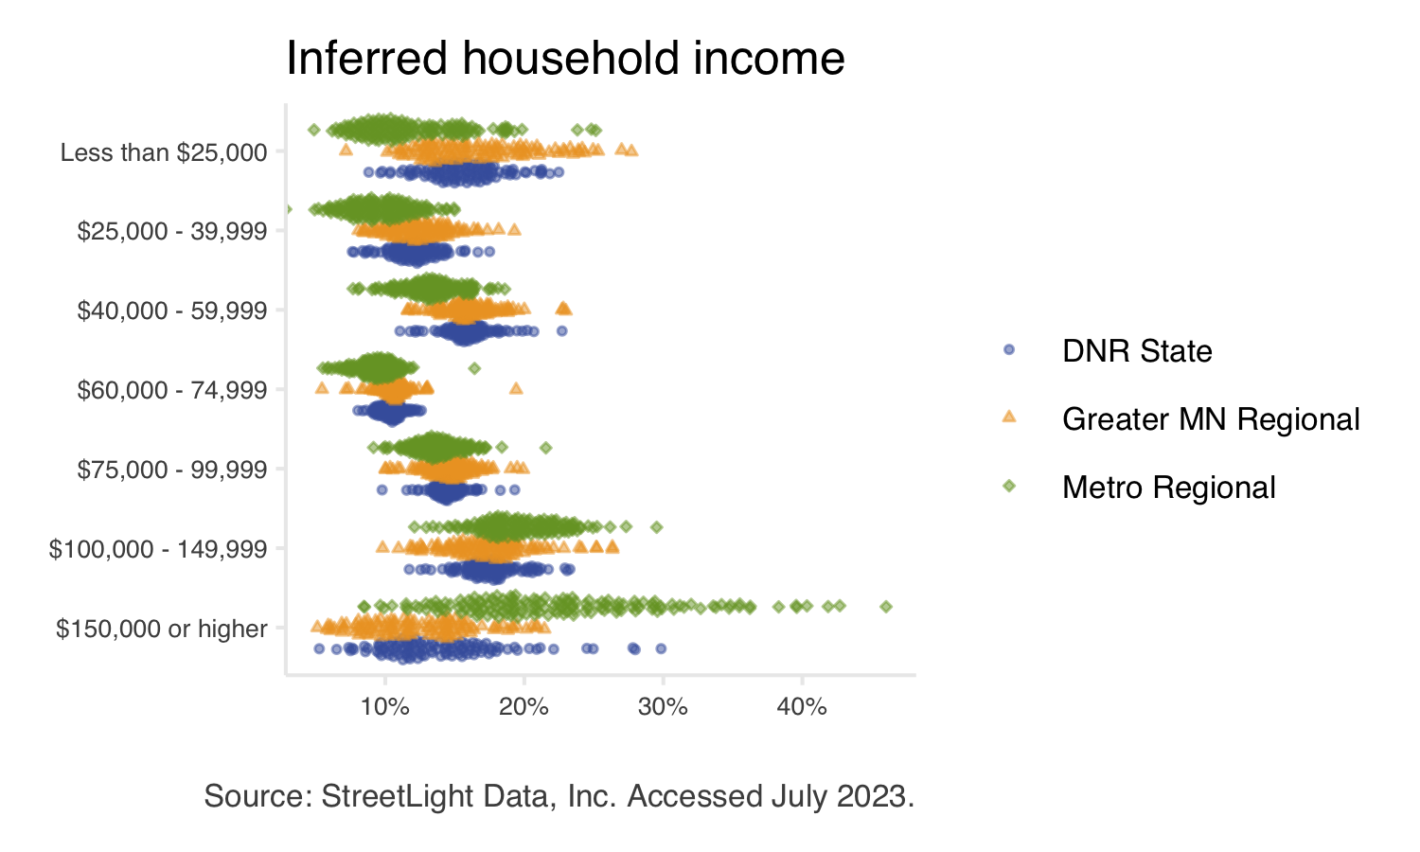

Figure 4.10: Inferred household income of park and trail visitors. Each point represents a single park or trail. Point color and shape indicates system.

# 5 Conclusion

This report has outlined the methods and key findings of this Legacy-funded park and trail research project. Additional resources, including interactive figures, unit-level fact sheets, and complete data downloads are available on the [project website](https://arcg.is/0Oee0W0). This section of the report summarizes recommendations from the project team.

## 5.1 Recommendations

### 5.1.1 Continue collaborative projects

The collaboration between Minnesota Legacy partners allowed us to leverage more information and resources than would have been possible if the project was internal to a single organization. We learned valuable information from partners at all three systems and combined collective knowledge to develop our methods. Collaboration to continue robust park and trail research that benefits all three Legacy partners should be considered in future work.

We additionally learned there is no one-size-fits-all solution for park and trail research. This project aimed to develop universal approaches for park and trail analysis, but still some bespoke solutions were necessary at the unit level. Within a park system, or even within a county or city, there may be two parks with such different qualities that different techniques are needed. For example, a park accessed primarily by vehicles may require a different approach than a park with minimal parking and extensive bike access. Due to this project’s scope, it focused on methods that apply to as many parks and trails as possible. Strategies may be improved for “edge cases,” likely with the help of park staff with detailed on-the-ground knowledge.

### 5.1.2 Continue exploration of novel data sources

The findings from this study were only possible due to the adoption and exploration of novel data sources (LBS data). While exploring new data sources and methods have inherent risks and challenges, the rewards may be significant.

However, no single data source can answer every research question about parks and trails. Like all data, LBS data has strengths and weaknesses. While it provides incredible spatial and temporal detail, it cannot provide information about visitor experiences or report real-time data, for example. Other data sources are needed to address such questions. LBS data may prove most insightful when combined with existing research methods.

Embracing the opportunities and challenges of novel data sources and strategies can provide impactful results. Of course, new or developing data sources have the potential to change rapidly and results from using these data sources are not guaranteed. We believe that the most robust parks research program would remain adaptable, leverage a variety of data sources, and continue experimenting with and developing new approaches.

For this project specifically, we note that industry-wide changes to the availability of LBS data have forced the data provider to discontinue providing LBS data after April 2022. While the data provider is migrating to other spatial data sources, this new data is not currently suitable for park and trail research. As such, the results from this project using LBS data should be viewed as a discrete research project which estimated visitation from January 2019 – April 2022 rather than part of a continuous (ongoing) research project. This change in availability of LBS data is emblematic of the inherit risks in using novel data sources, but the results from this project also demonstrate the rewards of exploring new data sources.

### 5.1.3 Connect with park staff to explore unit-level findings

Due to this project’s scope, it was impossible to connect individually with park and trail managers, staff, or researchers at each unit. However, location-based services (LBS) data allows for highly detailed analyses and applications which may be of interest to these audiences.

Significant on-the-ground knowledge about the park or trail of interest is often required for such analyses. Connecting park managers, staff, or researchers to this detailed data may allow for deeper analysis of individual units or generate more specific research questions. See Use Cases for additional examples of questions LBS data can answer.

### 5.1.4 Use findings to guide future work

The use of LBS data in this project has suggested several avenues for future research. In most cases, future work would not be based exclusively on LBS data. While LBS data has generated insightful results in this project, it has also clarified areas where additional work is needed to supplement LBS data or answer questions that LBS data cannot. Several potential research areas are described below.

* Interact data sources
  + LBS data showed that Minnesota’s parks and trails attract a wide range of visitors. Analysis of other data sources, such as intercept survey responses, to interact with LBS-derived visitor attributes and behavior may provide interesting results (e.g., does travel mode or distance traveled impact how visitors use parks or trails).
* Estimate vehicle multipliers (persons per vehicle)
  + One limitation of LBS data is that it cannot estimate the number of people in each vehicle arriving at a park. Therefore, a vehicle multiplier is needed to convert counts of vehicles to counts of people. This project has highlighted the need for high-quality vehicle multipliers: regardless of how vehicles are counted, vehicle multipliers are necessary to produce visitor counts. Vehicle multipliers are best estimated by survey data; this work indicates that vehicle multipliers may be a priority for future survey efforts.
  + Our data show distinct use patterns across parks and trails (e.g., weekend versus weekday peaks in use, seasonal variability, high use during special events). Vehicle multipliers may be influenced by these factors.
* Further analyze “visitation gap” and other equity questions
  + This project produced unit-level estimates of visitor’s race and ethnicity, education, and income. These inferred demographics from LBS data may compliment work aimed at understanding of inequities and barriers to accessing parks and trails for underrepresented groups. Comparing LBS demographics to bespoke reference populations at the unit level may also be useful.

## 5.2 Additional use cases

This project aimed to develop universal methods of park and trail analysis. Therefore, in-depth analysis of individual units was beyond the scope of this work. Still, many park- or trail-specific research questions can be addressed with LBS data provided. These analyses require substantial on-the-ground knowledge of the park or trail of interest. Possible use cases fall broadly into three categories: those that can be completed using the data provided, those that require a StreetLight license but use this project’s methods, and those that require a StreetLight license and use custom methods beyond this project’s techniques.

### 5.2.1 Using provided data

#### 5.2.1.1 Custom summaries

This project generally reports data summarized at the state or system level. The data provided includes unit-level data in monthly time intervals for trails and weekly time intervals for parks. This data can be used to address several questions:

* Data may be summarized at any geographic level. For your convenience, the data download includes counties, DNR areas, Greater Minnesota districts, and Metropolitan regional implementing agencies for summary purposes.
* Similarly, data may be summarized at any temporal level. For example, weeks or months may be grouped and summarized to analyze custom-defined peak versus off-peak visitation, amenity seasons (i.e., beach or skiing season), or before-and-after study periods.
* Editing vehicle multipliers in the provided Excel workbook will also modify associated visitor counts and mode share data. Accurate park-level vehicle multipliers can improve data quality; however, identifying park-level multipliers was beyond this project’s scope.
* Updating unit-level estimates of visitation to include additional data sources. For instance, LBS data estimates park visitation by counting visitors once upon each park entry (i.e., overnight campers making a day trip outside the park would be counted upon their return as well as initial entry but visitors making multiple stops or short trips within the park are only counted upon initial entry). Adding data from camping permit sales may allow for unit-level LBS estimates to align more closely with established use estimate definitions. Similarly, data estimating park use from minors (devices registered to minors under age 18 are not included in the LBS data source) may be added to LBS visitation estimates.

#### 5.2.1.2 Detailed unit-level explorations

The unit-level data can be explored and applied to questions which may offer opportunities to better understand or serve visitors. In some instances, the unit-level fact sheets or online interactives can used for these explorations. In other instances, using the data downloads may offer more detail and options for summarizing data. Here are several specific questions that may of interest, and can be explored:

* Exploring mode share information to identify infrastructure improvements. For example, additional bike storage may be needed at parks or trails with high bicycle mode share. Parks with low pedestrian mode share in an otherwise walkable area may indicate barriers to access (e.g., fenced areas or roads without crosswalks or bridges, or lack of links to public transit).
* Explore local and non-local visitation. Summaries are provided for each unit about the percent of visitors who live within or outside Minnesota. Since data about visitor home locations are provided by zip code, it is possible to explore visitation percents using bespoke geographies.

#### 5.2.1.3 Demographic comparisons to bespoke reference populations

Park staff may be interested in comparing the demographic estimates of specific park or trail units to bespoke reference populations. The summary report compares park and trail visitor demographics to the statewide population. However, comparisons to local or regional demographics may provide additional insights. Defining unit-specific reference populations is beyond this project’s scope, but the provided data can be used to compare visitor demographics with custom populations.

The provided spreadsheet titled “LBS_visitor_attribute_results_2023.07.xlsx” contains estimated demographic characteristics for each park and trail unit. Existing, online tools such as [Census Reporter](https://censusreporter.org/) can be used to help access census demographics for a [range of geographies](https://censusreporter.org/topics/geography/) (e.g., state, county, census tracts and block groups, zip codes, metropolitan areas, and others). Note that LBS data only provides selected demographic categories (race, income, education), while census data contains many more demographic axes. Comparing individual park- or trail-level demographics to bespoke reference populations may provide insights for park staff.

### 5.2.2 Using project methods (requires StreetLight license)

In addition to park- or trail-level analyses, LBS data can be used to analyze smaller or more specific geographies. Custom geographies can be used to address many park- or trail-specific questions. Several examples are described below. Note that, due to ongoing changes in LBS data availability, these analyses are currently recommended for time periods between January 2019 and April 2022.

**How many users drive to a given trailhead?** A researcher may define custom analysis zones encompassing relevant trailheads or parking lots and measure vehicle trips to those parking lots.

**Which park entrance receives the most use?** The number of trips passing through any number of user-defined entrance “gates” can be compared to identify the highest- or lowest-use entrances. The same approach could be used to determine which of several parking lots receives the most used. This information could be used to identify ideal locations for survey stations, permanent vehicle counters, high priority locations for signage or other visitor service, among others.

**How to schedule park and trail management to meet visitor needs?** Analyzing use over time at custom geographies may be used to schedule any number of activities. For example, identifying maximum hourly use at a specific parking lot may indicate when a surveyor will likely encounter the most park visitors (Figure 5.1). Conversely, identifying minimum hourly use in areas of interest may be helpful scheduling disruptive maintenance, such as cleaning restrooms or mowing grass.

Other applications of hourly data include scheduling lifeguards at beaches, determining visitor center hours, or determining if 9-to-5 commuters may use a trail.

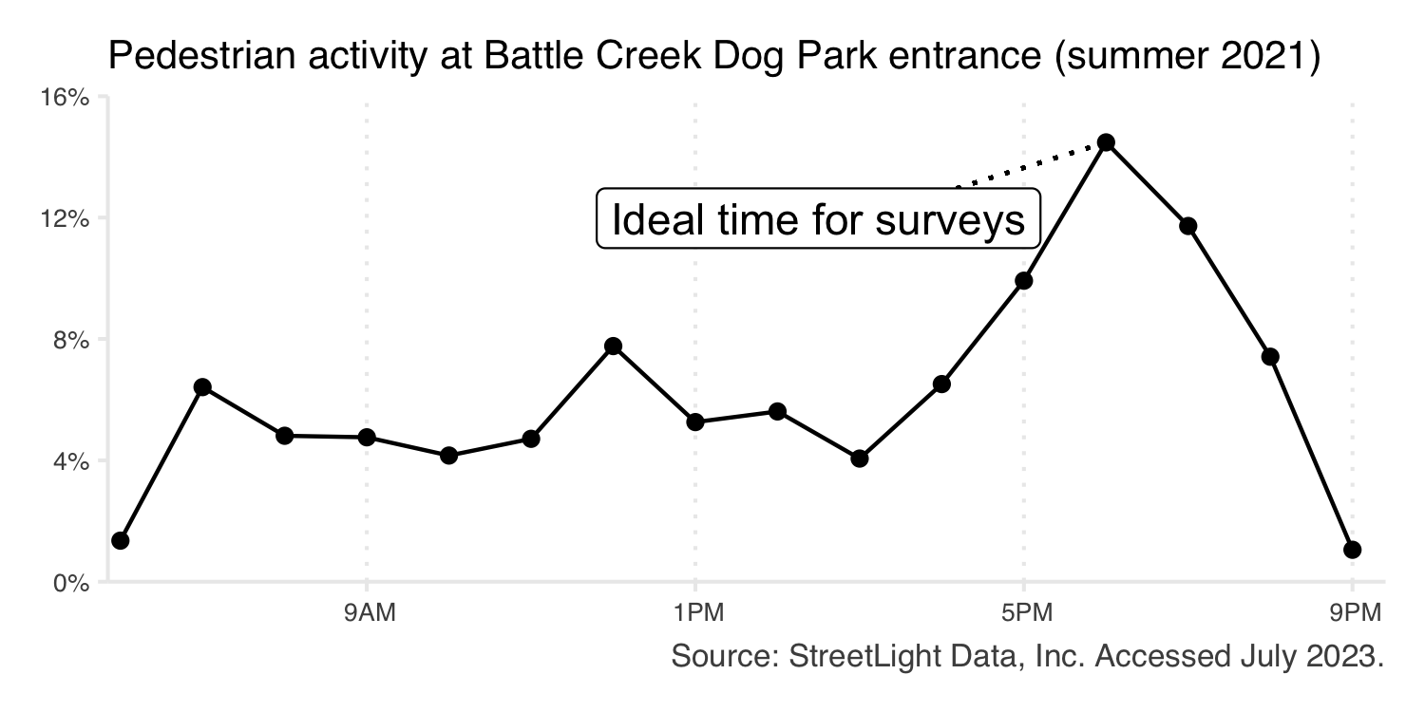

Figure 5.1: Average hourly pedestrian use at the entrance of Battle Creek Regional Park off-leash dog area (Metro Regional) during the summer of 2021.

# 6 Appendix

## 6.1 Resources

### 6.1.1 Our partner organizations

This research was made possible by collaboration with partner organizations and Legacy Amendment funding.

* [Minnesota Legacy and Trust Funds](https://www.legacy.mn.gov/) were the source of funding for this research.
* [The Parks and Trails Legacy Advisory Committee](https://www.legacy.mn.gov/ptlac) provided guidance for this research project.
* The [Department of Natural Resources](Department%20of%20Natural%20Resources) manages state parks and trails.
* [Greater Minnesota Regional Parks and Trails Commission](https://www.gmrptcommission.org/) designates regional parks and trails in the 80 counties of Greater Minnesota.
* Metropolitan regional parks and trails are supported by the [Metropolitan Council](https://metrocouncil.org/Handbook/Plan-Elements/Parks.aspx) in partnership with [ten regional implementing agencies](https://metrocouncil.org/Parks/About/Partners.aspx).

### 6.1.2 Data sources

Complete methods for this research can be found in the technical documentation.

* [StreetLight Data, Inc.](https://www.streetlightdata.com/) provided anonymized and aggregated location-based services data.
* The Minnesota Geospatial Data Commons contains geography files for [DNR State parks](https://gisdata.mn.gov/dataset/bdry-dnr-lrs-prk), [DNR State trails](https://gisdata.mn.gov/dataset/trans-state-trails-minnesota), [Metro Regional parks](https://gisdata.mn.gov/dataset/us-mn-state-metc-plan-parks-regional), and [Metro Regional trails](https://gisdata.mn.gov/dataset/us-mn-state-metc-trans-regional-trails-exst-plan). Greater MN Regional park and trail files were accessed via personal communication.

### 6.1.3 More about Minnesota parks and trails

* [Minnesota Great Outdoors](https://mn.gov/greatoutdoors/) is another Legacy-funded collaborative project between DNR, Greater MN Regional Parks and Trails Commission, and the Metropolitan Council to provide web-based information for park and trail users.

## 6.2 FAQ

### 6.2.1 What is this project?

This exploratory research project aimed to determine the utility of location-based services (LBS) data for estimating park and trail use in Minnesota. LBS data was obtained from StreetLight Data, Inc. and was used to estimate park and trail use across three park systems: Department of Natural Resources state parks and trails (DNR state), Greater Minnesota regional parks and trails (Greater MN regional), and Twin Cities metropolitan regional parks and trails managed by ten implementing agencies in collaboration with the Metropolitan Council (Metro Regional). The project was funded with Legacy Partnership Research Funds from the State of Minnesota Parks and Trails Legacy Fund in collaboration with the three systems.

###What is StreetLight Data? [StreetLight Data, Inc.](https://www.streetlightdata.com/) is the provider of LBS data for this project. StreetLight purchases anonymized LBS data from third-party vendors, such as [Cuebiq](https://www.cuebiq.com/). StreetLight then processes the data, completing quality assurance and statistical tests. The project team received aggregated and anonymized travel patterns which were used for analysis. The data vendor implements data privacy methods, and it is not possible to identify individuals or individual trips through this data source or these methods.

Broadly, LBS data is generated by GPS-enabled devices (i.e., smartphones) where users have “opted-in” to using location services. Common examples of third-party applications where users can opt in to using location services are weather, fitness, and mapping applications. Cell phone service (i.e., LTE, 3G, 4G) is not necessary for GPS functionality. StreetLight Data, Inc. uses “penetration rates” to account for incomplete adoption of GPS-enabled devices (i.e., smartphones) and users who have not opted-in to location services. StreetLight Data, Inc.’s algorithms clean the data and convert device count (i.e., sample size) into estimates of vehicles, pedestrians, and bikes which are used in this research. The LBS data provider does not explicitly measure visitors arriving by other transportation modes, but other modes (i.e., snowmobiles, boaters) may be captured and classified as either vehicle, bike, or foot visitors by the LBS data provider using their probabilistic models.

More information about StreetLight Data, Inc.’s process can be found [on their website](https://www.streetlightdata.com/).

### 6.2.2 What are the benefits of using LBS/StreetLight?

LBS data meaningfully complement existing park and trail use estimates (i.e., intercept surveys, manual counts, or physical trail counters). LBS data is available for parks and trails even when surveys or manual counts have not been performed. This research project processed data for all parks and trails eligible to receive Legacy funding, regardless of existing capacity for research or data collection.

Additionally, LBS data has unique strengths in providing detailed spatial and temporal information. This project produced estimates for individual parks at weekly time intervals and individual trails at monthly time intervals. Data is available for January 2019 - April 2022.

Please note that there are many park and trail research methods. Each has benefits and drawbacks; LBS data is not the appropriate tool for all research questions.

### 6.2.3 What can we measure?

The LBS data used in this project includes estimated counts of vehicles, bicyclists, and pedestrians. We must apply a vehicle multiplier (average number of persons per vehicle) to convert vehicle counts to visitor counts. These counts are combined to estimate of total use at each park and trail.

This data is available in monthly time intervals for trails and weekly time intervals for parks, allowing for detailed time series trend analyses.

Visitor demographics are inferred based on census data. While inferred demographics are informative, they are different than intercept surveyed responses and cannot capture visitors’ lived experiences.

The LBS data provider does not explicitly measure visitors arriving by other transportation modes, but other modes (i.e., snowmobiles, boats, equestrians, skiers) may be captured and classified as either vehicles, bikers or walkers by the LBS data provider using their probabilistic models. It cannot identify unique versus repeat visitors, nor can it measure how long visitors spend at a park or trail. Devices registered to minors (under age 18) are not included in the LBS data source.

### 6.2.4 How were vehicle multipliers determined?

For Metro Regional parks, agency-level vehicle multipliers ranging between 1.71 and 2.72 were applied. State parks use a vehicle multiplier of 3.2 based on current DNR practices. We recommend 2.46 as a baseline vehicle multiplier for Greater Minnesota Regional parks. This is the average of the suburban Metro Regional agency multipliers and the DNR State park multiplier.

### 6.2.5 Why don’t park boundaries match official park boundaries?

Park boundaries were edited to remove unrelated roads in order to isolate park visitors. In some cases, boundaries were expanded to include lake or river shores or amenities, such as trailheads and parking lots, that fell outside of original park boundaries. In many cases, boundaries were edited based on feedback requested throughout the project. Park and trail boundaries, in addition the number of parks and trails, remained constant over the course of this study (January 2019 – April 2022).

### 6.2.6 Why don’t trail segments match official trail alignments?

This can happen for several reasons. Very short segments, or segments which are primarily highways, may be excluded on purpose. Otherwise, differences between trail alignments and segments are explained by OpenStreetMap data availability. In some cases, when trails run alongside roads, the best OSM match will include a longer section of road than appropriate. In other cases, the trail simply isn’t represented in OSM data. This is most common for trails still under development or for short sections or spurs.

Trail geographies were edited based on provided shapefiles and maps available via respective agency websites, OpenStreetMap, and sources such as Minnesota Great Outdoors, AllTrails, etc. Revisions to OpenStreetMap data are beyond the scope of this project.

### 6.2.7 How does this project affect my park/trail?

Data from this project is intended to supplement existing data. All partners have assisted in funding this research project, but the data from this project is not linked to funding allocation.

### 6.2.8 What’s next with StreetLight?

Recent industry-wide changes to the availability of location-based services (LBS) data have forced StreetLight, and other data providers, to adopt new data sources and strategies. As of May 2022, LBS data is no longer available. Other data sources that StreetLight and other providers are migrating to are not suitable for park and trail research at this time.

### 6.2.9 What’s next for this project?

We recommend using the findings from this work to guide other research until the future of LBS data is more clear. For example, these results may be used to refine existing research questions. Please view the “Recommendations and Future Work” and “Use Case” sections for more detail. At this time, the results from this project using LBS data should be viewed as a discrete research project which estimated visitation from January 2019 – April 2022 rather than part of a continuous (ongoing) research project.

## 6.3 Park units excluded from analysis

Parks were excluded from the analysis for several reasons. Some parks were excluded from the project sample entirely, others were excluded from portions of the analysis but remained in the project sample. This appendix documents the basis for these exclusions.

### 6.3.1 Geography-based exclusions

Several units were dropped before any LBS analyses were run due to geography issues (Table 6.1). Islands were removed, as were parks less than 10,000m $​^{2}$ in area. Islands were excluded because the LBS provider does not explicitly measure boat activity. Units under 10,000m $​^{2}$ were excluded due to data coverage concerns (the LBS provider flags any areas under this threshold).

Table 6.1: Park units excluded from all analyses due to their geography.

| **System** | **Unit** | **Cause** |
| --- | --- | --- |
| DNR State | Garden Island (State Recreation Area) | Island |
| DNR State | Lake Minnetonka Islands, Three Rivers | Island |
| DNR State | Saint Croix Islands (State Recreation Area) | Island |
| Metro Regional | Sam Brown Memorial (State Wayside) | Less than 10,000 square kilometers |

### 6.3.2 Coverage-based exclusions

Several units were excluded from the project sample after LBS analyses were run. Units which were missing vehicle data for >50% of the weeks in the analysis period were excluded (Table 6.2). Several units returned vehicle and pedestrian, but no bicycle data (Table 6.3). These parks remained in the project sample and bike activity was assumed to be 0. Finally, a number of parks returned bike data for <50% of months in the analysis period (Table 6.4). These parks remained in the project sample, but no imputation was performed to fill missing bike estimates due to insufficient data. Bike use was assumed to be 0 for missing months at these units.

Table 6.2: Park units excluded after running LBS analyses due to low coverage (missing >50% of weekly records).

| **System** | **Unit** |
| --- | --- |
| DNR State | Devils Track Falls (State Wayside) |
| DNR State | Hill Annex Mine |
| DNR State | Joseph R. Brown (State Wayside) |
| Greater MN Regional | Northerly (Eligible) |

Table 6.3: Park units for which no bike data was returned

| **System** | **Unit** |
| --- | --- |
| DNR State | Franz Jevne |
| DNR State | Greenleaf Lake (State Recreation Area) |
| DNR State | John A. Latsch |
| DNR State | Kilen Woods |
| Greater MN Regional | Collinwood |

Table 6.4: Parks for which no bike imputation was performed due to low coverage (missing >50% of monthly bike records).

| **System** | **Unit** |
| --- | --- |
| DNR State | Beaver Creek Valley |
| DNR State | Big Stone Lake |
| DNR State | Buffalo River |
| DNR State | Caribou Falls (State Wayside) |
| DNR State | Carley |
| DNR State | Flood Bay (State Wayside) |
| DNR State | Franz Jevne |
| DNR State | George H. Crosby-Manitou |
| DNR State | Grand Portage |
| DNR State | Greenleaf Lake (State Recreation Area) |
| DNR State | Hayes Lake |
| DNR State | Inspiration Peak (State Wayside) |
| DNR State | John A. Latsch |
| DNR State | Judge C. R. Magney |
| DNR State | Kilen Woods |
| DNR State | Kodonce River (State Wayside) |
| DNR State | La Salle Lake (State Recreation Area) |
| DNR State | Lac qui Parle |
| DNR State | Monson Lake |
| DNR State | Old Mill |
| DNR State | Ray Berglund (State Wayside) |
| DNR State | Schoolcraft |
| DNR State | Split Rock Creek |
| DNR State | Upper Sioux Agency |
| DNR State | Zippel Bay |
| Greater MN Regional | Bend in the River (GRPC) |
| Greater MN Regional | Big Elk Lake |
| Greater MN Regional | Big Falls Campground and Horse Camp |
| Greater MN Regional | Collinwood |
| Greater MN Regional | Fish Lake (Eligible) |
| Greater MN Regional | Garvin |
| Greater MN Regional | Granite Falls Memorial |
| Greater MN Regional | Hok Si La (Eligible) |
| Greater MN Regional | Hole in the Mountain |
| Greater MN Regional | Irving and John Anderson |
| Greater MN Regional | Kraemer Lake |
| Greater MN Regional | Lac qui Parle |
| Greater MN Regional | Lake Washington |
| Greater MN Regional | Milford Mine Memorial |
| Greater MN Regional | Mississippi River (GRPC) |
| Greater MN Regional | Ney Nature Center (Eligible) |
| Greater MN Regional | Northland |
| Greater MN Regional | Plum Creek |
| Greater MN Regional | Robert Ney Memorial |
| Greater MN Regional | Rockville |
| Greater MN Regional | Root River (Eligible) |
| Greater MN Regional | Sandstone Robinson |
| Greater MN Regional | Springvale (Eligible) |
| Greater MN Regional | Stanley Eddy |
| Greater MN Regional | Twin Lakes |
| Metro Regional | Cedar Lake Farm, Scott County |
| Metro Regional | Kingswood, Three Rivers |
| Metro Regional | Lake Sarah, Three Rivers |
| Metro Regional | Noerenberg Gardens, Three Rivers |
| Metro Regional | Square Lake, Washington County |

## 6.4 Park geography exceptions

All park geography was edited using the procedure described in the parks methodology section of this report. In a number of cases, however, we deviated from the procedure to improve LBS performance at a given park. Table 6.5 documents these changes and a brief explanation of our rationale. The most common change was to reduce the size of the buffer used to remove unrelated roads from park boundaries. This was in order to avoid removing parking lots or other amenities close to the road.

Table 6.5: Parks for which additional geographic edits were conducted.

| **System** | **Unit** | **Exception** |
| --- | --- | --- |
| DNR State | Afton | Reduced road buffer to 10m |
| DNR State | Banning | Based on feedback, manually included additional parking lot |
| DNR State | Bear Head Lake | Expanded water buffer to create consistent shoreline |
| DNR State | Big Stone Lake | Reduced road buffer to 20m, expanded water buffer to create consistent shoreline, manually added overlook area |
| DNR State | Cascade River | Based on feedback, included section of road previously removed |
| DNR State | Fort Ridgely | Based on feedback, included historic Fort Ridgely inholding |
| DNR State | Fort Snelling | Reduced road buffer to 20m |
| DNR State | Frontenac | Based on feedback, manually included additional parking lot |
| DNR State | Glendalough | Based on feedback, manually included Molly Stark boat launch |
| DNR State | Gooseberry Falls | Based on feedback, reduced road buffer to 15m to retain Gitchi Gami state trail |
| DNR State | Grand Portage | Based on feedback, manually included additional parking |
| DNR State | Hayes Lake | Based on Feedback, included section of road previously removed |
| DNR State | Itasca | Based on feedback, included SNA |
| DNR State | Kilen Woods | Reduced road buffers near bridge to 10m |
| DNR State | Kodonce River (State Wayside) | Based on feedback, manually included additional parking |
| DNR State | Lac qui Parle (DNR) | Based on feedback, manually included park office which lies outside of park boundary |
| DNR State | Lake Bronson | Reduced select road buffers to 5m |
| DNR State | Lake Carlos | Based on feedback, manually included lazy river parking lot |
| DNR State | Lake Shetek | Based on feedback, remove previously included cabins |
| DNR State | Lake Vermilion-Soudan Underground Mine | Based on feedback, manually included additional parking |
| DNR State | Maplewood | Based on feedback, removed previously included cabins |
| DNR State | McCarthy Beach | Based on feedback, manually included additional parking |
| DNR State | Ray Berglund (State Wayside) | Reduced road buffer to 3m |
| DNR State | Rice Lake | Based on feedback, manually included park entrance and filled in gap in original shapefile |
| DNR State | Saint Croix Boom Site (State Wayside) | Reduced road buffer to 3m |
| DNR State | Split Rock Lighthouse | Based on feedback, excluded lighthouse, included Gitchi Gami and scenic outlook |
| DNR State | Temperance River | Based on feedback, manually included additional parking |
| DNR State | Upper Sioux Agency | Based on feedback, manually included historical site |
| Greater MN Regional | Alexander Ramsey | Reduced road buffer to 5m |
| Greater MN Regional | Appleton OHV (Eligible) | Reduced road buffer to 25m |
| Greater MN Regional | Bend in the River (GRPC) | Reduced road buffer to 20m |
| Greater MN Regional | Bluffs Traverse | Manually included additional parking |
| Greater MN Regional | Cohasset Tioga | Reduced road buffer, reduced water buffer to create consistent shoreline |
| Greater MN Regional | Collinwood | Reduced buffer on city roads to 15m |
| Greater MN Regional | Fish Lake (Eligible) | Original shapefile was misaligned: edited polygon to reflect published maps of the park, reduced road buffer to 10m. Further refinement requires revised shapefile. |
| Greater MN Regional | Garvin | Reduced road buffer to 10m |
| Greater MN Regional | Grand Marais Recreation Area (Eligible) | Reduced road buffer to 10m |
| Greater MN Regional | Granite Falls Memorial | Reduced road buffer to 20m |
| Greater MN Regional | He Mni Can - Barn Bluff | Reduced select road buffers to 5m |
| Greater MN Regional | Irving and John Anderson | Reduced road buffers to 20m |
| Greater MN Regional | Jay C. Hormel Nature Center | Removed private property (Gerard Academy, Austin Country Club) |
| Greater MN Regional | Kensington Rune Stone | Increased water buffer to create consistent shoreline |
| Greater MN Regional | Pine Valley (Eligible) | Reduced road buffer to 15m |
| Greater MN Regional | Plum Creek | Reduced road buffer to 15 |
| Greater MN Regional | Robbins Island | Reduced road buffer to 5m |
| Greater MN Regional | Robert Ney Memorial | Reduced road buffer to 5m |
| Greater MN Regional | Rockville | Reduced road buffer to 15m |
| Greater MN Regional | Root River (Eligible) | Increased water buffer to create consistent shoreline |
| Greater MN Regional | Sandstone Robinson | Reduced road buffer to 15m |
| Greater MN Regional | Spirit Mountain | Reduced road buffer to 15m |
| Greater MN Regional | Stanley Eddy | Original shapefile was misaligned: edited polygon alignment to reflect published maps of the park. Reduced road buffer to 20m. Further refinement requires revised shapefile. |
| Greater MN Regional | Twin Lakes | Increased water buffer to create consistent shoreline |
| Metro Regional | Above the Falls, MPRB | Reduced road buffer |
| Metro Regional | Central Mississippi Riverfront, MPRB | Reduced buffer on all non-highway roads |
| Metro Regional | Hyland-Bush-Anderson Lakes, Bloomington | Reduced select road buffers to 5m |
| Metro Regional | Hyland-Bush-Anderson Lakes, Three Rivers | Reduced select road buffers to 5m |
| Metro Regional | Keller, Ramsey County | Reduced road buffers to 5m |
| Metro Regional | Lake Byllesby, Dakota County | Based on feedback, expanded park boundary 50ft east of Harry Ave |
| Metro Regional | Lake Elmo, Washington County | Increased water buffer to create consistent shoreline |
| Metro Regional | Lake George, Anoka County | Reduced road buffers to 5m |
| Metro Regional | Lake Sarah, Three Rivers | Reduced road buffers to 15m |
| Metro Regional | Lake Waconia, Carver County | Based on feedback, manually removed access to DNR managed boat launch. Further refinement requires revised shapefile. |
| Metro Regional | Lebanon Hills, Dakota County | Based on feedback, removed Camp Butwin inholding |
| Metro Regional | Lilydale-Harriet Island, Saint Paul | Reduced road buffers to 15m |
| Metro Regional | Long Lake, Ramsey County | Reduced road buffers to 15m |
| Metro Regional | Miesville Ravine, Dakota County | Based on feedback, manually included portion of park in Goodhue County. Further refinement requires revised shapefile. |
| Metro Regional | Minneapolis Chain of Lakes, MPRB | Created road-inclusive and road-exclusive polygons. Reduced road buffers to 15m in road-exlusive polygon. |
| Metro Regional | Minnehaha, MPRB | Created road-inclusive and road-exclusive polygons. Reduced road buffers to 15m in road-exlusive polygon. |
| Metro Regional | Mississippi Gateway, Three Rivers | Reduced road buffer to 15m |
| Metro Regional | Mississippi Gorge, MPRB | Reduced road buffer to 5m |
| Metro Regional | Mississippi Gorge, Saint Paul | Reduced road buffer to 5m |
| Metro Regional | Noerenberg Gardens, Three Rivers | Reduced road buffer to 20m |
| Metro Regional | Nokomis-Hiawatha, MPRB | Created road-inclusive and road-exclusive polygons. Reduced road buffers to 20m in road-exclusive polygon. |
| Metro Regional | North Mississippi, MPRB | Reduced road buffer to 15m |
| Metro Regional | North Mississippi, Three Rivers | Reduced road buffer to 15m |
| Metro Regional | Phalen, Saint Paul | Created road-inclusive and road-exclusive polygons. Reduced road buffers to 5m in road-exclusive polygon. |
| Metro Regional | Pine Point, Washington County | Reduced road buffer to 15m |
| Metro Regional | Rice Creek Chain of Lakes, Anoka County | Reduced road buffer to 5-20m |
| Metro Regional | Rum River Central, Anoka County | Increased water buffer to create consistent shoreline |
| Metro Regional | Spring Lake, Dakota County | Based on feedback, removed previously included road segments |
| Metro Regional | Spring Lake, Scott County | Based on feedback, manually added two parking lots |
| Metro Regional | St. Croix Bluffs, Washington County | Based on feedback, included additional land |
| Metro Regional | Theodore Wirth, MPRB | Reduced road buffer to 20m |
| Metro Regional | Whitetail Woods, Dakota County | Based on feedback, manually included trailhead |

## 6.5 Unresolved park geography concerns

The project team was not able to resolve every concern regarding park geography. Table 6.6 documents parks for which additional geography edits may be appropriate. There are a few key concerns remaining. Some park shapefiles may not include all relevant parking; others were misaligned and manually edited. Narrow parks or parks with complex geographies are challenging to isolate and may be better-refined by staff more familiar with the park.

Table 6.6: Parks with unresolved geography concerns.

| **System** | **Unit** | **Concern** |
| --- | --- | --- |
| DNR State | Cuyuna Country (State Recreation Area) | Complex or narrow geography, difficult to isolate |
| DNR State | Gooseberry Falls | Difficult to isolate from Hwy 61 and/or Gitchi Gami State Trail |
| DNR State | Grand Portage | Difficult to isolate from Hwy 61 and/or Gitchi Gami State Trail |
| DNR State | Kodonce River (State Wayside) | Difficult to isolate from Hwy 61 and/or Gitchi Gami State Trail |
| DNR State | Split Rock Lighthouse | Difficult to isolate from Hwy 61 and/or Gitchi Gami State Trail |
| DNR State | Temperance River | Difficult to isolate from Hwy 61 and/or Gitchi Gami State Trail |
| DNR State | Tettegouche | Difficult to isolate from Hwy 61 and/or Gitchi Gami State Trail |
| Greater MN Regional | Bluffs Traverse | Parking may lie outside of boundary |
| Greater MN Regional | Cohasset Tioga | Complex or narrow geography, difficult to isolate |
| Greater MN Regional | Fish Lake (Eligible) | Original shapefile misaligned |
| Greater MN Regional | Frazee (Eligible) | Roads could not be removed |
| Greater MN Regional | Grand Marais Recreation Area (Eligible) | Roads could not be removed |
| Greater MN Regional | Lake Brophy | Water boundary may include private waterfront and/or exclude public waterfront |
| Greater MN Regional | Mississippi River (GRPC) | Complex or narrow geography, difficult to isolate |
| Greater MN Regional | Robbins Island | The portion of the park on County Hwy 41 (Rau park unit) is challenging to separate from the highway itself. |
| Greater MN Regional | Sawtooth Bluff (Eligible) | Parking may lie outside of boundary |
| Greater MN Regional | Stanley Eddy | Original shapefile misaligned |
| Metro Regional | Above the Falls, MPRB | Complex or narrow geography, difficult to isolate |
| Metro Regional | Central Mississippi Riverfront, MPRB | Complex or narrow geography, difficult to isolate |
| Metro Regional | Hyland-Bush-Anderson Lakes, both units | Original shapefile incorrectly assigned parcels to implementing agencies |
| Metro Regional | Mississippi Gorge, MPRB | Complex or narrow geography, difficult to isolate |
| Metro Regional | North Mississippi, Three Rivers | Complex or narrow geography, difficult to isolate |

## 6.6 Trail units/segments excluded from analysis

### 6.6.1 Geography-based exclusions

Trails were excluded from the analysis for several reasons. Some trails were removed before LBS analyses were run due to limited OSM data (Table 6.7. In these cases, some OSM segments may have been identified, but coverage was insufficient for reasonable analysis. Additionally, any identified OSM segments less than 50ft in length were excluded (Table 6.8. In these cases, trails remained in the analysis.

Table 6.7: Trails excluded from all analyses due to insufficient OSM coverage

| **System** | **Unit** |
| --- | --- |
| DNR State | OHV access to Taconite via USFS Rd 11404 |
| Greater MN Regional | Houston County trail |
| Greater MN Regional | Red Lake River Corridor |
| Greater MN Regional | Zumbro River |
| Metro Regional | Mississippi Gorge/West River Parkway, Saint Paul |
| Metro Regional | Northeast Diagonal, MPRB/Three Rivers |
| Metro Regional | Rice Creek North Extension, Ramsey County |

Table 6.8: Summary of OSM segments dropped from analysis due to length (<50ft)

| **System** | **Unit** | **Dropped segments** |
| --- | --- | --- |
| DNR | Luce Line | 20 |
| DNR | Paul Bunyan | 12 |
| DNR | Sakatah Singing Hills | 10 |
| Greater MN | Duluth Traverse | 30 |
| Metro | Rum River, Anoka County | 2 |
| Metro | West Mississippi, Three Rivers | 38 |

### 6.6.2 Coverage-based exclusions

Several trail units/segments were excluded from the project sample after LBS analyses were run. Two units returned no LBS data for any segments (Table 6.9). When individual trail segments did not return LBS data, the associated trail remained in the project sample and use was assumed to be zero on missing segments. In total, 200 identified OSM segments returned no LBS data (Table 6.10).

Table 6.9: Trails for which no LBS data was available

| **System** | **Unit** |
| --- | --- |
| DNR State | Camp Ripley/Veterans Memorial |
| DNR State | Chester Woods |

Table 6.10: Summary of OSM for which no LBS data was available. Use was assumed to be zero on these segments.

| **System** | **Unit** | **Dropped segments** |
| --- | --- | --- |
| DNR | Blazing Star | 1 |
| DNR | Blue Ox | 14 |
| DNR | Brown's Creek | 2 |
| DNR | C.J. Ramstad/North Shore | 23 |
| DNR | Camp Ripley/Veterans Memorial | 2 |
| DNR | Casey Jones | 1 |
| DNR | Central Lakes | 2 |
| DNR | Chester Woods | 3 |
| DNR | Cloquet-Saginaw | 1 |
| DNR | Dakota Rail | 2 |
| DNR | David Dill-Arrowhead | 27 |
| DNR | David Dill-Taconite | 6 |
| DNR | Douglas | 11 |
| DNR | Gandy Dancer | 5 |
| DNR | Gateway | 13 |
| DNR | Gitchi-Gami | 11 |
| DNR | Glacial Lakes | 1 |
| DNR | Goodhue Pioneer | 1 |
| DNR | Great River Ridge | 4 |
| DNR | Harmony-Preston Valley | 4 |
| DNR | Heartland | 4 |
| DNR | Luce Line | 2 |
| DNR | Matthew Lourey | 3 |
| DNR | Mill Towns | 3 |
| DNR | Minnesota Valley | 1 |
| DNR | Paul Bunyan | 2 |
| DNR | Root River | 6 |
| DNR | Shooting Star | 5 |
| DNR | Taconite | 7 |
| DNR | Willard Munger, Hinkley-Duluth Fire Segment | 4 |
| Greater MN | Aitkin County Northwoods ATV, Rabey Line | 1 |
| Greater MN | Battle Lake to Ashby | 4 |
| Greater MN | Camden | 1 |
| Greater MN | Cook County Mountain Bike, Britton Peak | 1 |
| Greater MN | Cook County Mountain Bike, Pincushion | 1 |
| Greater MN | Lake Country | 2 |
| Greater MN | Lake Vermillion, Cook County | 1 |
| Greater MN | Marshal Kittson | 4 |
| Greater MN | Otter Tail County, Perham to Pelican Rapids | 2 |
| Greater MN | Prospector Loop | 9 |
| Greater MN | Soo Line, North: Aitkin County | 1 |
| Greater MN | Soo Line, North: Carlton County | 1 |
| Metro | Crow River, Three Rivers | 1 |